Palm/Passion Sunday
Welcome to Johns Island Presbyterian Church. We are
delighted you have chosen to worship with us!

Gathering Around the Word
Please let us quiet our hearts and minds in preparation for worship.

Chiming of the Hour
Prelude: “Open the Gates of the Temple” joseph f. knapp

Lighting of the Christ Candle

Call to Worship: (responsively) In Hebrew, “Hosanna” means “Save NOW!”
Leader: Hosanna, ruler of all, creator of worlds!
People: Reclaim this suffering earth.
Leader: Hosanna, righteous Jesus, saving Lord!
People: Redeem us from sin’s deadly grip.
Leader: Hosanna, renewing Spirit, living Word!
People: Restore to us the joy of your salvation.

Hymn of Praise: 197 “Hosanna, Loud Hosanna” ellacombe

Procession of the Palms

*Call to Confession

*Prayer of Confession (unison)
O God, we sing and praise you, when we are happy of heart and strong of spirit, when we are among others who praise you, too. But in times of stress, we seek scapegoats to be targets for our anger. We betray those we love and who have loved us, and we turn against you, too busy to seek you, too selfish to obey you. Your compassion is without bounds, O God, for you forgive us again and again. You restore us to a right spirit and bring us together to worship you again. God of steadfast love, teach us how to be steadfast; through Jesus Christ we pray. Amen.

*Assurance of Pardon

*Gloria Patri: 581 "Glory Be to The Father" greatorex

Proclaiming the Word

Time with Young Disciples Laura Harley, Director of Faith Formation

Older children will now rejoin their parents for worship. Children ages 4 years old through Second Grade are invited to leave the Sanctuary for children’s church upstairs. Ages 3 and under will go to the nursery behind the Sanctuary.

*Those who are able, please stand.
Prayer for Illumination

Gospel Reading: Matthew 21: 1-11 Pew Bible p. 21-22
Leader: This is the Word of the Lord.
People: Thanks be to God.

Anthem: “Hosanna, Hosanna We Sing” Stan Pethel
Sermon: “The One Who Holds and Saves Us”
Dr. Jeri Parris Perkins

*Hymn: 196 “All Glory, Laud and Honor” valet will ich dir geben

Responding to the Word

*Affirmation of Faith (unison) Romans 8:31-35, 37-39
What then are we to say about these things? If God is for us, who is against us? He who did not withhold his own Son, but gave him up for all of us, will he not with him also give us everything else? Who will bring any charge against God’s elect? It is God who justifies. Who is to condemn? It is Christ at the right hand of God, who indeed intercedes for us. Who will separate us from the love of Christ? Will hardship, or distress, or persecution, or famine, or nakedness, or peril, or sword?
No, in all these things we are more than conquerors through him who loved us. For I am convinced that neither death, nor life, nor angels, nor rulers, nor things present, nor things to come, nor powers, nor height, nor depth, nor anything else in all creation, will be able to separate us from the love of God in Christ Jesus our Lord.

Minute for Mission Rob Keeler

Minute for Manse Skip Grooms

Minute for Mission (11 a.m.) Jane Marvin

Celebrations and Concerns

Prayers of the People and the Lord’s Prayer
Leader: May the peace of our Lord Jesus Christ be with you;
People: and also with you.
Leader: Let us pray …

Our Father, who art in heaven, hallowed be thy name, thy kingdom come, thy will be done, on earth, as it is in heaven. Give us this day our daily bread; and forgive us our debts, as we forgive our debtors; and lead us
not into temptation, but deliver us from evil. For thine is the kingdom, and the power, and the glory, forever. Amen.

Offertory Sentences
Offertory: "There Is a Balm in Gilead"
Traditional African American Spiritual
*Doxology: 606 "Praise God from Whom All Blessings Flow"
*Prayer of Dedication (unison)
God of mercy, we can scarcely perceive the extravagance of your holy love for all generations. In Jesus, you entered into the beauty and anguish of our lives. Jesus poured out his spirit in compassion that we might come to know the fullness of your love.
Grant us the wisdom to proclaim his praise with sincerity and love. Grant us the willingness to respond with the gift of our selves. Amen.

*Hymn: 198 "Ride On! Ride On in Majesty” st. drostane

Bearing and Following the Word into the World

*Charge and Benediction

*Choral Response: "Amen" Nelsie T. Johnson
Please remain in your pew box until the conclusion of the choral response.

*Postlude: “All Hail King Jesus” David Moody

If you have ordered a lily for Easter, please be sure to take it
with you after the 11 a.m. service next Sunday!
The care facility we have donated to in the past can no longer
receive them.

Continuing Prayer Concerns**
Members and Families: Ryan Hitch (nephew of Steve and Nancy Hitch), Kathy Berlin, Peyton Smith and Family, Betsy Strowd, Mark Calbi, Sally Catlin, Beth Condit, Marthanne Limehouse, John Wells
Friends of JIPC: Roy Burbage, Amelia Bayer, Leonie Born, Melissa Crawford, Moorea “Mighty Mo” Davis, Kurt and Carol Dieterie, Christopher Gill, Robbie Hart, Bonnie Heim, Mary Hill, Susan Hopkins, Eden Kastenbaum, Jeff Kamper, Olivia Lauterbach, Deanna Papastrat, Libby Puckette, Brian Rawl, Rod Vellenoweth
Bereavements: Family of Eileen Bolan, Family of Bennie Anthony Slay III, Family of Marvin Cavanaugh, Family of Pete Hubbard, Family of Carol Cook, Family of Mary Melson, Family of Carl E. Schroeder, Family of David Bergstrom, Family of Herk Sims, Family of Lynda Jeanne Nerhood, Family of Patricia A. Bergfors, Family of Ardra McKinney Withers (Malori Hay), Family of Barbara Campbell, Family of Patricia Keating, Family of Bob Pelletier, Family of Wayne Barfield, Family of Bob Hardy, Family of Sam Reed, Family of Jacob Van de Graaf, Family of Peter Grant, Family of Joseph Hall, Family of Dee Sikes, Rebecca Wick and Family, Family of Chrystal-Krikit Brafford (Wilkie family), Family of Taunya White, Family of Ron Kramer, Family of Willis Richard Simpson, Family of Mario Calbi
Armed Forces: HM1 Jeffrey Thornton (Lauren Jones and family), Lt. Ian Burgoyne and Lt. Annie Burgoyne (James and Erin Burgoyne); Maj. Holly Adamson (Gerry Brokaw and Kay Hudson); Maj. Will Hay (Malori Hay and Family); Cpt. August Kirchner (Gail Kavanaugh); Maj. Gen. Charles L. Moore, Jr. (Mellen Moore); Captain Riley Reed Carrigan (Joan Reed); SSG Thomas Ritchie (Nancy Anne Ritchie); Ensign Brian Paul Bird (Gail Roddey)
Healthcare and First Responders: Jason Brandon, Stephen Erickson, Roger Hart, Malori Hay, Amy Johnson, Sheriff Carl Ritchie (Nancy Ann Ritchie)

**If you notice anything that should be changed,
please contact the church office.
Announcements
Today’s Sunday Elders are Bev Stribling and Danielle Patterson.
Leading the Prayer of Dedication at the 8:30 a.m. service is Stone Barrett and at the 11:00 a.m. service is Aribella Patterson.
Maundy Thursday worship will be at 6:30 p.m. on Thursday and will include Communion by Intinction.
Good Friday worship will be from noon until 3 p.m. We will hear the Crucifixion Story at the top of each hour, and you may spend whatever time you wish in personal prayer and meditation in the Sanctuary.
Holy Saturday Service Project On Saturday, April 4th, from 9:30-11:30 a.m. volunteers aged 10 and older are invited to our annual cleaning of the gravestones. All you need to bring is work gloves and a bottle of water to stay hydrated. Contact Ruby Jenkins, (843) 810-8931, or Todd Lynch, (919) 522-1397, if you plan to attend!
Cornbread Bakers Unite! Plan to attend Taste of the Islands’ Churches, a fundraiser for Feeding of the Multitude, on April 11th from 11 a.m. to 2 p.m. at Wadmalaw Community Center. JIPC has signed up to bring cornbread! See The Post for more details.
Adult Church School class has begun a new book study on Jon Meacham’s book The Hope of Glory: Reflections on the Last Words of Jesus from the Cross. All are invited to attend. Reach out to Tim White with any questions, 1whitetm1@gmail.com. The next class is April 12th.
Monday Evening Bible Study meets from 5:30-6:30 p.m. at Barbara and Jock Vincentsen’s home, 1020 Old Wharf Road, Seabrook. They will resume meeting on Tuesday, April 14th.
Women’s Zoom Bible Study will resume meeting on April 22nd, and they will be studying What My Grandmothers Taught Me. Books are in the office, ready for pick-up! To receive the Zoom link, contact Linda in the office or at ldeeter@jipc.org!
JIPC Church History Tours Have you ever wondered what these church pews would say if they could talk? To learn more about how God has been working here for more than three centuries, email Tina Marshall, TinaArdMarshall@gmail.com, to schedule a tour.
The Flower Calendar has openings May 10, 17, 24, and 31. Please contact Patty Anderson, (843) 261-3122, or Jan Ward, (843) 810-1510, with any questions.
Our nursery is open to children ages three and under in the room behind the Sanctuary on the left side of the building. An usher can show you the way.
Giving Use the QR code on the back of this bulletin or text GIVEJIPC to 73256.
JIPC WEEKLY CALENDAR
Today, March 29 – Palm Sunday
8:30 am Worship
10:15 am Choir Rehearsal, Sanctuary
11:00 am Worship
12:00 pm Handbell Rehearsal
Monday
9:00 am Staff Meeting, Conference Room

Tuesday
9:00 am Deadline for bulletin announcements
10:00 - 11:00 am AA, Parlor
Wednesday
11:00 am Deadline for information for Friday Post
11:00 am Choir Rehearsal, Sanctuary
3:00 pm Building and Grounds, Conference Room
Thursday
8:30 am Men’s Bible Study, Zoom
6:30 pm Maundy Thursday Service with Communion
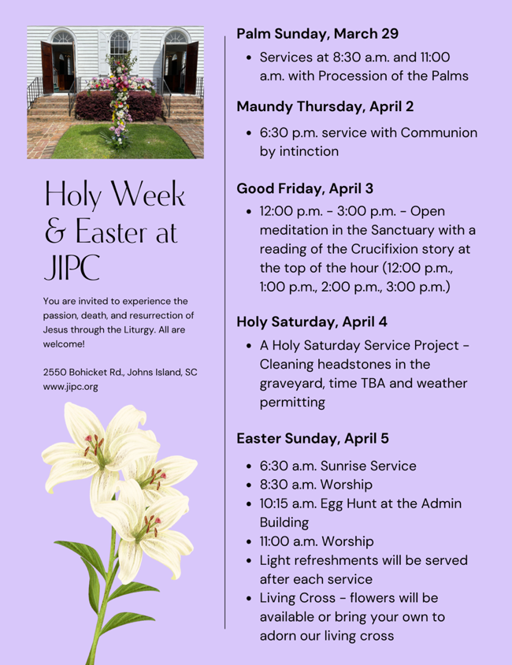
Friday Church Office Closed
12:00 pm – 3:00 pm Good Friday Service in the Sanctuary
Saturday
9:30 – 11:30 am Holy Saturday Service Project
Next Sunday, April 5 – Easter Sunday
6:30 am Worship – Bring your favorite lawn chair!
8:30 am Worship
10:15 am Egg Hunt – Around Admin Building
10:15 am Choir Rehearsal, Sanctuary
11:00 am Worship

