How to update your member profile:

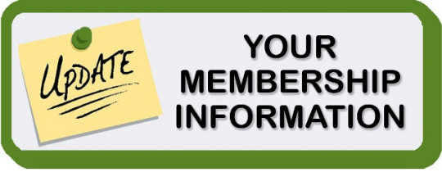

- Go to stmarysohio.org
- Click member login
  - If you don’t know this information or need any help call 419-300-4611 or email admin@stmarysohio.org
- Once you’re logged in your able to access all of your member information. You can update, add, or edit anything on your profile, just when you’re done always save!
- Don’t forget to log out when your done.

