PYM’s FALL YOUTH DAY OF SERVICE
October 12th 2018, 10:00 AM – 2:00 PM
Sprout Therapeutic Riding and Education Center (Aldie, VA.)
(www.sproutcenter.org)

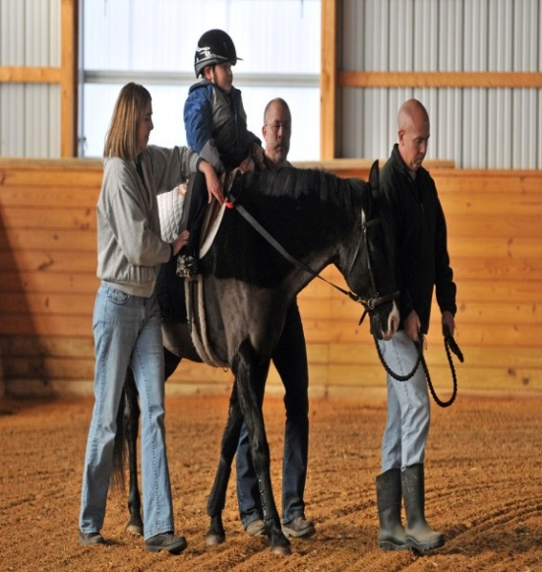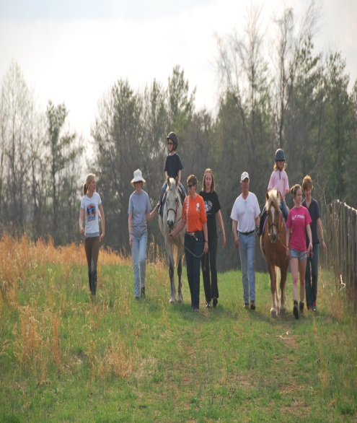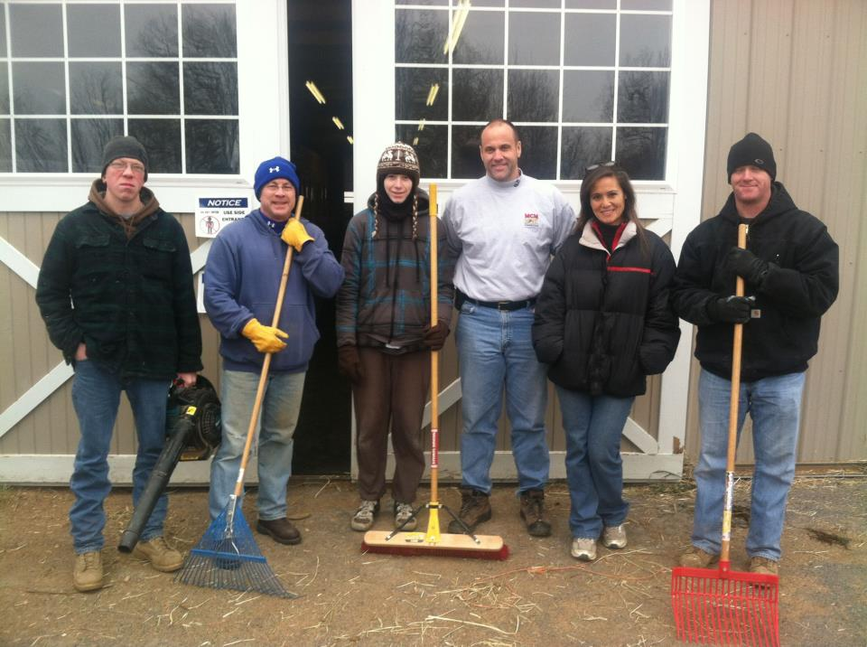
Come join the Parish Youth Ministry Committee and other 6th - 12th grade youth from all over the Diocese for our first event of the year, Fall Youth Day of Service (FYDOS). FYDOS is an event focused around volunteer work and giving back to the community and will be held at the Sprout Therapeutic Riding and Education Center. The Sprout Center is a nonprofit organization that provides equine assisted activities and therapies to individuals. Their work revolves around raising public awareness for special needs and providing opportunities for individuals/groups in a horse farm environment. Our work will revolve around whatever is needed to make their jobs easier on the farm! The Sprout Center is located at 40685 John Mosby Hwy Aldie, VA 20105. The event is FREE (pizza lunch provided) and the schedule is below. Registration is now open and the deadline is October 10th.
10:00 AM – Arrive & Welcome
10:30 AM – Orientation to Sprout Center
11:00 AM – Volunteer work!
1:00 PM – Pizza Lunch (Free!)
1:30 PM – Closing Prayers & Remarks
2:00 PM – Depart in Peace

Questions? Contact Mike Wade (804 622 3190 or mwade@thediocese.net)

PYM Fall Youth Day of Service Registration Form
October 12, 2018 – 10 a.m.-2 p.m., Sprout Center. Aldie, VA.
Adults and youth must register. For 6th through 12th grade youth.

Name: ______________________________________________________________________________

E-Mail: _________________________________ Home phone: (______) _____________________ ___

Church & name of accompanying adult: ___________________________________________________

Any special physical or dietary needs: ____________________________________________________________________________________
____________________________________________________________________________________
The event is free for all participants and includes the service project and lunch (pizza).

Please mail your forms to: The Diocese of Virginia
Attn: Christian Formation Office, c/o Michael Wade
110 West Franklin St. Richmond, VA, 23220-5095.

Adult Advisors: Please include a list of the youth for whom you will be responsible at this event along with your registration. If you are unable to get your forms in on time (that’s okay!), just simply notify the Christian Formation Office of your plans to attend and the number of youth/adults you’re bringing.

Parents/Guardians: I understand that the Diocese will sometimes record images, sound or video of diocesan events for use in marketing and promotional material, and on Web sites owned by the Diocese. Last names are not printed in conjunction with photos of youth.
If you do NOT want such images published of your child, please indicate by checking this box. [ ]

Medical and Liability Release Form for Minors

I hereby give my permission for my child to attend the Diocese of Virginia’s PYM Youth Day of Service and in the event of an accident or illness, to receive emergency medical treatment as deemed necessary by a licensed physician. I also agree by execution of this document to release Parish Youth Ministries, the staff, the Diocese of Virginia, and all others acting for or on behalf of the Diocese of Virginia from all liability whatsoever, for personal injury, or damages to property, real or personal, caused by, or arising out of activities sponsored by Parish Youth Ministries.

______________________________________________
Signature (to be signed by parent/guardian of all conference participants)

home__________________________________ cell__________________________________ work_________________________________
Contact numbers for parent(s)

____________________________________________________________________________________________________________
Insurance company and policy number

____________________________________________________________________________________________________________
Emergency contact

home__________________________________ cell__________________________________ work_________________________________

