Results from Invitational Science Olympiad at NJH, Bothell, WA

4 RMS Science teams participated at Invitational Science Olympiad at Northshore Middle school on Jan19, 2019 where a total of 33 teams participated. RMS teams performed well and Team rank, top medalists and ranks are mentioned below.
RMS Blue placed 2nd at the Tournament.
Team Name | Rank
RMS BLUE | 2
RMS GREEN | 5
RMS YELLOW | 7
RMS ORANGE | 8

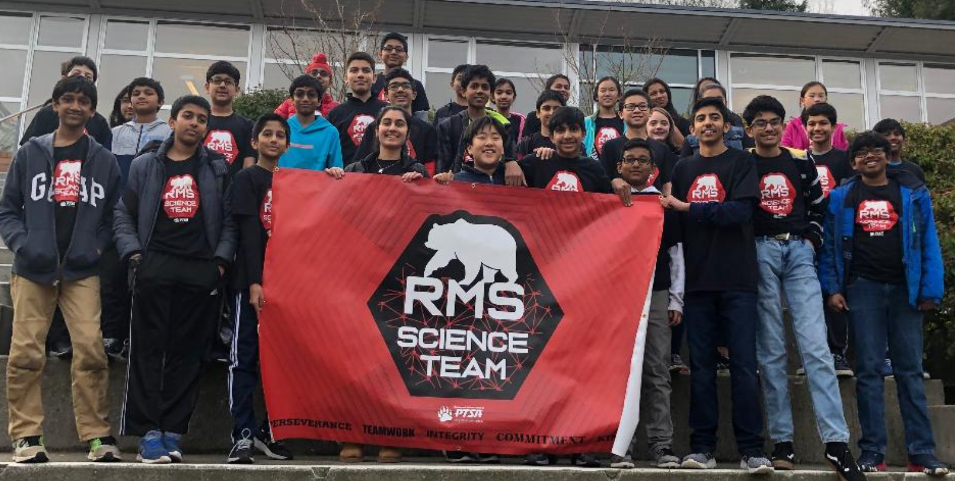

Medals/  Ranks | Winning student names | Event Name | RMS team
1st | Neev Sheth | Mystery Architecture | RMS Orange
1st | Payton Gergen | Mystery Architecture | RMS Orange
1st | Divij Aswinkumar | Experimental Design | RMS Blue
1st | Manav Balakrishnan | Experimental Design | RMS Blue
1st | Nihaar Movva | Experimental Design | RMS Blue
1st | Evan Kim | Anatomy & Physiology | RMS Blue
1st | Rohan Rammanohar | Anatomy & Physiology | RMS Blue
1st | Evan Kim | Circuit Lab | RMS Blue
1St | Aakash Banerji | Circuit Lab | RMS Blue
1st | Nishil Vankamamidi | Disease Detective | RMS Blue
1st | Rohan Rammanohar | Disease Detective | RMS Blue
1st | Sohil Bhatia | Dynamic Planet | RMS Blue
1st | Isha Mehta | Dynamic Planet | RMS Blue
1st | Krithi Iyer | Game On | RMS Blue
1st | Shruti Badrish | Game On | RMS Blue
1st | Sanjay Rajesh | Meteorology | RMS Blue
1st | Aryan Kondapally | Meteorology | RMS Blue
1st | Divij Aswinkumar | Road Scholar | RMS Blue
1st | Shruti Badrish | Road Scholar | RMS Blue
1st | Sanjay Rajesh | Rollercoaster | RMS Blue
1st | Aryan Kondapally | Rollercoaster | RMS Blue
1st | Nihaar Movva | Thermodynamics | RMS Blue
1st | Evan Kim | Thermodynamics | RMS Blue
1st | Vihan Dalvi | BoomiLever | RMS Green
1st | Srikrishna | BoomiLever | RMS Green
1st | Prisha Shah | Write it Do it | RMS Yellow
1st | Pracheeta Iyer | Write it Do it | RMS Yellow
2nd | Rohan Rammanohar | BoomiLever | RMS Blue
2nd | Aakash Banerji | BoomiLever | RMS Blue
2nd | Sohil Bhatia | Crime Busters | RMS Blue
2nd | Divij Aswinkumar | Crime Busters | RMS Blue
2nd | Shruti Badrish | Herpetology | RMS Blue
2nd | Divij Aswinkumar | Herpetology | RMS Blue
2nd | Aarna Chowdhary | Disease Detective | RMS Green
2nd | Pranavi Rohit | Disease Detective | RMS Green
2nd | Akshath Srinivasan | Rollercoaster | RMS Green
2nd | Rajit Joshi | Rollercoaster | RMS Green
3rd | Divya Gatta | Water Quality | RMS Orange
3rd | Eva Jain | Water Quality | RMS Orange
3rd | Nishil Vankamamidi | Elastic Launched Glider | RMS Blue
3rd | Nihaar Movva | Elastic Launched Glider | RMS Blue
3rd | Eshan Rathi | Heredity | RMS Blue
3rd | Aparna Iyer | Heredity | RMS Blue
3rd | Manav Balakrishnan | Solar System | RMS Blue
3rd | Aakash Banerji | Solar System | RMS Blue
3rd | Aarna Chowdhary | Dynamic Planet | RMS Green
3rd | Pranavi Rohit | Dynamic Planet | RMS Green
3rd | Di Mao | Leaf | RMS Green
3rd | Annabella | Leaf | RMS Green

