Results from Invitational Science Olympiad at Camas, WA

8 RMS Science teams participated at Invitational Science Olympiad at Camas high school on Dec 1st ,2018 where a total of 38 teams participated. RMS teams performed very well, and team rank and top medalists are mentioned below. RMS Blue placed 1st at the Tournament.
Team Name | Rank | 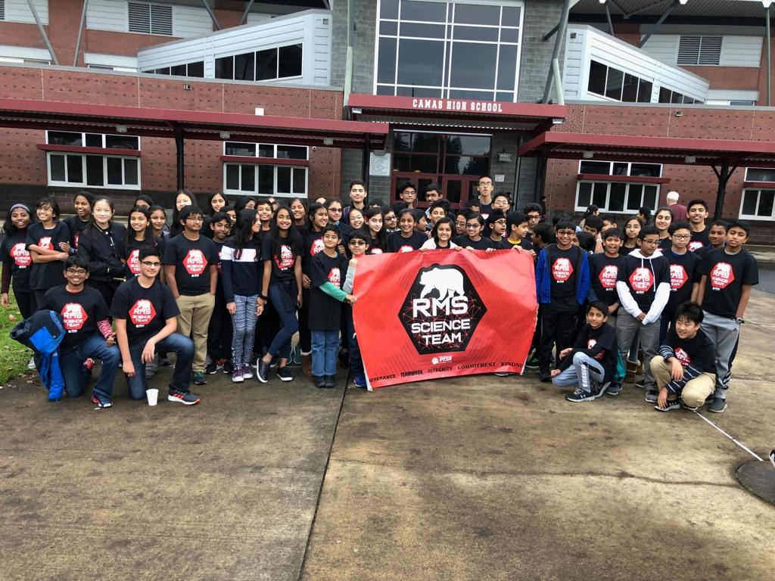
RMS BLUE | 1
RMS GREEN | 5
RMS WHITE | 9
RMS ORANGE | 12
RMS PURPLE | 15
RMS YELLOW | 28
RMS GREY | 18
RMS NEON | 38

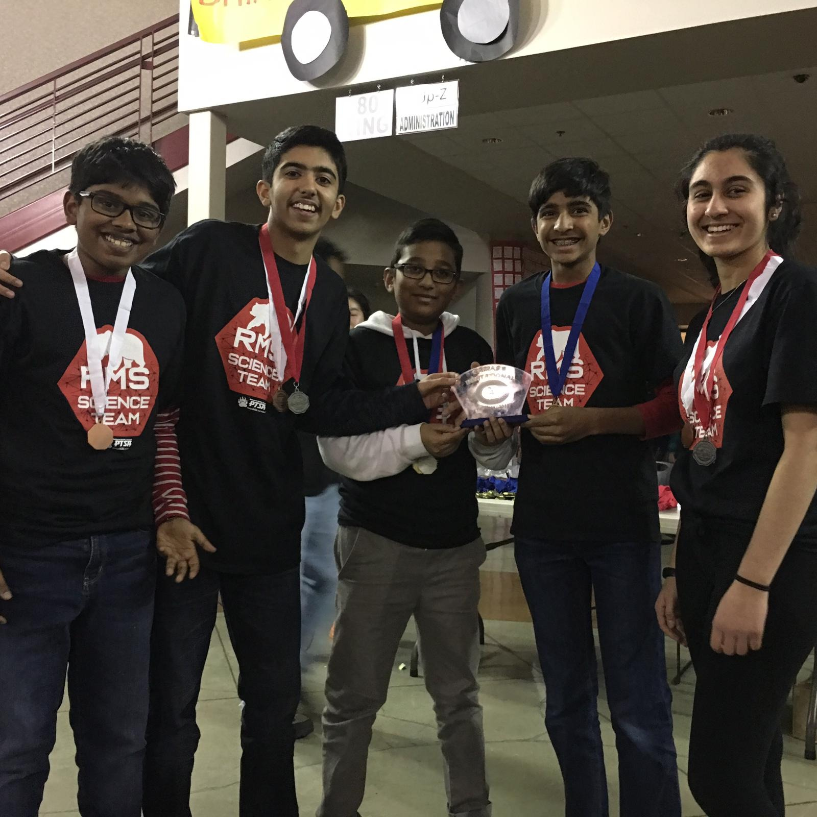 RMS Blue placed 1st at the Tournament.
L-R: Rohan Rammanohar, Sohil Bhatia, Nihaar Movva, Divij Aswinkumar, Isha Mehta
Missing in the picture: Evan Kim, Manav Balakrishnan, Nishil Vankamamidi, Eshan Rathi, Aakash Banerji

Medals/  Ranks | Winning student names | Event Name | RMS team
1st | Sanjay | Rollercoaster | RMS White
1st | Aryan | Rollercoaster | RMS White
1st | Sri Krishna | BoomiLever | RMS Green
1st | Vihaan Dalvi | BoomiLever | RMS Green
1st | Krithi Iyer | Game On | RMS Green
1st | Shruti Badrish | Game On | RMS Green
1st | Krithi Iyer | Water Quality | RMS Green
1st | Shruti Badrish | Water Quality | RMS Green
1St | Divij Aswinkumar | Experimental Design | RMS Blue
1st | Manav Balakrishnan | Experimental Design | RMS Blue
1st | Nihaar Movva | Experimental Design | RMS Blue
1st | Evan Kim | Circuit Lab | RMS Blue
1st | Aakash Banerji | Circuit Lab | RMS Blue
2nd | Sanjay | Meteorology | RMS White
2nd | Aryan | Meteorology | RMS White
2nd | Aarna Chowdhary | Disease Detective | RMS Green
2nd | Pranavi Rohit | Disease Detective | RMS Green
2nd | Aishika Koppolu | Rollercoaster | RMS Orange
2nd | Prisha Sood | Rollercoaster | RMS Orange
2nd | Sohil Bhatia | Dynamic Planet | RMS Blue
2nd | Isha Mehta | Dynamic Planet | RMS Blue
2nd | Manav Balakrishnan | Solar System | RMS Blue
2nd | Aakash Banerji | Solar System | RMS Blue
2nd | Nihaar Movva | Thermodynamics | RMS Blue
2nd | Evan Kim | Thermodynamics | RMS Blue
3rd | Sanjay | Circuit lab | RMS White
3rd | Aryan | Circuit lab | RMS White
3rd | Aparna | Write It, Do It | RMS White
3rd | Nirupama | Write It, Do It | RMS White
3rd | Aarna Chowdhary | Battery Buggy | RMS Green
3rd | Pranavi Rohit | Battery Buggy | RMS Green
3rd | Rajiv Arvind | Rollercoaster | RMS Purple
3rd | Vidit Setty | Rollercoaster | RMS Purple
3rd | Evan Kim | Anatomy & Physiology | RMS Blue
3rd | Rohan Rammanohar | Anatomy & Physiology | RMS Blue
3rd | Sohil Bhatia | Density Lab | RMS Blue
3rd | Isha Mehta | Density Lab | RMS Blue

