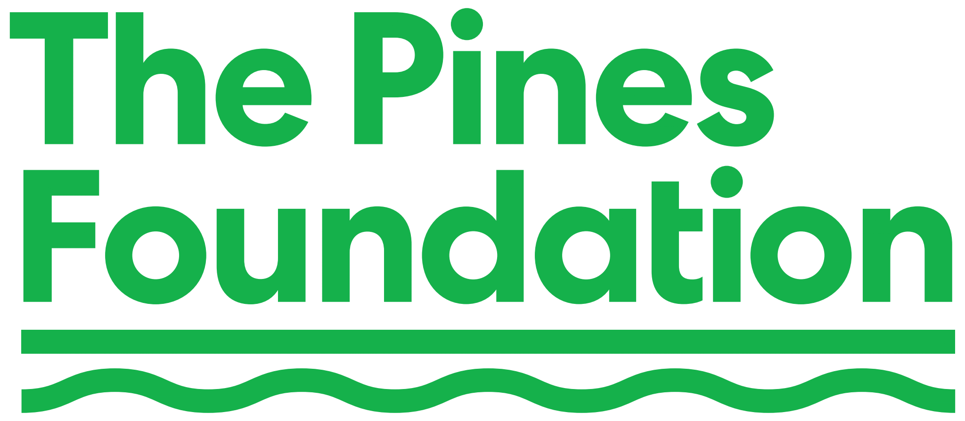

Brockman Grants Program

The Pines Foundation is the Section 501(c)(3) public charity affiliate of the Fire Island Pines Property Owners Association (FIPPOA). The Foundation is dedicated to preserving, protecting, and enhancing the quality of life in the environmentally-sensitive community of Fire Island Pines, New York.

In addition to the Foundation’s ongoing grants program (which makes occasional grants, for example, to the Stonewall Foundation, Friends of Carrington, and the Pines Conservation Society), the Foundation has established the Brockman Grants program in order to provide financial support to individuals and organizations undertaking projects that interpret, enhance, reflect, positively impact, and display the history, cultural diversity, and lived experience of Fire Island Pines.

Artistic Production Grants help fund the production and exhibition of artistic creations. Meant to be exhibited in public spaces, these projects should feature high levels of thought, artistic production, and public engagement. Artistic Production Grants may include costs for transportation, supplies, production, exhibition, and publication. Fees for salaries, administrative costs, and other operating costs are not covered.

Research and Production Grants are awarded to individuals or organizations pursuing a research objective having to do with Fire Island Pines. These projects should feature high levels of thought, and proven research and analytic skills. The intended outcome should be the appearance of the research in a recognized publication or published book. Research Production Grants will be made to help cover the costs associated with the project, which may include transportation, supplies, access to records, and costs associated with publication. Fees for salaries, administrative costs, and other operating costs are not covered.

Community Enhancement Grants are awarded to individuals or organizations seeking through individual or collective action to provide demonstrable benefit to the Fire Island Pines community. Community Enhancement Grants will be made to help cover the costs associated with the project, and may include costs for transportation, supplies, and publicity. Fees for salaries, administrative costs, and other operating costs will not be covered.

The Brockman Grants Committee will be appointed annually by the President of FIPPOA. The Committee will be co-chaired by a member of the FIPPOA Board of Directors. It will consist of a diverse group of community members with relevant expertise in evaluating and selecting grantees. The Committee’s mission is to review grant requests and make funding recommendations to the Pines Foundation Board.

The Application Process

The Brockman Grant’s funding is limited to an annual aggregate of $10,000. Individual grants are limited to a maximum of $5,000 per grantee per year.

Applications are due by April 15 of the calendar year. A completed application should be sent to the Co-Chairs of the Brockman Grants Committee at BrockmanGrants@fippoa.org. We anticipate informing grant applicants of the status of their application by May 15. If a grant is made, a Grant Agreement will be required to be signed.

Grants will be made in the form of wire transfer or Automated Clearing House (ACH) transfer payable to the grantee, on a schedule to be determined in consultation with the grantee.

**********************************

BROCKMAN GRANT APPLICATION PROCESS
The following information must be provided
Indicate NA if the question is Not Applicable
Applications are due by April 15, 2025

- Date: _______________

2. Applicant’s Name ________________

3. Applicant’s contact information _____________ (cell)
______________ (email)

4. Indicate if you are seeking an Artistic Production Grant, a Research and Production Grant, or a Community Enhancement Grant AND the title of the Project_______________________

5. Amount of Brockman Grant Sought_____________

6. Please provide a detailed description of the Project (no more than 500 words in total).

7. If the applicant is an individual, please provide the applicant’s CV, related experience and, if available, a sample of prior work.

8. Has the applicant lived, visited, or worked in Fire Island Pines? Please be specific.

9. If the applicant is an organization, please provide its mission statement, proof of 501(c)(3) status, the organization’s EIN, its most recent financial statements, and its most recent Form 990 if required to be filed.

10. Provide a line-by-line Budget for the Project, including expenses and funding sources other than a Brockman Grant.

11. Please state if the applicant is seeking or has received other financial support for the project, include the amount, and the source, and the source’s contact information.

12. Please provide a line-by-line itemization of what the requested Brockman Grant will cover.

13. Will the proposed project require performance or display space in Fire Island Pines? If so, of what nature? Keep in mind that display and performance space in the Pines can be challenging to arrange.

14. Is there anything else you would like to tell us?

NOTE: The Brockman Grants Committee may request clarification of information provided, or additional information, in its review process.
(2-17-25)

