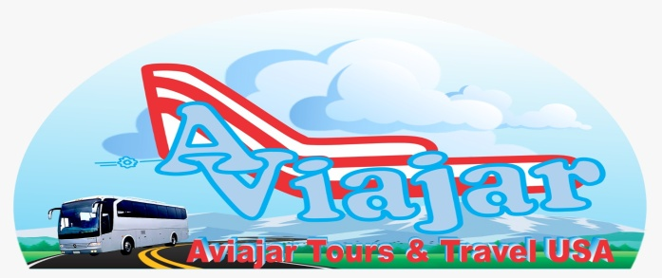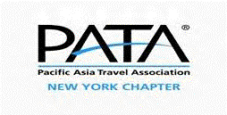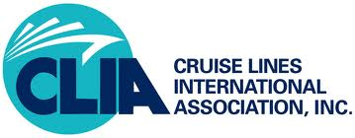

Tour representative of Air, Land and Sea
“ DUBAI & ABU DHABI PLAN “
9 DAYS (Sept 10 to 18, 2023) DAY 01 – NEW YORK TO DUBAI / SEPT 10 Direct international flight Emirates Airline, duration 11; 50 minutes arriving the next day
DAY 02- / SEPT 11 Arrival in Dubai, reception and transfer to the hotel. In the afternoon Dubai Metro experience, we will visit the Emirates Mall and its ski slope, Dubai Mall (Dancing Fountain show - Aquarium) Accommodation.
DAY 03 - DUBAI CITY TOUR / FULL DAY WITH LUNCH / SEPT 12 Breakfast Private transportation, bilingual guide tour of contrasts of old and new Dubai, lunch at the DUBAI mall in front of Burj Khalifa. • POINTS OF INTEREST: Bastakyia, Dubai Creek, The Souk, The Jumeirah Mosque, Burj Al Arab and Burj Khalifa, Le Palm, Emirates Mall, Monorail ride, and cross the streams by ABRAS boat, Visit and admission included to the Dubai Museum , • PICK UP TIME: 30 minutes before departure time from your hotel or Dubai Internet City Metro, • Return: Emirates Mall, Dubai Mall, Burjuman City Center or Deira City Center DAY 04 – DUBAI / SEPT 13 Breakfast. ½ day Beach at Jumeirah Beach Park (admission included) return to hotel. In the afternoon, our assistant will accompany you to the departure point of the 4x4 vehicles with air conditioning, to start the Safari through the desert, crossing endless sands and spectacular dunes. At dusk we will arrive at a traditional Bedouin camp where we will attend a barbecue with traditional Arabic music, return to the Hotel
DAY 05 – DUBAI – ABU DHABI / SEPT 14 Breakfast. at 9:30 a.m. Departure for Abu Dhabi, the largest city and capital of the United Arab Emirates. Accommodation. Afternoon free to enjoy the hotel facilities, swimming pool and private beach. DAY 06 – ABU DHABI CITY TOUR / FULL DAY WITH LUNCH / SEPT 15 Breakfast in Abu Dhabi, the capital of the United Arab Emirates. It is the ideal introduction to the capital of the UAE and the island on which it is located. The name Abu Dhabi Sheikh Zayed Grand Mosque, one of the largest mosques in the world; it houses more than 30,000 faithful. The Mosque clad in marble, Islamic carvings and landscaping work. Then towards the center of Abu Dhabi. We will visit the Al Hosn fort, ancestral home of the Al Nahyan and the heart of Abu Dhabi. We will continue to the Heritage Village, a museum that represents the traditional activities of the Arab community, Lunch. In the afternoon, we will drive along the Corniche and its array of white mosques, glass-clad offices, and elegant high-rise apartments to the tip of the breakwater for a magnificent view of the city. and the famous Saadiyat giant island project, The tour will continue to the Louvre Museum, Louvre Abu Dhabi is a museum of art and civilization, located in the Cultural District. After the visit, we will move to the famous island of Yas, which is home to the FORMULA 1 YAS circuit, the WARNER bros park and the Ferrari amusement park in the world. The world's largest air-conditioned indoor park with a RED FERRARI sign as a landmark. Visit a craft center in Abu Dhabi / returning to the hotel. DAY 07 – ABU DHABI – DUBAI / SEPT 16 Breakfast, we enjoy the beach at noon transfer to Dubai, hotel accommodation 6:30 pm Transfer to the port to our traditional Arab boat, the Dhow. Dubai Creek Cruise. We will be able to taste a banquet of traditional Arabic and international food, with views of the souks and palaces of the city. Once the cruise is over, return to the hotel DAY 08 – DUBAI / SEPT 17 Breakfast. Free day at your disposal to walk on your own or enjoy the hotel facilities. Recommended markets of Alkarama and Deira Mall Market or the Ice Bar at night. Accommodation DAY 09 – DUBAI – USA / SEPT 18 Breakfast, transfer to the airport to board the flight to New York.

INCLUDES:
*International Air Tkts New York – Dubai – New York (Transfers in / out)
* 5 nights in Dubai (Hotel Tower Plaza 5*) / 2 nights in Abu Dhabi (Hotel Royal M 5*) *Journeys in Minibus or Buses with A.A. according to the travel group.
*11 meals (7 breakfasts, 2 lunches, 2 dinners) *City Tour full day with lunch in Dubai and Abu Dhabi according to itinerary *Visit ½ day to the beaches of Jumeirah Beach Park *Visit and admission Burj Khalifa tallest building in the world & admission to the Aquarium
* Safari tours (pm) Toyota 4x4 with dinner BB in a Bedouin Camp.
* Dhow Dinner Cruise around Dubai Creep with Shows and drinks on board *Bilingual guides throughout the tour. *Hotel tax and tourist tax in both cities $35 P/P included

* NOT INCLUDED:
*Services or food not specified in the itinerary.
*Tips: Guide, Drivers, Hotels: $10 per day x 8: $80 + $40 Coordinator from NY
“” These will be collected on September 10. At JFK Airport “”: Total $120

VALUE X PERSON: * Double & triple room $2,680 * Single room $3,190

DEPOSIT: $960 Jun 01 Non-refundable (Deposit reserve and issue air Tkt)
2nd. Payment: $920 Jul 01 - 3rd. Payment: $800 Aug. 01/23

CANCELLATION POLICIES & PENALTIES

AIR TICKETS: they are not refundable or transferable. They may be modified for another date with a penalty and rate adjustment in force on the date of the change/According to the airline's policies

CANCELLATION ON 2nd / 3rd PAYMENT: * 90 days before 30%. * 45 days before 50% - *30 days before 100% TKT PRICE. AIR: they can be modified, if they have not been issued in the terms of the contract

SPECIAL NOTE:
By accepting our policy, passengers agree that we have no responsibility for alterations, itinerary cancellations, delays, strikes, illnesses, thefts, losses, bus breakdowns, accidents, weather or any other event. It is recommended to purchase health insurance.

VISA TO DUBAI: AMERICAN CITIZENS DO NOT NEED
A VISA FOR RESIDENTS IN THE USA & HOLDERS OF PASSPORTS FROM SOME COUNTRIES YES
IF PROCESSED THROUGH THE OPERATOR IN DUBAI, THE COST IS $140 US GUARANTEED IF THE FORM IS FILLED, DOCUMENTS ATTACHED, + MONEY. THE PROCESS TAKES 3 TO 5 DAYS.
THE VISA WILL BE SENT BY EMAIL TO PRINT.

Alejandro Garrido
Director Aviajar Tours & Travel USA
POB. 516-312 4525
alejogarry@hotmail.com – alejoaviartours@yahoo.es

