2017 LGBT Health Awareness Week Materials
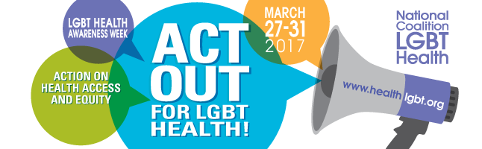

March 27 – 31

Read the LGBT Awareness Week news release here.
About LGBT Health Awareness Week
The National Coalition for LGBT Health is pleased to announce the 15th annual National LGBT Health Awareness Week, March 27-31, with the theme of “Act Out for LGBT Health! Action on Health Access and Equity.” The theme is based on feedback from a survey of Coalition members, who identified access and health equity as a key issue in LGBT healthcare. Some of the issues facing LGBT individuals include access to public accommodations, structural health disparities, discrimination in healthcare, and behavioral health outcomes.

To see the latest Awareness Week news, visit the Coalition’s Facebook and Twitter pages.
Table of Contents
PARTNERS 2
ACTIVITIES 3
GOALS 4
#HASHTAGS 4
LOGOS 4
SAMPLE POSTS AND TWEETS 9
STIs 9
Youth 9
Access To Care 9
Behavioral Health 10
Transgender Health 11
HIV 11
PrEP 12
Social Determinants of Health 12
Physical Health 13

PARTNERS
The Coalition is proud to announce that the following organizations as Partners for National LGBT Health Awareness Week:
- ACRIA  - African American Office of Gay Concerns  - AIDS Resource  - American College of Nurse-Midwives  - Anthem/Amerigroup  - ASPIN  - Austin CBC - Hektoen Institute  - Avita Pharmacy  - Baltimore City Health Department  - BiNet USA  - BiRequest NYC  - Bisexual Resource Center  - Brightpoint Health  - California LGBT Health and Human Services Network  - Center for Black Equity, Inc.  - Center of Excellence for Transgender Health, UCSF  - Centro San Vicente  - Columbia/Boone County Department of Public Health and Human Services  - Community Health Center, Inc.  - Crescent Community Health Center  - Department of Public Health City of St Louis  - DePaul University  - Emory University; Rollins School of Public Health  - Equality North Carolina  - Equality Texas  - Equitas Health  - Equitas Health Institute for LGBTQ Health Equity  - ERISE WILLIAMS & ASSOCIATES INC  - Esparitu Midwifery  - G III Associates  - Golden Rule Services  - Greenwich Department of Health  - Hartford Gay & Lesbian Health Collective  - Health Education Learning Project  - Hetrick Martin Institute  - Hudson River Health Care  - India Street Public Health Clinic  - LBGT PA Caucus  - Legacy Community Health  - LGBT Center Orange County  - LGBT Health Policy and Practice Program, GWU  - Magic City Acceptance Center  - Magic City Wellness Center  - Mary's House For Older Adults  - Massachusetts Department of Public Health  - Mazzoni Center  - Men's Health Network  - Messiah College  - Migrant Health Center  - Mount Sinai Health System | - NAESM, Inc.  - National Center for Lesbian Rights  - NYU Langone Medical Center - LGBT Council  - One Colorado  - Open Door Health Center of Illinois  - Our Safe Space Ally Center  - Out2Enroll  - Palmetto Project  - Philadelphia Department of Public Health, Get Healthy Philly  - Pozitive Approach Counseling and Consultation Services, LLC  - Pridelines Community Center; South Florida Bisexual+ Network  - Quest Diagnostics  - Rad Care  - RAD Remedy  - REACH Initiative Johns Hopkins School of Nursing  - Resource Center  - RIT Student Wellness  - Rollins School of Public Health  - Rutgers Robert Wood Johnson Medical School  - SBHM, Inc.  - Seventh-day Adventist Kinship, International, Inc.  - South End Community Health Center  - South Florida Bisexual+ Network  - Special Health Resources for Texas, Inc.  - STI Regional Response Coalition, Washington University in St. Louis (Infectious Disease Division)  - Tapestry Health  - Terros Health  - Test Positive Aware Network  - Texas Children's Hospital  - The AIDS Institute  - The Alliance for Positive Change  - The American Cancer Society  - Trans Queer Pueblo  - Treasure Coast Food Bank in partnership with the Health Council of Southeast Florida  - Unity Wellness Center  - Universal Fellowship of Metropolitan Community Churches (UFMCC)  - University of Michigan / Michigan Medicine  - University of North Carolina at Chapel Hill LGBTQ Health Disparities Research Collaborative  - UNM Medical Group, Inc. - Truman Health Services  - Vanderbilt Program for LGBTI Health  - Washington University School of Medicine Infectious Diseases  - Wellness Services, Inc.  - WHC/CIRCLE CARE Center  - Whitman-Walker Health  - PROMO

Click here to become a Partner for the Week.

ACTIVITIES
Activities for the Week include:

THUNDERCLAP: Join our Thunderclap kicking off the 2017 National LGBT Health Awareness Week!  Date: Monday, March 27  Time: 10 am EST | Sign up here!
TWITTER CHAT: Join us for the #MillennialMon Twitter chat about LGBT health with Young Invincibles and Out2Enroll!
Date: Monday, March 27
Time: 3:00 - 4:00 pm EST
WEBINAR: ACT OUT for Equity: Understanding the Impact of Social Determinants of Health on LGBT Health Equity
Date: Tuesday, March 28
Time: 2:00 - 3:00 pm EST
Speaker lineup and agenda
TWITTER CHAT: Join us for the #WellnessWed Twitter chat about LGBT health with Moms Rising and Out2Enroll!  Date: Wednesday, March 29  Time: 2:00 - 3:00 pm EST | .
WEBINAR: ACT OUT for Access: Understanding the AHCA's Impact on LGBT Health Equity

Date: Thursday, March 30
Time: 2:00 - 3:00 pm EST
Speaker lineup and agenda

GOALS
For the National Coalition for LGBT Health, the top goals of this year’s LGBT Health Awareness Week are:
- Creating positive action for LGBT healthcare access by raising awareness of LGBT health disparities among policy-makers, the public, and the LGBT community
- Educating the public about efforts to reduce the stigma and discrimination LGBT individuals face in the healthcare system
You can participate in this LGBT Awareness Week by through the following hashtags and social media handles, social media posts, Twitter Chats, and webinars.

#HASHTAGS
On social media, the Coalition will be using the following hashtags throughout the week. These hashtags are included in the sample Facebook posts and Tweets below. Please use them in drafting your own Tweets. You may use any or all hashtags that correspond with LGBT Health related posts you plan to share throughout the Week. Use them with news stories, local health facts, and more. Please be creative and tag the National Coalition for LGBT Health in your posts as well.
#ActionToAccess
#LGBTHealthWeek
#LGBTHealth

LOGOS

Right click on the following images to download this year’s official LGBT Health Awareness Week logos:

Facebook Banner image
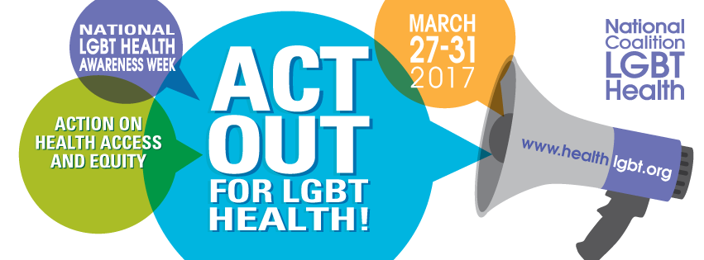
Twitter Banner image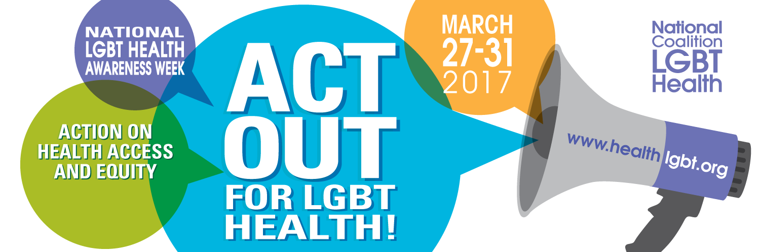
Twitter Profile Image
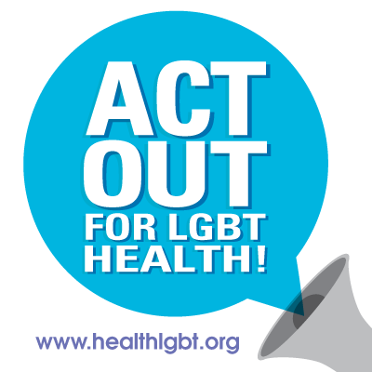
Facebook Profile Image

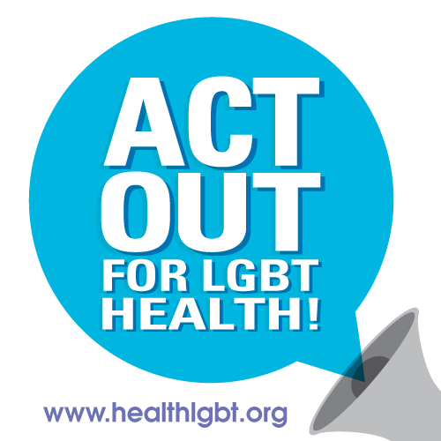

Instagram
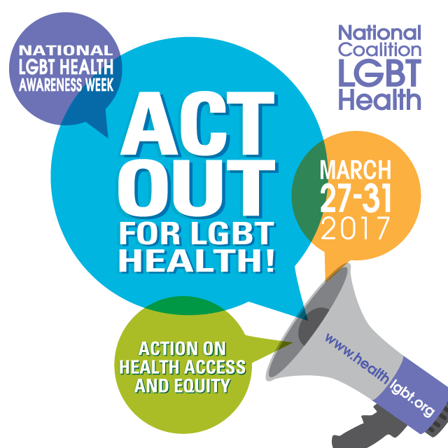
Poster

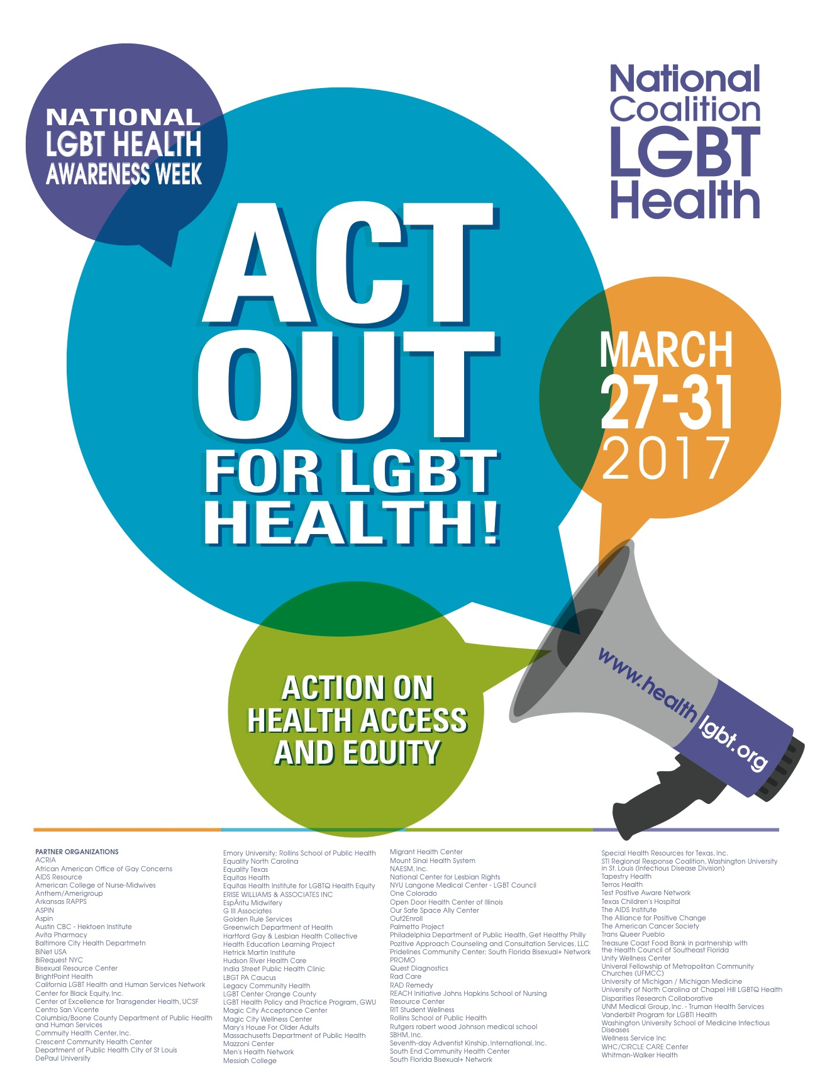

SAMPLE POSTS AND TWEETS
Below are sample Facebook posts and Tweets that the Coalition and its partners will be using throughout LGBT Health Awareness Week on social media. Scroll downto find sample posts by topic:

STIs
- HPV most common STI, major cause of anal cancer. MSM 17x more likely to develop anal cancer. HPV vaccine could reduce rates #LGBTHealth #STIs
- MSM account for 72% of new Syphilis cases and 15-25% of new Hepatitis B infections #LGBTHealth #STIs
- Sexually active gay and bisexual men should get tested every 3-6 months for #STIs —.@CDCgov. #LGBTHealth

Youth
- 40% of homeless youth identify as #LGBT, many experience behavioral health issues, such as depression, substance use, risky sexual behavior
- #LGB youth who are rejected 8x more likely to have tried to commit suicide #LGBTHealth .@TrevorProject is safe place to talk: 866-488-7386
- #LGB youth who are rejected 6x more likely to have high levels of depression #LGBTHealth .@TrevorProject is safe place to talk: 866-488-7386
- LGB youth who are rejected 3x more likely to use drugs #LGBTHealth .@TrevorProject is safe place to talk: 866-488-7386
- LGB youth who are rejected 3x more likely to have risky sexual behavior #LGBThealth .@TrevorProject is safe place to talk: 866-488-7386

Access To Care
- 56% of LGB and 70% of Trans folks experienced discrimination in healthcare settings #LGBTHealth #ActionToAccess
- Call State Reps with @openstates and give your support for Non-Discrimination bills. #LGBTHealth #AccessToAction https://openstates.org/
- 31% of #gay and #bisexual men don’t have regular place to receive medical care or have a regular physician #LGBTHealth #ActiontoAccess
- LGBT elders face barriers to health due to isolation, lack of social services #LGBTHealth #ActiontoAccess
- Many health insurance plans have exclusions that deny #transgender individuals coverage for some services #ActiontoAccess
- Trans people have a high prevalence of mental health issues, HIV, STIs, but least likely to have health insurance #LGBTHealth
- 56% of LGB ppl experience discrimination in healthcare - free #LGBTHealth provider trainings avble: at healthlgbt.org #ActiontoAccess
- 70% of #trans ppl experience discrimination in healthcare - free #LGBTHealth provider trainings avble at healthlgbt.org #ActiontoAccess
- 1 in 5 LGBT individuals withhold info about their sexual history from healthcare provider #LGBThealth #ActionToAccess
- Only 51% of #gay #bisexual men living w/#HIV remain in treatment over course of a year – PCP trainings avble @ https://tinyurl.com/h77g5bg
- 52% of academic faculty practices have no #LGBTHealth training – free trainings available online: http://tinyurl.com/zfwgwyt #ActiontoAccess
- #LGBTHealth Centers provide care to #LGBT. Many rely on #Medicaid and #ACA for insurance. Say No to #AHCA and 24 mil. ppl losing insurance.

Behavioral Health

- #AHCA doesn't provide equal care for people on #Medicaid. It's bad for #LGBTHealth who need mental health services. #ActionToAccess
- Contact your Representative and let them know that #AHCA is unacceptable. #LGBTHealth #ActionToAccess http://bit.ly/1e8pAws
Discrimination and stigma contribute to higher rates of mental illness among LGBT individuals. #LGBTHealth #ActiontoAccess
- LGBT individuals 2.5x more likely to experience depression, anxiety, substance use. #LGBTHealth
- Lack of acceptance from family contributes to higher rates of mental illness, substance abuse among LGBT individuals #LGBTHealth
- LGB youth are 4x more likely to attempt suicide. .@TrevorProject is a safe place to talk: 866-488-7386 #LGBTHealth #ActionToAccess
- #Bisexual men are more likely to have mental health issues compared to gay men #LGBTHealth #BHAM
- 1 in 10 #bisexual women have experienced serious psychological distress in the past 30 days #LGBTHealth #BHAM
- #Bisexual men and women are more likely to smoke than all other men and women #LGBTHealth #BHAM
- Smoking rates are higher for lesbian and bisexual women than heterosexual women #LGBTHealth #BHAM

Transgender Health
- #Trans ppl experience barriers to care: lack of insurance, trained providers -#LGBThealth trainings avble: healthlgbt.org #ActiontoAccess
- 90% of #trans ppl don’t believe there are enough trained providers to care for them - #LGBThealth training @ healthlgbt.org #ActiontoAccess
- 50% of #transgender individuals report having to teach their providers about some aspect of their healthcare needs #LGBTHealth
- 33% of #transgender individuals had a negative experience related to being transgender when seeking care
- 23% of #transgender individuals did not seek care due to fear of mistreatment #ActiontoAccess
- 33% of #transgender individuals could not afford to see a healthcare provider #LGBTHealth #ActiontoAccess
- 25% of #transgender individuals had issues with their insurance related to their gender identity #ActiontoAccess
- 25% of #transgender individuals who sought coverage for hormones were denied #ActiontoAccess
- 56% of Black #transgender women are living with HIV #LGBTHealth #ActiontoAccess
- 55% of #Trans people who sought coverage for transition-related services were denied coverage #LGBTHealth #ActionToAccess
- The #ACA banned discrimination against #Trans people in healthcare settings that receive federal funds. #LGBTHealth #ActionToAccess
- @PPFA provides health services for #Trans ppl. Call your Rep, tell them to #StandWithPP bit.ly/1e8pAws #LGBTHealth #ActionToAccess

HIV
- 56% of gay and bisexual men say they have never been recommended to take an HIV test #LGBTHealth
- Only 30% of #gay, #bisexual men were tested for HIV in past yearr. Find test location near you: locator.aids.gov. #LGBTHealth
- #Gay, #Bisexual, MSM accounted for 67% of new #HIV infections in 2014 #LGBTHealth Find test location near you: locator.aids.gov. #LGBTHealth
- 30% of gay, bisexual men have never gotten tested for HIV. Find test location near you: locator.aids.gov. #LGBTHealth
- 44% of gay, bisexual men under 35 have never gotten tested for HIV. Find test location near you: locator.aids.gov. #LGBTHealth
- 28% of Transgender women live w/ HIV. Many don’t know their status. Find testing locations near you: locator.aids.gov #LGBTHealth
- 90% of transgender women newly diagnosed w/ HIV are African American or Latina #LGBTHealth
- 1 in 6 #Gay and #Bisexual Men will get #HIV if current incident rate persists. Expand access to #PrEP to #EndTheEpidemic #LGBTHealth
- 1 in 2 Black gay, bisexual men diagnosed w/#HIV if current trends persist Find test location near you: locator.aids.gov. #LGBTHealth
- 1 in 4 Latino gay, bisexual men diagnosed w/#HIV if current trends persist. Find test location near you: locator.aids.gov. #LGBTHealth
- 2005-2014: overall #HIV diagnoses decreased 19%, but increased 6% among #gay and #bisexual men due to increases among Black and Latino men

PrEP
- Nearly 60% of #gay, #bisexual men don’t know about #PrEP – learn more at https://tinyurl.com/hm4t7xw #LGBTHealth
- Do you know about PrEP? Taken daily, PrEP reduces the risk of HIV by over 90%. Talk to your doctor about PrEP.
- #PrEP reduces the risk of HIV by over 90% when taken daily. learn more at https://tinyurl.com/hm4t7xw #LGBTHealth
- #PrEP for #HIV can be $13K/yr w/o insurance. Tell Congress 24 mil ppl deserve insurance. #LGBTHealth #ActionToAccess bit.ly/1e8pAws
- One in three Primary Care Providers haven’t heard about #PrEP - learn more at https://tinyurl.com/hm4t7xw #LGBTHealth

Social Determinants of Health
- Homophobia isn’t only thing that can impact #LGBThealth – discrimination like racism, sexism, and xenophobia hurt LGBT individuals
- Social determinants of health like poverty and homeless hurt #LGBTHealth, particularly #transgender individuals and communities of color
- #ACA prohibits discrimination against #LGBTHealth, yet 100 Anti-LGBT bills have been introduced in states in 2017 goo.gl/ct4DrL
- Be prepared for #ActionToAccess for #LGBTHealth. Download #5Calls! https://5calls.org/

Physical Health

- Heart disease is a top killer of women. Risk factors: obesity, stress, smoking – all high among #lesbians and #bisexual women #LGBTHealth #BHAM
- #Lesbians and #bisexual women are more likely to be overweight or obese #LGBTHealth #BHAM
- #Lesbians have lower rates of breast and cervical cancer screenings compared to heterosexual women #LGBTHealth #BHAM
- Almost half of #bisexual women have been raped and about 75% have experienced other forms of sexual violence #LGBTHealth #BHAM

