Lahaina fire Survivor, Christine Borge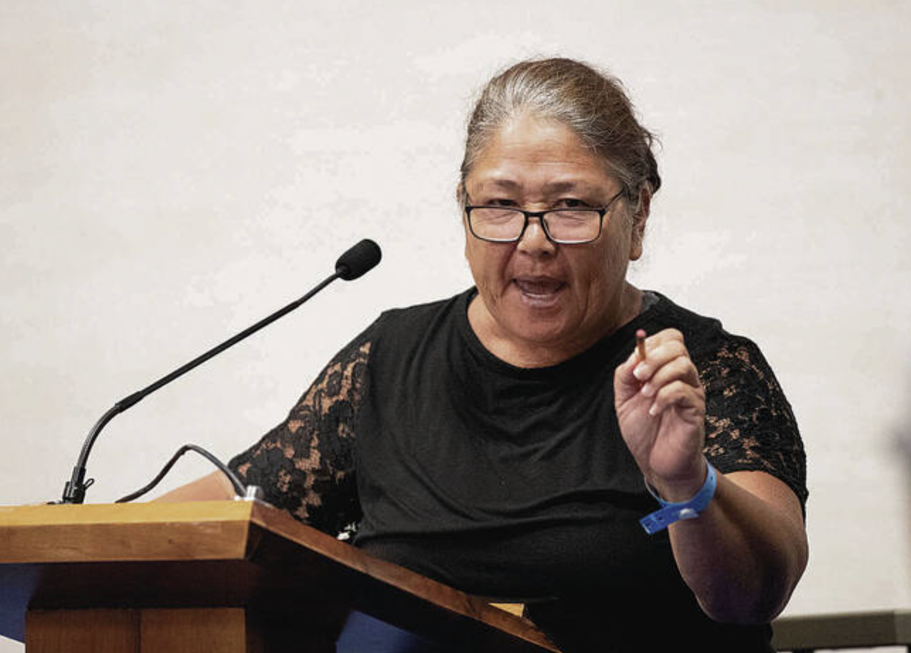 Lahaina fire survivor Christine Borge was angry when she spoke at the August 22, 2023, before the council members at the Maui County Council meeting held in the Kalana O Maui Building. Her moving 3-minute testimony ties so much about this together.
https://mauicounty.granicus.com/player/clip/1879
Hello my name is Christine Borge. I guess you could say I am a kupuna. I am 61. Was living on Eighth Street when it happened. I walked away with nothing accept my dog. I’ve been a part of the human experience ever since. First, we were in Maui Prep. They passed out toilet paper because they wouldn’t let us use the bathroom. I guess they think we look like leprosy people to them because of our dark skin and we went to Baldwin High, now I am at Swirl Lahina.
We need help because we’re being told by people from the mainland culturally insensitive to fill out papers that will give the America which I am a forced American. I am not a proud American, I am forced to be American in Hawaii. You’re telling us to fill out this paperwork so you can give us the least amount of money. All I have had is $700. FEMA is fighting with SBA. I walked out yesterday because I am hearing conflicting things stories about what paper I should fill out.
We need meetings in Lāhainā. So many people, my employees there of Filipino ancestry. You know, they are Filipino, they don’t know how to fill out these papers out. Four out of five of us have lost our homes they are burned to the ground. We are only been told stand in this line sign here. What are we signing? who is it benefiting? Us or America? That’s what I want to know.
And I want to know when we get to go back to our home in Wahine? Maybe its gone but for reasons I don’t want to discuss we need to go back there. Are you going to just scrape it all away and say disaster zone and America is going to get what they want Satellite City because this was planned years ago. It’s now happening and all the poor people, the homeless the hardworking people of the hotels the kupuna, we lost everything so you could have your Satellite City.
This isn’t fair I feel like I was used. I feel like crap on the ground. This is not right and we should not be treated this way. We are in a hotel and we have no communication. I cannot watch the news. I don’t know what is going on. I just happened to see on Facebook there is a meeting here. We couldn’t even have our pastor come in and ask us if we need prayer in the very beginning but Oprah could come in. Who is she? Who is she? They say, oh she knows the governor. We didn’t need her in there in Baldwin High. Get her out.
We also don’t need people like Cana Shekee (sp?) telling tourists don’t come to Maui because some of us, thousands of us work in the hotel industry. They pay our mortgage, they give us our medical, the medical besides the county is pretty good for somebody ofd like me. So don’t tell tourists don’t come Maui because you are not speaking for us, the working people. You are speaking for yourself.
Tourists come, we love you we have aloha. You have given us money through your donations we are not saying don’t come. Come, we are saying come because you will be helping us, the lower people, the grains of sand of Maui are what we are. We are not the ones living up in Launiupoko. Not one of those houses burn. Puamana is still there Lahaina Shores is still there. Everything beyond Civic Center is there. But the homes where we were working, where we were scraping, where we have less thousand dollars a month to pay for our basic needs of gas and food.
We busted our ass and this is what we get. Nobody called us. Our phones didn't work from five in the morning. The fire was not 10 o'clock when I went to work. The fire was still there. There was no water. Tell me if that's a coincidence. No water, no warning. And everybody talking about the Satellite City before the fire. Lahaina gonna be the first satellite city.
‌
Well hey, Jeff Bezos, you got what you wanted. Oprah, you got what you wanted. And the guy who owns the night, you got what you wanted. Fuck us all over. That's what happened. We need help in Lahaina. Who's going to come now and ask us, can I pray for you, Auntie? Thank you. Can I help you with your paperwork? Because all we got so far was $700, and we don't know who to call or anything. It's culturally insensitive in that zone.

