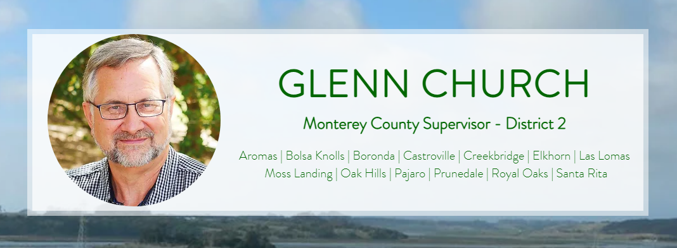

Feb. 20, 5:03pm
Dear Friends and Neighbors,
As we all know, there was another fire at the Vistra facility Tuesday night. We are barely a month from the January 16 fire. The wounds from that catastrophic even haven’t even begun to heal. Now we are faced to deal with yet another fire. Unfortunately, we must be prepared for future fires like the one on Tuesday. Whether it be water, as rain, which causes a violent chemical reaction to lithium, or the disturbances when the debris is moved during cleanup, the risk of the fire reigniting remains.
There are a few questions that I know people are seeking answers. I will try to address as best as I can.
The recent emergency alerts from Alert Monterey County only included those who lived in Moss Landing and the Elkhorn area near the Elkhorn Slough. This was done because when the fire erupted, the wind was blowing smoke towards the ocean, not inland. It was those in the immediately surrounding area that were considered most at risk.
Although the entire area of North County and beyond was subjected to the smoke and fallout from the January fire, the alerts that went out failed to inform the broader population that was affected in the January 16 fire. I have raised with Monterey County officials that the next time there is a fire, the county needs to notify all the communities of North County affected by this disaster. I also have requested that updates be timelier, especially for early the next day. Many people waited hours for an update on Wednesday morning that all was clear.
I highly recommend that if you are not signed up with Alert Monterey County, that you should do so. You will receive notices by text, email or telephone calls when an alert is issued. Please click here to sign up for emergency alerts.
The recent “white smoke” observed at Vistra is not smoke. It is steam. It is not coming from the batteries, but a natural gas plant operated by Vistra. Natural gas has been used at the site for many decades, at least since the 1960s when PG&E ran the power plant.
All batteries at both PG&E and Vistra facilities remain offline. Vistra has stated that they will not consider putting the batteries online until an investigation of the fire has been complete, which Monterey County requested in January. I consider it highly unlikely that any of the batteries will turn on this year. PG&E needs to keep their batteries offline as the fallout from the Vistra fire has contaminated that site as well. It is also highly unlikely that those batteries will be turned online this year. The community should feel somewhat relieved that the batteries will not go active anytime soon. The county does not have authority to compel the facilities to either stay offline or close. They are both utilities. Utilities are solely regulated by the state, in particular, the California Public Utilities Commission (CPUC), which oversees the operation and safety of all utilities.
The EPA continues to monitor the site as do county officials. There are five fixed air monitors around the plant perimeter and at six locations in the nearby community area. Any potential flareup should be detectable a few hours in advance as this one was when smoke was detected after 6 PM on Tuesday evening.
Some people have contacted me expressing concern about vehicles, trailers and other equipment entering the Vistra site. These are not batteries nor is Vistra engaging in any cleanup yet. This equipment is being staged for when they are approved to begin cleanup. Vistra will need to get a demolition permit from the county and Coastal Commission. It is going to be a highly technical and deliberate cleanup that will take months. A major fire last May at a battery facility in San Diego, the Otay-Mesa facility, is still being cleaned up nine months after the fire. It is quite possible that this one will take even longer. When the cleanup begins, I will notify the community.
As we move forward, review our options as a community and county, I am going to regularly communicate any new developments.
Please don’t hesitate to reach out to my office with questions or concerns. You can reach us at 831-755-5022 or district2@countyofmonterey.gov.
Sincerely,
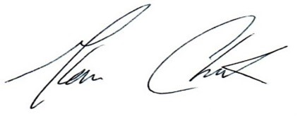
Glenn Church
District 2 Supervisor

