Title: NYC DOB and DDC to Address Design Professionals on October 19th at NYC Design Professionals Day.

On Friday October 19th, the New York City Department of Buildings (DOB) will provide several presentations to inform design professionals and the construction industry about important design considerations and about conducting inspections in the City, as well as the recent initiatives by the department. The event will be held at the NYU Tandon School of Engineering (NYU-Poly), Pfizer Auditorium, 5 Metrotech Center, Brooklyn, NY 11201. For more information and to RSVP to the event use the following link: RSVP to Event.
The full day event will begin with a keynote speech by DOB's First Deputy Commissioner Thomas Fariello R.A., who will discuss recent developments and an update on the online filing system being implemented by the department. DOB's Chief Structural Engineer Dan Eschenasy, PE, F.SEI, SECB, will provide an overview of post fire structural investigations by design professionals (1 PDH). Chief of DOB's Forensic Engineering Unit, Tim Lynch PE, will discuss Building Typology and NYC's building classifications system (1 PDH) as well as lessons from the recent damage assessments in Puerto Rico (1 PDH). In addition, DOB's Director of Sustainability Enforcement, Holly Savoia PE will discuss TR-8 energy progress inspections conducted by design professionals in New York City (1 PDH).
In addition, the Deputy Commissioner of the NYC Department of Design & Construction (DDC) Eric Macfarlane, PE, M.ASCE, will provide an overview of New York City’s efforts to engineer sustainability and resiliency in the face of Global warming and associated sea level rise projection and extreme weather events (1 PDH). Mr. Macfarlane will discuss NYC's emissions reduction efforts to date and NYC's Roadmap to 80% GHG reduction by 2050. Also discussed will be a few DDC projects and case studies related to sustainability and resiliency and 80X20 efforts to preserve and improve the quality of life for NYC residents. For more information and to RSVP to the event use the following link: RSVP to Event.

The presentation by DOB's Director of Sustainability Enforcement, Holly Savoia PE will include a discussion on changes in the energy code and the continually evolving knowledge base of design professionals in an effort to improve energy performance and sustainable building practices in construction. Strong enforcement and education are a necessary component of this effort, and TR-8 progress inspectors play a crucial part in the bridge between the design phase and construction. The presentation will identify the resources available to design professionals for the conduct of progress inspections with respect to the energy code, the administration process to be followed, lessons learned by the Department of Buildings during a recent pilot study of alteration projects, a discussion of challenges, and what is coming up on the horizon.

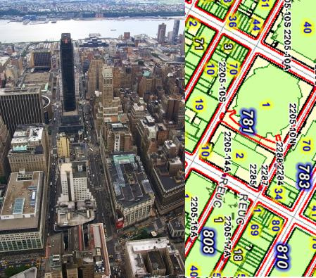

The presentation by DOB's Chief Structural Engineer Dan Eschenasy, PE, F.SEI, SECB, will include an overview of Post Fire Structural Investigations. Material specific methods of post-fire inspection and evaluation will be presented. Following a fire incident structural engineers are called to evaluate the structural stability and condition of the remaining structure and determine the needs for structural repairs. Fire characteristics and the effect of fire on various construction materials will be discussed (steel, concrete, stone and wood).

The presentation by Chief of DOB's Forensic Engineering Unit, Tim Lynch PE, will include discussion on Building Typology and NYC's building classifications system. From NYC's most humble one roomed timber framed bungalow to the super tall 1700’ high towers being constructed today, and from 400 year old historic houses to buildings which will exist far into the future, NYC has always endeavored to classify the buildings by occupancy, fire rating and zoning. From these classifications are derived the codes for architectural, structural, MEP systems and the likes. Mr. Lynch will discuss how these classifications are used in the current codes and how one can convert the 1.2 million existing buildings back and forth between the codes and the relevant technical specs that go with these.
Mr. Lynch, who travelled to Puerto Rico after hurricane Maria, will also discuss the lessons from recent damage assessments in Puerto Rico. NYC DOB responded to a request for post disaster damage assessment following Hurricane Maria last year. Their mission focused on damage assessment of essential facilities as well as residential structures. The presentation will describe the mission, preparation for the mission, effective use of GIS mapping and mobile apps, data sharing, post inspection image analysis as well as lessons learned.

For more information and to RSVP to the event use the following link: RSVP to Event.

Note: NYSSPE facilitates posting on this blog, but the views and accounts expressed herein are those of the author(s) and not the views or accounts of NYSSPE, its officers or directors whose views and accounts may or may not be similar or identical. NYSSPE, its officers and directors do not express any opinion regarding any product or service by virtue of reference to such product or service in this blog.

