10:00 AM COFFEE HOUR – June – Sept.

Coffee Host Responsibilities – UPDATED Fall 2023

Preparation (before coming to church)

- Buy a ½ gallon of cranberry juice. Put receipt in cash box and reimburse yourself. (no need to buy milk or coffee creamer any longer – we have shelf-stable creamer at the church)

- Pick up Munchkins at Dunkin Donuts, on Trapelo Road, (near intersection of Beech Street) in Belmont. They are paid for -- just ask for the All Saints' Church order.

Set Up

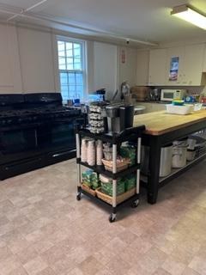
The Coffee Cart is kept in the kitchen during the week. It has on it:

- 2 Keurig Coffee Makers
- K-cups
- Creamer (shelf stable – does not need refrigeration)
- Coffee Cups
- Sugar & Sweet & low (in small metal containers) & coffee stirrers
- Napkins

- Fill the Keurig Reservoirs and then push the cart out to Brewster Hall. Plug in the Keurigs. (an extension cord can be found on the table near the kitchen).
- Put the K-cup holder, the sugar, the napkins, etc. on the table next to the cart.
- Get baskets from the kitchen (you will find them in the cabinet under the pass through to Brewster Hall. Line them with napkins and put the munchkins in them.
- Fill a couple of pitchers with water and the juice you bought. Put some cold cups next to the pitchers.
- Put the cash box on the table for donations (you will find it in the cabinet under the pass through)
- Grab the small waste basket from the kitchen and place it beside the Coffee Station for the used K-cups.
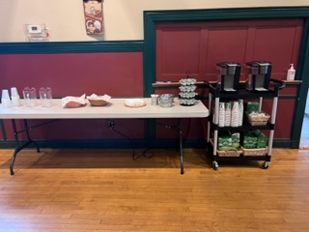

- Check to be sure the Tea station in the kitchen is well-supplied. Extra supplies are in the cabinet under the pass through in Brewster Hall.

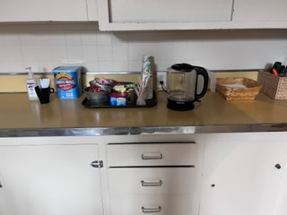

Clean up

- After coffee hour, refill any supplies needed on the coffee cart. Load it up with all the stuff and push it back into its spot in the kitchen.

- Wash the pitchers and put all the other supplies away.

- Take the extra munchkins home or throw them away.

- Empty trash from barrels in kitchen and large gray one in Brewster Hall. Put trash outside in black trash bins (just to the right of the upper door to Brewster Hall). Replace trash bags with new ones from the janitor’s closet.

- Please give cash to one of the Co-Rectors or a Warden.

Thanks for helping by being a coffee hour host/hostess!

