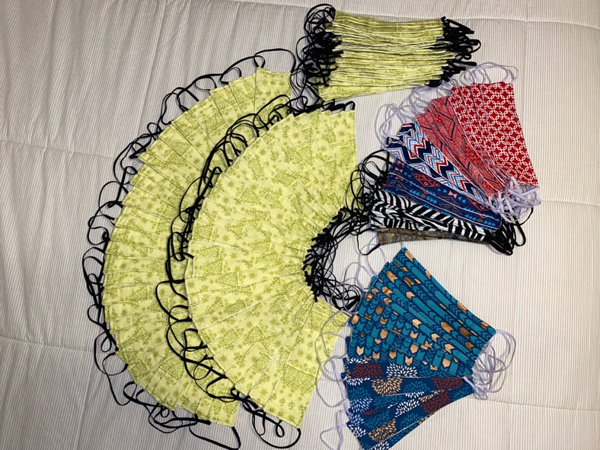
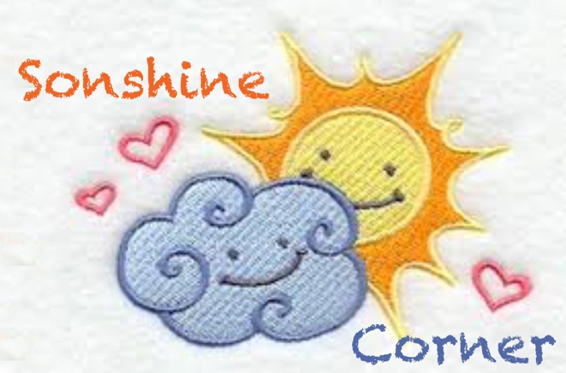
Sonshine Corner:
Burden or Blessing?
by Madeleine Fazenbaker
I told you all in an article last year, about our dear friend Peggy Baker that passed away a year ago. Peggy was an avid sewer. She sewed quilts by the dozens.
She introduced us to machine embroidery and taught us many things. She also taught us about generosity. She informed my mother prior to her death, that when she passed away, she wanted Mom to be responsible for finding useful purposes for her large fabric collection. She did not want it wasted, thrown away or dismissed as just another inconvenient job connected to her death. She wanted the fabric to be enjoyed and useful in some way that helped someone. My mother takes last requests very seriously. She has tried very hard to honor the last requests of several of her friends.

We did not know the scope of the collection until we received it. It filled a garage, and it took us weeks to move and sort it. Over the past year, we have given it away one box at a time, to a group that sews for Little Dresses and Britches for Africa. The ladies that sew for this charity were so very excited to receive Peggy’s fabric and have not had to invest any of their resources into the project for a year. They have produced over 700 pieces of clothing with Peggy’s gift. We have given them all the large cuts of fabric and were left with the little pieces.

Mom and I wondered what we would do with these smaller pieces (i.e. fat quarters) and then this coronavirus came along. We knew we had plenty of fabric in those boxes of pieces to sew masks. What started out as a way for us to help people in our community with immunocompromised systems and other health issues has grown. With the nationwide recommendation to cover the faces of those out in public, we have had a flood of requests for the masks. We are trying to meet the needs of those required to work in essential services in public. The gift that started out as a burden to sort and give away over the course of a year has become a huge blessing to so many in our community. Peggy wanted her fabric to help someone, and it has helped the children in 3rd world countries, who will receive the clothing made from it, and it has also stayed in her community and helped hundreds of people here.

I have not missed a deadline for submission for this article since I started writing it over six years ago, but I did miss this one. I got caught up in sewing to meet the demand we have had since word got out that we were sewing these masks. Just this morning, we have completed the request we received night before last for 80 masks for the Dollar General Stores in our community. We have supplied masks for nine local restaurants, two grocery stores, a credit union, part of the police department and now the Dollar General stores and countless individuals. We have a habit of taking a large purse with us when we have to go out, stuffed with masks, packaged in sandwich bags, and handing them to strangers as we cross their path. Our Easter activity was to take these little baggies and tape them to the driver side doors of trucks at our two local truck stops. The drivers that were in their trucks were very happy to receive them. At the time I'm writing this article, Mom and I have completed and given away 800 masks, all in Peggy’s precious memory. Our new catch phrase is “Peggy would be proud.”

Sometimes we don’t see the value of the gift we are given. If it’s not obvious to us right away, we just think of the unwanted gift as another burden. We don’t realize that sometimes the unwanted gift is the direction finder for us. There are so many other things I could be doing during this time of quarantine, but I choose to do this for two reasons. It helps people. While it may not be the best protection for the coronavirus, it is better than nothing, which is why it was suggested to us to wear a mask. It also gives us a mental uplift that we are being pro-active about the issue. Even the smallest ounce of prevention, may be worth a pound of cure, which is why they want us to wash our hands often. For me, sewing is relaxing, it’s productive and evidently it’s catching on!

Our local Walmart is sold out of sewing machines, thread, fabric, elastic, pins, needles and all things sewing related. Quarantined families are looking for activities their kids can do at home, and “Home Ec” as it was once known, has become trendy. So now my hobby has caught on and I don’t appear quite as weird to my peers who have looked at me for years like I was from outer space! Yes, I was out of date, un-cool, not trendy, and others saw me as not connected with the modern world. But perhaps this is a moment for which I was made, to have this talent at this time, to serve as many people as possible through a stressful time with a very small piece of fabric that helps them cope. All I personally had to invest was my time and talent.

And by the way, if you are bored, “you ain’t livin’ right!” If God gave you the ability to get up and breathe and move about, even if it is only in your home under quarantine, he gave you the opportunity to accomplish something. Be thankful you are here, and make the day worth living…..

God Bless, stay well and we’ll see you later.
Madeleine Fazenbaker

