Technology Enables Continuing Meetings for DOK
by Dona Ace, Diocesan President, Daughters of the King

During my recent staycation, among other worthwhile activities, I worshiped at the Washington National Cathedral online and noticed the organist had placed his cell phone nearby on the organ. I smiled when I saw it. It’s always been my hope that our digital tools would create connections, not cause us to be apart from each other in our own little world. Today’s tenuous time has provided a chance to make that happen. As technology has evolved we have spent years using those gadgets and programs that mostly seemed to push us apart. However, the coronavirus crisis is showing us that the internet and modern technology are capable of pulling us all together to meet, to see, and to hear each other in a most meaningful way!

We are seeing an explosion of creativity as people use technology as a bridge across physical distances. No need for physical social distancing if a software application is being used to organize Daughters' meetings, support those who are alone, and bring a glimmer of familiarity, hope and love to our lives.

Two of our Diocesan DOK Chapters recently did just that! Candace Fitch, chapter president of DOK St. Andrew’s, Las Cruces, organized their monthly meeting through email attachments. Then she held the meeting at the usual time using group texting. Daughters who weren’t able to text were encouraged to email Candace. Candace said everyone proceeded through the agenda items easily. She added, “We’ll hold the next meeting the same way, we will not even know that we’ve been apart.”

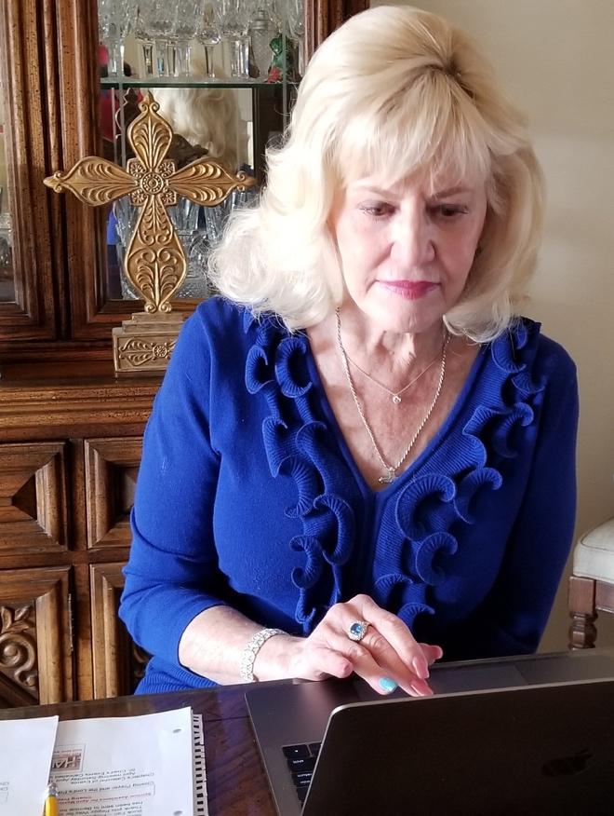
Cathy Conn, chapter president of DOK St. Chad’s, Albuquerque, scheduled their chapter meeting using a software app that allows users to meet online in a live setting, with video as well as audio capabilities. Cathy was the host and all other participants joined the host as interactive participants just like a regular meeting. All participants could see and hear each other as Cathy led the discussions needed for the business meeting, the daily prayer list, and future service projects. “Our Daughters were all missing each other, so this was such a meaningful way to keep us all connected and not feel so isolated!”, she said. Daughters who were apprehensive about this tool before the meeting were praising it afterwards.

How fortunate we are that people are finding ways to move their real-world support systems online during this period of social isolation. The fact that I had the opportunity to converse and view the Daughters live at our recent meetings, and worship live at the National Cathedral is amazing! And I am glad the organist laid his cell phone on the organ so I could be reminded of how wonderful it has been to have technology as my friend during the COVID-19 crisis.

