
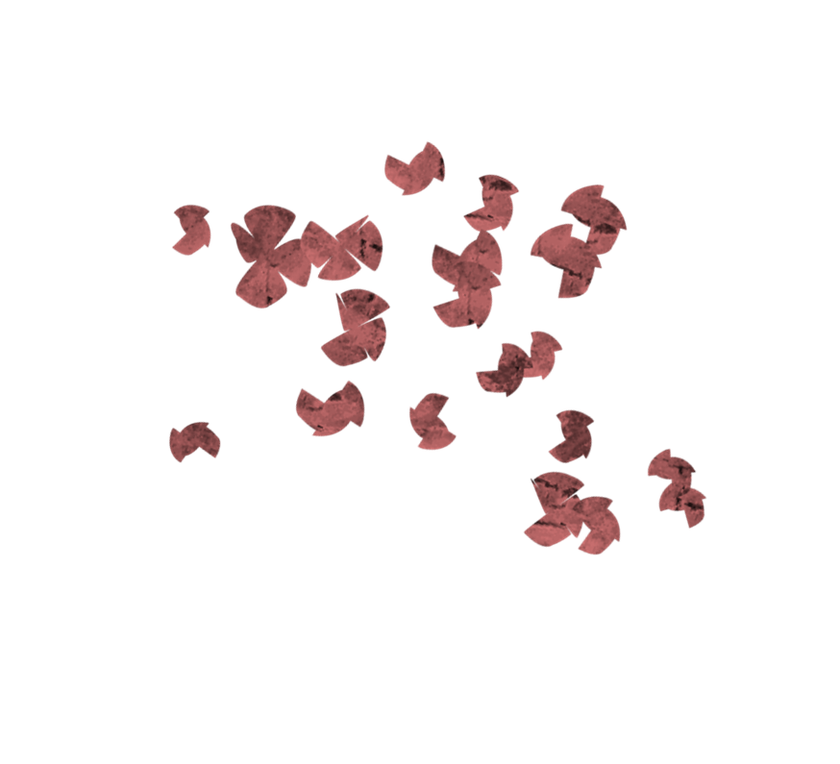
for more information contact: jeanne kennedy at 502-429-4984

Iyengar YOGA
GLEASON HALL AT St JAMES’ episcopal
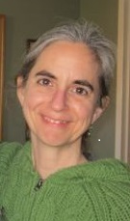
1st and 3rd Mondays
10:30-11:45
$10 per class

with jeanne kennedy
Improve posture, strength, flexibility and balance as you stretch and awaken your body. Learn basic yoga poses to improve your physical wellbeing and feel a sense of quietness within. This class is accessible to anyone regardless of age or physical condition.
Jeanne Kennedy has been teaching yoga for 14 years and has studied extensively in the Iyengar yoga method. She is a certified Iyengar yoga teacher.
Just bring yourself, water, and comfortable clothes. Mats provided.

