FOCUS QUESTION
How does the DEL Dancemaker App help me create an original dance?
OBJECTIVE
- Explore using technology to create dances
- Make a dance using the Movement Sentence model

Indicators of Student Learning
CONTENT – Students will know:  - The DEL Dancemaker App and its functionally  - The Laban Movement Analysis (LMA) concepts The Elements of Dance  - The Movement Sentence model  - The definition of migration | SKILLS – Students will be able to:  - Use the app functionality to create an original dance  - Improvise action words  - Create and perform a dance using the Movement Sentence model  - Discuss migration: who migrates? why do people migrate?

WHAT IS MIGRATION? Estimated time to complete: 50 minutes (2 sessions of 25 min each)
Human migration is people moving from one place to another. When migrating, people move to a new region, state or country and stay there. Humans are have migrated throughout history. Sometimes the movement is voluntary, but sometimes people are forced to move due to weather, disease, economic conditions or war.
Before beginning the dance making project, read the definition of migration and discuss these two questions:
- Can you think of any examples of migration in the past? Who migrated? Why did they migrate?
- Can you think of any migration happening in the present? Who is migrating? Why are they migrating?

ACTIVITY SEQUENCE
The DEL Dancemaker App is easy to use and free of charge as long as you have access to the internet just follow the links to download the app on your phone or tablet. In this project, you will use the MAKE A DANCE feature to create your original dance. Follow the steps below and have fun!!! Watch this video on how to use the DEL DanceMaker App: https://youtu.be/CE9ozc4t9jY

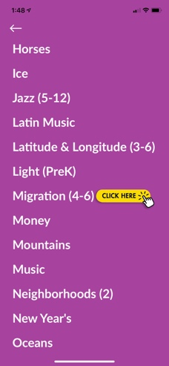
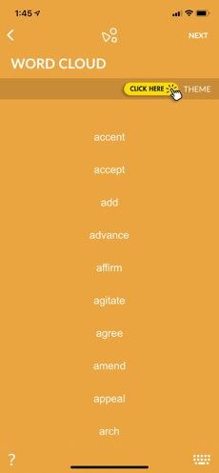
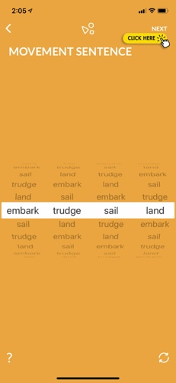
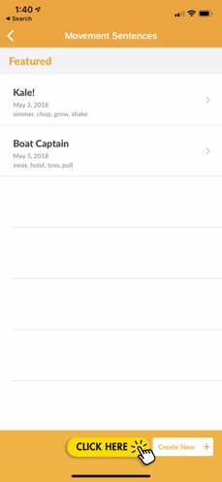
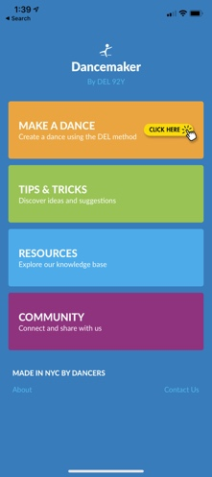
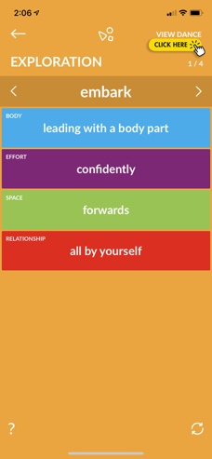

Step 1 & 2 Step 3 Step 4

Step 1: Use the following links to download the DEL Dancemaker App to a phone.

https://apps.apple.com/us/app/dancemaker/id1180809091
https://play.google.com/store/apps/details?id=com.dancemaker.android

Step 2: When you open the application the first time you will find FOUR choices.
Tap on MAKE A DANCE

Step 3: MAKE A DANCE
- At the lower right-hand tap “Create New +”
- Tap on the top bar labeled THEME
- Scroll down to the MIGRATION theme
- Choose these FOUR actions from the migration list: EMBARK – SAIL - TRUDGE - LAND
- Click next. You will see your 4 actions highlighted
- Scroll until you find the order of actions you prefer, or use the circular arrows bottom right to choose a random sequence
- Try out movements until you find a movement for each action in your dance
- Click next again. Now you are in EXPLORATION and will have fun adding details to your dance!

Step 4: EXPLORATION
- Choose an idea from each category BODY, EFFORT, SPACE, RELATIONSHIP. Look for ideas that support the theme of migration.
- Tap BODY – scroll through the suggestions. Tap one you like.
- Tap EFFORT – scroll through the suggestions. Tap one you like.
- Tap SPACE - scroll through the suggestions. Tap one you like.
- Tap RELATIONSHIP - scroll through the suggestions. Tap one you like. The possibilities are endless as long as you are having fun and dancing!

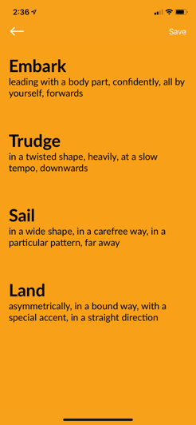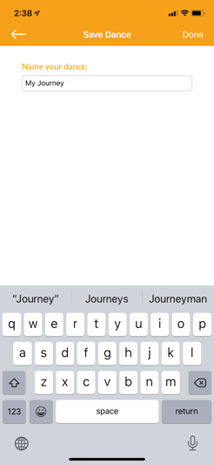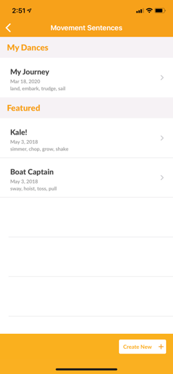
Step 4 Step 5

- You can tap VIEW DANCE on the top right of the screen, or tap the forward arrow and use the same steps with your next action. Take your time. Your dance is getting more complex and you want to have fun. You don’t need to choose a suggestion from each category.

Step 5: SAVE AND PRACTICE YOUR DANCE
- Tap View dance and then tap save. Title your dance. Your dance will be saved in the app so you can dance it again.
- Practice all the ideas for each action. Can you remember them? When you practice, imagine you are part of a migration.
- How do you feel?
- Add a still shape at the beginning and the end of the dance. Practice the movement sentence at least three times. You can ask someone at home to read the actions and the variations while you move.
- Can you think about music for this dance? Practice the dance to music at least two times.
- TIP: You might want to invite family members to do the dance with you.

Step 6: REFLECTION

Discuss these two questions with a family member:

- Can you think of any examples of people migrating by boat in the past? Who migrated? Why did they migrate?
- Can you think of any migration happening by boat in the present? Who is migrating? Why are they migrating?
Write a journal entry responding to these questions:
- When you are performing your dance, can you imagine yourself as a migrant? How do you feel?
- What was your experience using the dancemaker app? Is it easy to use? Why or why not? Do you think your dance helped you to understand migration? Why or why not?

EXTENSIONS
- Record on video your dance and send it to your teacher.
- Take a screen shot of your dance in the app and send it by text or email to your teacher.
- Exchange the screen shot of your dance in the app with a classmate or a friend so you can create a dance using each other’s movement sentences.
- Choose a different piece of music to dance to. Try describe how the music changes the way the dance feels.
- Change the order of the actions.
- Change the movement ideas for each action.
- Draw your dance!
- Try the Ocean Fun dance from the instructional video: https://youtu.be/CE9ozc4t9jY

RESOURCES
The DEL Dancemaker App is easy to use and free of charge as long as you have access to the internet just follow the links to put the app on your phone or tablet.

https://apps.apple.com/us/app/dancemaker/id1180809091
https://play.google.com/store/apps/details?id=com.dancemaker.android

MODIFICATIONS AND ACCOMMODATIONS
Here are some modifications and accommodations to the lesson to support all learners.

Step 1 and 2: As written above

Step 3: MAKE A DANCE
- Tap on Make A Dance
- At the lower right-hand tap “Create New +”
- Tap on the top bar labeled THEME
- Scroll down to the MIGRATION theme
- On a piece of paper write the word Migration as a heading.
- Choose these THREE actions from the migration list: SAIL – LAND - EMBARK on your phone
- Click next. You will see your 3 actions highlighted
- Scroll until you find the order of actions you prefer, or use the circular arrows bottom right to choose a random sequence
- Write your actions down in order on your paper.
- Click next again. Now you are in EXPLORATION and will have fun adding details to your dance!
Step 4: EXPLORATION
- For each action choose one category - BODY, EFFORT, SPACE or RELATIONSHIP.
- Scroll through the suggestions for that category. Tap one you like.
- Add these new ideas to your paper next to each action. You can also draw a picture of the action!
Step 5: SAVE AND PRACTICE YOUR DANCE
- Tap View dance and then tap save. Title your dance. Your dance will be saved in the app so you can dance it again.
- Practice each action. Can you remember them?
- Practice the movement sentence in order at least three times. Have a helper read the sequence as you dance.
- Choose music for the dance. Practice the dance to music at least two times.
- TIP: You might want to invite family members to do the dance with you.

Step 6: REFLECTION

Discuss these questions with a family member:

- Can you think of any examples of people migrating by boat in the past? Who migrated? Why did they migrate?
- Can you think of any migration happening by boat in the present? Who is migrating? Why are they migrating?
- When you are performing your dance, can you imagine yourself as a migrant? How do you feel?
- What was your experience using the dancemaker app? Is it easy to use? Why or why not? Do you think your dance helped you to understand migration? Why or why not?

Blueprint for Teaching and Learning in Dance
☒ Dance Making  ☐ Develop Skills and Techniques  ☒ Improvise  ☒ Choreograph  ☒ Perform | ☒ Developing Dance Literacy  ☒ Understand Dance as a Means of Expression and Communication  ☒ Apply Dance Vocabulary, Terminology and Symbols  ☐ Analyze, Critique and Communicate About Dance  ☐ Identify and Compare Dance Styles, Genres,  Major Works and Artists | ☒ Making Connections  ☐ Understand Dance History and the Social and Cultural Significance of Dance (Theatrical, Ritual & Social Dances)  ☐ Connect Dance to Other Arts and Disciplines  ☒ Utilize Technology in Connection with Dance  ☐ Connect Dance to Health and Well-Being | ☒ Community and Cultural Resources  ☐ Engage with Community and Cultural Institutions,  Colleges and Universities  ☒ Use Dance Research Resources  ☐ Share Dance Experiences in and Between Schools | ☒ Careers and  Lifelong Learning  ☐ Learn About Careers in and Related to Dance  ☐ Set and Work Toward Goals  ☒ Value Dance as a Source  of Enjoyment and Lifelong Learning

NYS Learning Standards for the Arts
Artistic Processes
☒ | ☒ | ☒ | ☐
Anchor Standards
☒ Anchor Standard 1: Generate and conceptualize artistic ideas and work.  ☒ Anchor Standard 2: Organize and develop artistic ideas and work.  ☒ Anchor Standard 3: Refine and complete artistic work. | ☐ Anchor Standard 4: Select, analyze, and interpret artistic work for presentation.  ☐ Anchor Standard 5: Develop and refine artistic techniques and work for presentation.  ☒ Anchor Standard 6: Convey meaning through the presentation of artistic work. | ☐ Anchor Standard 7: Perceive and analyze artistic work.  ☒ Anchor Standard 8: Interpret meaning in artistic work.  ☐ Anchor Standard 9: Apply criteria to evaluate artistic work. | ☐ Anchor Standard 10: Relate and synthesize knowledge and personal experiences to inspire and inform artistic work.  ☐ Anchor Standard 11: Investigate ways that artistic work is influenced by societal, cultural, and historical context and, in turn, how artistic ideas shape cultures past, present, and future.

