

CALIFORNIA STATE UNIVERSITY, LONG BEACH

College of Health and Human Services Community Affiliations Project

Department and Faculty Community Agency Network Study

By

Becky Nash, Ph.D.

Aili Malm, Ph.D.

School of Criminology, Criminal Justice, and Emergency Management

California State University, Long Beach

1250 Bellflower Blvd.

Long Beach, CA 90840

August 5, 2020

Introduction
In this report, we present findings from a social network study of community affiliations within the College of Health and Human Services (CHHS). We break the study into two sections. First, we examine community affiliations by academic department. Second, we examine community affiliations of individual faculty members within CHHS. Each study includes descriptive analyses of the network, subgroup analyses to uncover shared ties within tightly knit subnetworks, and centrality measures to identify central players, including academic departments, faculty members, and community agencies. The central purpose of this research is to create a network of CHHS departments and faculty members and their ties to community organizations.

CHHS Department Connections to the Community
Descriptives
The main CHHS department network (Figure 1) uses data compiled by CHHS in November 2019. The data consist of connections between 11 departments (Criminology, Criminal Justice, and Emergency Management; Family and Consumer Sciences; Healthcare Administration; Health Sciences; Kinesiology; Nursing; Physical Therapy; Public Policy and Administration; Recreation and Leisure; Speech/Language Pathology; and Social Work) and 1468 community organizations. This network consists of ties between CHHS academic departments (red circles) and community agencies (blue squares). Ties are defined as a relationship between CHHS departments and community agencies to which the departments provide academic and professional services.
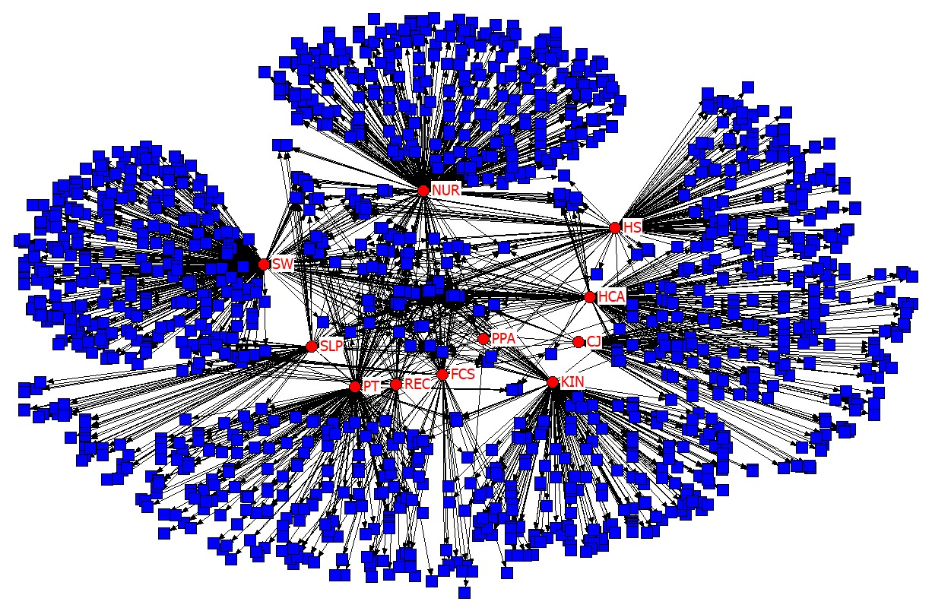
Figure 1. CHHS Department Network
ª Red circles are CHHS departments; Blue squares are community agencies of the 11 CHHS academic departments.

The School of Nursing and the School of Social Work have the majority of ties in the network, 27% and 26.4% of ties respectively. The departments of Kinesiology, Physical Therapy, Healthcare Administration, and Health Sciences comprise 15.3%, 13.7%, 13.2%, and 11.2% of the ties respectively in the overall network. Finally, Speech/Language pathology (6.9%), the School of Criminology, Criminal Justice, and Emergency Management (4.6%), the Department of Family and Consumer Sciences (4.4%), and Public Policy and Administration (0.3%) have the lowest number of ties in the overall network.

Subgroup Analysis: K-Core and Shared Affiliations
To further understand this large network, a k-core analysis (k ≥ 2) was conducted to capture community agencies with ties to at least two CHHS departments. This reduces the network to 150 community agencies with 555 ties to CHHS departments (see Figure 2). In figure 2, circles are CHHS departments and squares are community agencies. In this reduced network, CHHS departments worked with between two and nine shared community agencies. The agencies are colored by the number of CHHS departments to which they are tied (for example, all agencies in gray are tied to two different CHHS departments). This graph shows that CHHS departments are often connected to the same agencies.

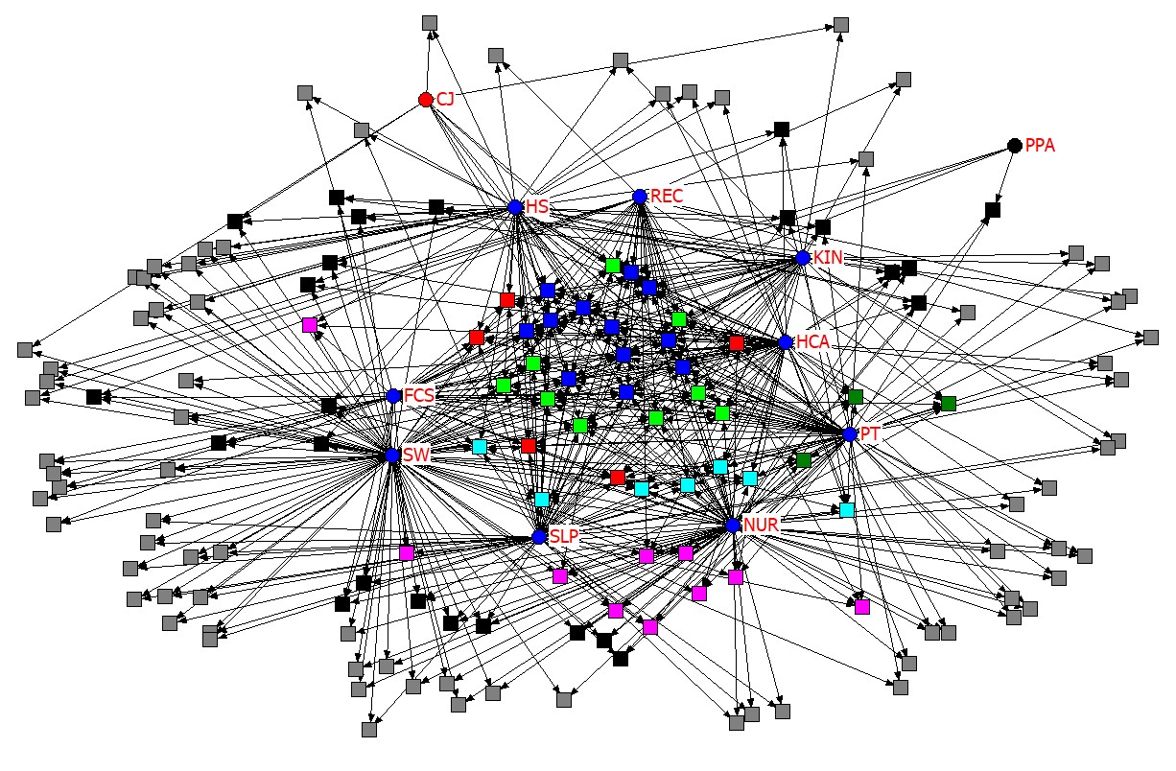
Figure 2. CHHS Department Affiliations Network with K-core ≥ 2
ª Gray = 2-core; Black = 3-core; Pink = 4-core; Dark Green = 5-core; Light Blue = 6-core; Red = 7-core; Light Green = 8-core; Dark Blue = 9-core; circles = CHHS departments, squares = community agencies.

Figure 3 shows the 9-core network of shared ties from the k-core analysis. In this network, nine CHHS departments (FCS, HCA, HS, KIN, NURS, PT, REC, and SLP) all share ties to twelve community agencies. These agencies are listed in table 1.
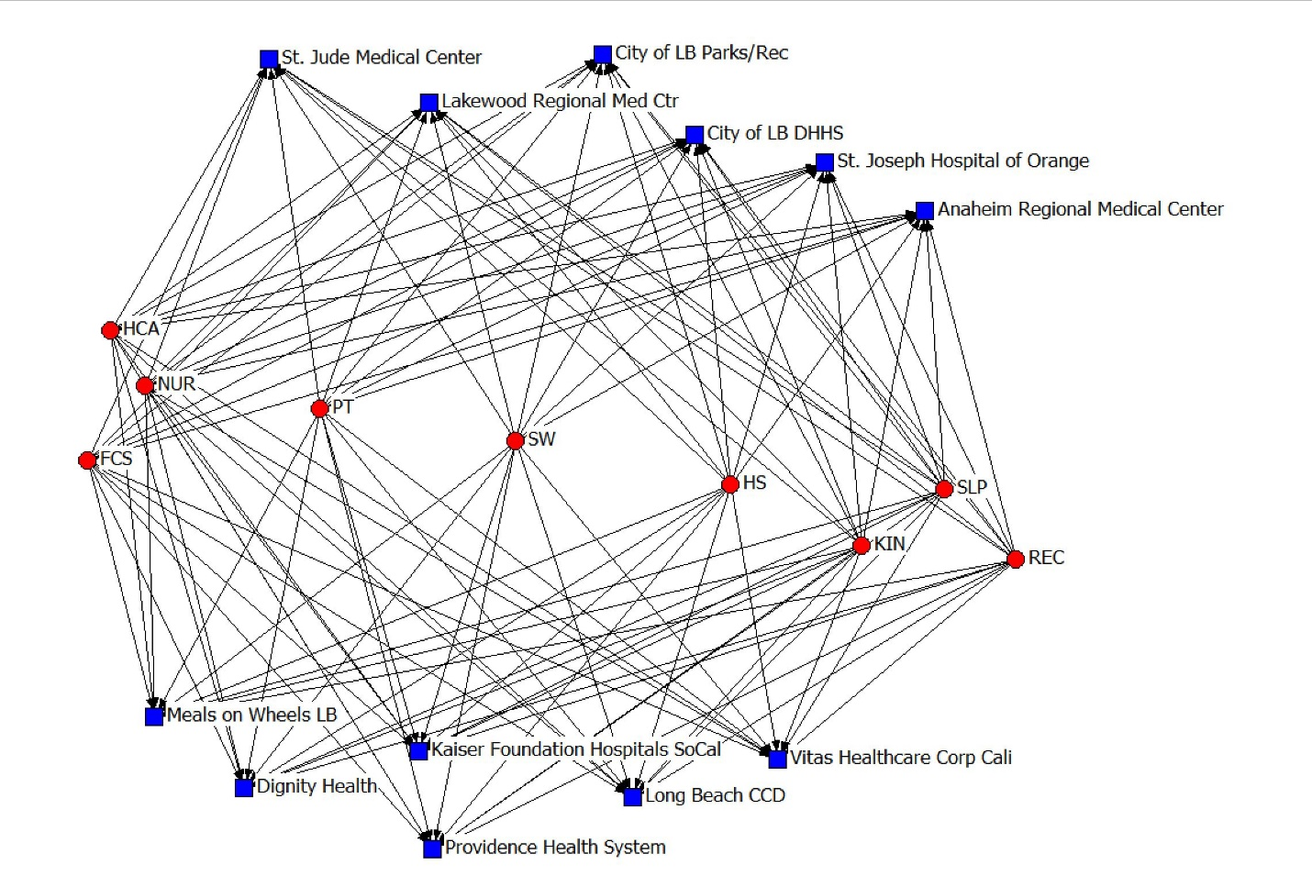
Figure 3. 9-core network
ª Red circles are CHHS departments, blue squares are community agencies

Table 1. 9-core Analysis Network
Community Organization
Anaheim Regional Medical Center
City of LB DHHS
City of LB Parks/Rec
Dignity Health
Kaiser Foundation Hospitals SoCal
Lakewood Regional Medical Center
Long Beach CCD
Meals on Wheels LB
Providence Health System
St. Joseph Hospital of Orange
St. Jude Medical Center
Vitas Healthcare Corp California

Table 2 presents the number of agencies shared between different departments in the College. For example, Nursing and Social Work share the greatest number of community agencies (54). Nursing and Healthcare Administration are working with 41 of the same agencies. CCJEM and PPA share the least number of agencies with other departments. This is perhaps not surprising as they are not as health-focused as the other eight departments.

Table 2. Total Number of Agencies Shared between Departments
 | CJ | FCS | HCA | HS | KIN | NUR | PPA | PT | REC | SLP | SW
CJ | ---- | 7 | 7 | 9 | 8 | 6 | 3 | 7 | 7 | 7 | 9
FCS | 7 | ---- | 29 | 24 | 24 | 30 | 3 | 30 | 20 | 30 | 38
HCA | 7 | 29 | ---- | 33 | 28 | 41 | 3 | 38 | 21 | 33 | 42
HS | 9 | 24 | 33 | ---- | 22 | 28 | 3 | 28 | 18 | 28 | 40
KIN | 8 | 24 | 28 | 22 | ---- | 26 | 3 | 30 | 20 | 27 | 29
NUR | 6 | 30 | 41 | 28 | 26 | ---- | 3 | 49 | 23 | 41 | 54
PPA | 3 | 3 | 3 | 3 | 3 | 3 | ---- | 4 | 3 | 3 | 3
PT | 7 | 30 | 38 | 28 | 30 | 49 | 4 | ---- | 26 | 41 | 42
REC | 7 | 20 | 21 | 18 | 20 | 23 | 3 | 26 | ---- | 22 | 27
SLP | 7 | 30 | 33 | 28 | 27 | 41 | 3 | 41 | 22 | ---- | 49
SW | 9 | 38 | 42 | 40 | 29 | 54 | 3 | 42 | 27 | 49 | ----

Centrality Measures
Centrality measures are used to uncover central players in the network. Centrality is an attribute of individual actors in a network but it is also a measure of how the overall network structure contributes to a single node’s, influence, power, social capital, and/or brokerage in a network (Everton, 2012; Hanneman and Riddle, 2005). Table 3 ranks departments by three different types of centrality.
Degree centrality is a count of the number of ties an actor has in a network; the more ties, the more power and influence they have in the network (Everton, 2012; Hanneman and Riddle, 2005). The School of Nursing and the School of Social Work have the greatest number of ties to community agencies (397 and 388 respectively). For instance, their students may have more choices to acquire knowledge or employment after graduation, and their faculty members may have more research and grant opportunities since these Schools have the greatest number of ties within the community.
Betweeness centrality measures the extent to which an actor lies on the shortest path between other actors (Borgatti and Everett, 2006, p. 474). Betweeness centrality locates the brokers of a network who have the power to bridge the gap between others in the network. For example, the School of Nursing and the School of Social Work both have the largest betweeness centrality scores and thus have considerable social capital and influence. Their position in the network can lead to increased opportunities for students and faculty.
Eigenvector centrality measures the extent to which a node is connected to other well-connected nodes in a network. This measure of centrality assumes that ties to more central actors are more important than ties to actors on the periphery of a network (Everton, 2012). Again, the School of Nursing and the School of Social Work have the highest eigenvector centrality scores in the network. This means that both schools have connections with the most influential agencies in the community.

Table 3. CHHS Department Centrality Measures
Department | Out-degree | Department | Betweeness  Rank | Department | Eigenvector  Rank
NURS | 397 | NURS | 1 | NURS | 1
SW | 388 | SW | 2 | SW | 2
KIN | 225 | KIN | 3 | PT | 3
PT | 201 | PT | 4 | HCA | 4
HCA | 194 | HCA | 5 | SLP | 5
HS | 165 | HS | 6 | KIN | 6
SLP | 102 | CCJEM | 7 | HS | 7
CCJEM | 67 | SLP | 8 | FCS | 8
REC | 65 | REC | 9 | REC | 9
FCS | 64 | FCS | 10 | CCJEM | 10
PPA | 5 | PPA | 11 | PPA | 11

CHHS Faculty Connections to the Community
Descriptives
The CHHS faculty network (figure 3 below) was created from survey data sent to all CHHS faculty, both tenured/tenure-track (n = 152) and non-tenure/lecture (n = 322) for a total of 474 faculty members as of the spring 2020 semester. The survey asked faculty members to list all community agencies to which they have a tie within the last three years. Ties are defined as a relationship between CHHS faculty members and community agencies to which they provide academic, professional, and volunteer services. The overall response rate is 121 faculty members (25.53%), including those who declined or did not complete the survey. After removing these respondents from the data, the total number of faculty members used in this study is n = 98 (20.68%).
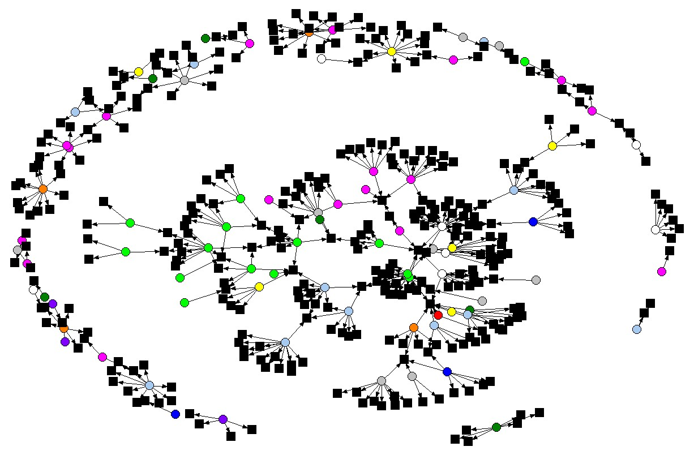 Figure 3. Main CHHS Faculty Affiliation Network by Department
ª Circles are individual faculty members and squares are individual community affiliations,
^{b} Pink = CCJEM; Light blue = FCS; Yellow = HCA; White = HS; Dark green = KIN; Green = NURS; Blue = PPA; Red = PT; Orange = REC; Purple = SLP; Gray = SW; Black = community affiliations.
^{c} Isolates are not included.

The main CHHS faculty network has a total of 430 nodes and 400 ties between nodes; faculty make up the rows (n = 98) and community affiliations make up the columns (n = 332) of the binary matrix. Out of the 98 respondents, the School of Criminology makes up the majority with 23.47% of respondents followed by the School of Nursing (15.31%), Family and Consumer Sciences (11.22%), and the School of Social Work (11.22%). The department of Health Sciences makes up 7.14% of respondents while Healthcare Administration (8.16%) and Kinesiology (9.18%) have the same percentage of respondents. Recreation and Leisure consists of 4.08% of respondents, while the departments of Speech Language Pathology and Public Policy and Administration make up 5.10% and 3.06% respectively. Finally, 2.04% of respondents are from the department of Physical Therapy. When considering faculty rank, the majority of respondents were lecturers (41.84%), followed by assistant professors (26.53%), full professors (17.35%), and associate professors (14.29%).
When considering the geo locations of community agencies tied to CHHS faculty, 68.37% are local agencies, 18.98% are national agencies, 10.54% are state agencies, and 0.90% are a mixture of local, state, and national geo locations. We also considered the type of agency. Respondents could choose from six characteristics (educational, governmental, healthcare, non-profit, public safety, and public sector) and they could choose any that applied. Out of the 332 community agencies, 33.43% are some combination of all six choices. A little over 26% are educational (26.20%), 18.98% are non-profit agencies, 9.34% are healthcare based, 5.12% are government agencies, 3.61% are public safety related, and 3.01% of agencies are in the public sector.

Subgroup Analysis: K-core and Shared Affiliations
A k-core analysis (k ≤ 2) was conducted on the main faculty network to uncover faculty members with shared community affiliations. The k-core analysis produced a range of k-cores from 0 to 2. The 2-core network is examined here and uncovers all faculty members that share at least two ties (community affiliations), reducing the overall network to 43 nodes with 61 ties (21 faculty, 22 community affiliations).
Analyses were conducted to allow us to look at centrality measures for both faculty members and community affiliations. Figure 4 presents a sociogram of the network, where nodes are sized by their degree centrality (larger nodes have more ties in the network) and colored by their rank (lecturer, assistant professor, associate professor, and full professor). Figure 4 reveals that the Long Beach Department of Health and Human Services (local), American Gold Star Manor (local), Pathways Volunteer Hospice (local), and Long Beach Memorial Hospital (local) are some of the community agencies with the greatest number of ties to faculty members in the subnetwork. Actors 114hs (lecturer), 61n (full professor), and 95n (assistant professor) are some of the faculty members with the greatest number of ties to community agencies.

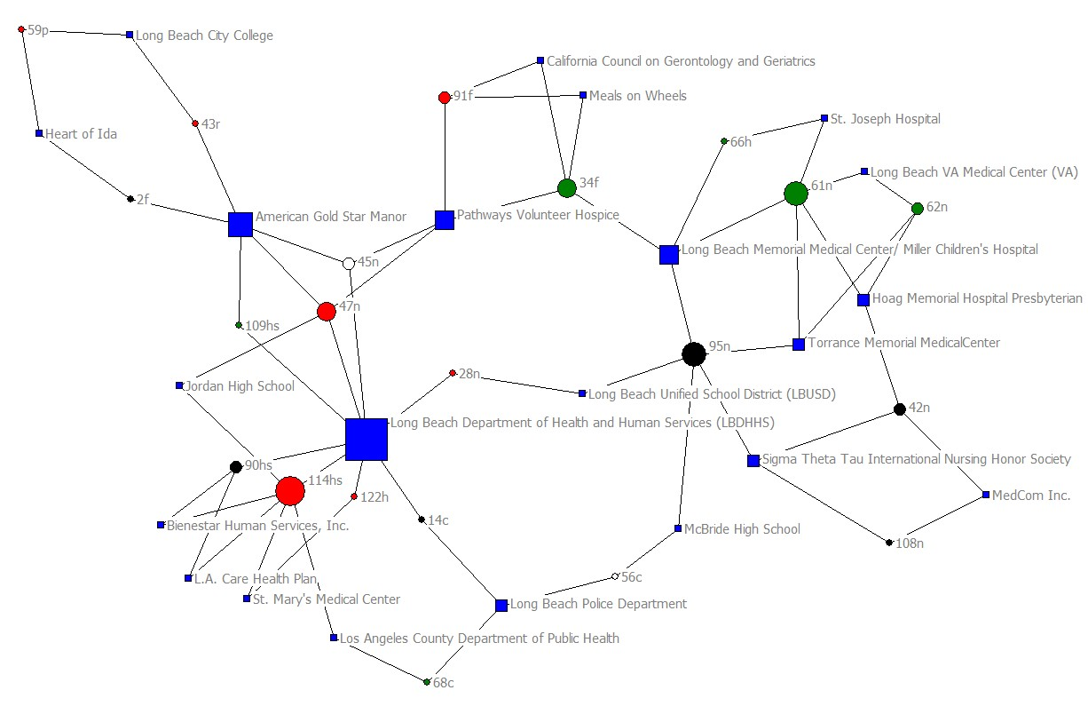
Figure 4. 2-core Faculty Network by Rank and Degree Centrality
ª Circles = faculty members; Squares = community affiliations,
^{b} Red = lecturer; Black = assistant professor; White = associate professor; Green = full professor; Blue = community affiliations,
^{c} Nodes are sized by their degree centrality scores (larger nodes = larger degree centrality scores).

Faculty Centrality Measures
Centrality measures were analyzed to uncover the central players in the CHHS faculty network. Table 4 captures the highest degree, betweeness, and Eigenvector centrality scores for faculty members in the network along with their academic rank and department affiliation.

Table 4. Highest Centrality Scores for Faculty Members
Faculty ID | Out-degree | Rank | Faculty ID | Betweeness  Rank | Rank | Faculty ID | Eigenvector  Rank | Rank
114hs | 24 | Lect. | 114hs | 1 | Lect. | 114hs | 1 | Lect.
47n | 15 | Lect. | 47n | 2 | Lect. | 47n | 2 | Lect.
54f | 13 | Asst. | 95n | 3 | Assoc. | 90hs | 3 | Asst.
102h | 12 | Lect. | 34f | 4 | Full | 45n | 4 | Assoc.
68c | 12 | Full | 28n | 5 | Lect. | 109hs | 5 | Full
62n | 11 | Full | 45n | 6 | Assoc. | 122h | 6 | Lect.
109hs | 10 | Full | 43r | 7 | Lect. | 28n | 7 | Lect.
34f | 10 | Full | 109hs | 8 | Full | 14c | 8 | Asst.
16f | 10 | Assoc. | 62n | 9 | Full | 110sw | 9 | Asst.
ª Faculty ID letters are the departments and schools to which each faculty member belongs.
^{b} c = Criminal Justice, f = Family and Consumer Sciences, h = Healthcare Administration, hs = Health Sciences, n = Nursing, r = Recreation and Leisure, sw = Social Work

Degree centrality counts the actual number of ties an actor has in a network. In this network, faculty member 114hs (lecturer) from the department of Health Sciences stands out with the highest degree centrality score of 24 and is connected to the most community agencies in the entire network. Following for most connections to community agencies is faculty member 47n (lecturer) from the School of Nursing and faculty member 54f (assistant professor) from Family and Consumer Sciences, with 15 agency ties and 13 agency ties respectively.
Betweeness centrality captures actors who are important because they bridge the gap between other actors in the network. Again, the Health Sciences faculty member 114hs (lecturer) and 47n from Nursing have the highest scores in the network. Their position allows them control over information flow, which may affect internship and employment opportunities for students, as well as possible research and professional opportunities for other faculty members within and across disciplines. We must also consider that sharing information with community agencies about other experienced faculty colleagues in the College can arguably influence community agencies by providing them with CHHS faculty who have years of experience, research, and expertise.
Recall that Eigenvector centrality measures a node’s importance based on other central nodes to which it is connected. Again, we see familiar “faces” among highly central faculty members with actors 114hs, a lecturer from Health Sciences, and actor 47n, a lecturer from Nursing having the highest scores. Since actors 114hs and 47n have the highest degree, betweeness, and Eigenvector centrality scores, we must also consider both faculty members and community agencies to which they are connected. These actors will have access to all the ties of actor 114hs and actor 47n. We must also consider the actors with the lowest Eigenvector centrality scores as they may benefit from creating more shared ties with other highly central actors in the network, thus having access to more social capital.

Community Agency Degree Centrality
In this study, we also calculated degree centrality for the community agencies to uncover those with the most ties to CHHS faculty. Table 5 shows the community agencies with the highest degree centrality scores in the network. The Long Beach Department of Health and Human Services (local) and American Gold Star Manor (local) have the highest scores, having connections with nine different faculty members for each of the agencies. All agencies in table 5 are considered local for their geo location by the faculty who have a relationship with them. A majority of the agencies in table 5 are multiple types (consisting of combinations of educational, governmental, healthcare, non-profit, public safety, and public sector) depending on the faculty who have ties with them.

Table 5. Highest Degree Centrality Scores for Community Agencies
Affiliation Name | Degree  score | Geo Location | Type
American Goldstar Manor | 9 | Local | Multiple
Long Beach Department of Health and Human Services | 9 | Local | Multiple
Long Beach Memorial Medical Center | 5 | Local | Multiple
Long Beach Police Department | 5 | Local | Multiple
Hoag Memorial Hospital Presbyterian | 4 | Local | Healthcare
Long Beach City College | 4 | Local | Education
Long Beach Unified School District (LBUSD) | 4 | Local | Multiple
Pathways Volunteer Hospice | 4 | Local | Multiple
McBride High School | 3 | Local | Education
Meals on Wheels | 3 | Local | Multiple
Sigma Theta Tau International Nursing Honor Society | 3 | Local/National | Multiple
St. Joseph Hospital | 3 | Local | Multiple
Torrance Memorial Medical Center | 3 | Local | Healthcare

Conclusion
This study shows that CHHS departments and faculty have extensive local and statewide networks with agencies and organizations. These networks facilitate opportunities for outreach, research, and student engagement. To build this vast network, the college and departments should consider the following suggestions:
- Create informal groups of faculty members working with the same agencies. Faculty could then share information and opportunities with one another. This may also reduce bureaucratic redundancy for the agency and the college.
- Well-connected faculty should consider involving more junior faculty members in their community partnerships. This would not only promote collegiality, but also grow the CHHS community network.
- CHHS should consider formally and informally rewarding faculty who work to engage community partners. This could include recognition in the RTP process, awards for increasing partnerships, awards for mentoring junior faculty in community engagement, etc.
- The CHHS should also consider acknowledging central community agencies, in the form of a partner’s night, or something similar. This would increase the sense of cohesion between the college and the community. This expanded cohesion is likely to encourage community agencies to speak about the good work being done by CHHS faculty in the community.

References
Borgatti, S. P., & Everett, M. G. (2006). A graph theoretic perspective on centrality. Social Networks, 28(4), 466-484.
Borgatti, S. P., Everett, M. G., & Freeman, L. C. (2002). UCINET 6 for Windows: Software for social network analysis. Harvard: Analytic Technologies.
Everton, S. F. (2012). Structural analysis in the social sciences: Disrupting dark networks. Cambridge University Press.
Hanneman, R. A., & Riddle, M. (2005). Introduction to social network methods. Riverside, CA: University of California, Riverside. Retrieved from https://faculty.ucr.edu/~hanneman/nettext/

A k-core is a group of actors connected to k group members so that all actors in a 2-core have two or more ties to other actors or affiliations in the network (Everton, 2012).
Out of the 98 faculty members who completed the survey, thirteen do not have any ties to community agencies and are considered isolates.
Four (1.20%) community agencies were not labelled with any geo location.
One (0.30%) community agency was not labelled with any type characteristic.
To calculate centrality scores in a meaningful way, the main faculty 2-mode network was symmetrized to create a 1-mode, undirected network of all ties between faculty members and community agencies.

