CANDIDATE BIOGRAPHIES
SENIOR WARDEN CANDIDATE – ARTHUR E. PIZZANO
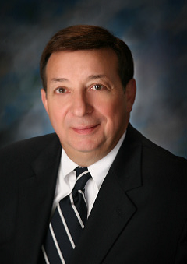
Art’s professional background is comprised of over 4 decades of service to communities of people. His career, working in a variety of local government settings, included appointment as Fairfield City Manager, where he led that city for 17 years; retiring this past May. Art and his family became members of Christ Church Glendale shortly upon their arrival to the Cincinnati area in 1998. Sandy and Art were married at St. Paul’s Episcopal Church in Englewood, New Jersey in June of 1972. They chose to have an interdenominational wedding service, which was officiated jointly by a Catholic Jesuit Priest and an Episcopal Priest.

Art has served 2 terms on the CCG Vestry, notably during much of the period when our church was beginning to envision its future growth and development needs and opportunities. He subsequently chaired the Building Our Vision Contractor Selection Committee and was on the BOV Fundraising Consultant Selection and Lead Gifts Committees. Art also was co-chair of CCG’s Rector Search Committee; a critical assignment as we move together into this truly transformational period in our congregation’s spiritual and
programmatic development. During this past year he has served as Senior Warden.

