SMITH BAPTIST ASSOCATION 2023 ANNUAL CHURCH PROFILE

Report information from September 1, 2022 – August 31, 2023, or
October 1, 2022 – September 30, 2023

Church Information
Church Name
Office Phone Fax
Physical Address
Mailing Address
City Zip Church Email
Church Website Secretary Name
Email

Pastor Information
Pastor Name
Birthdate: Month Day Year Start Date with Church: Month Day Year
Wife Name Home Address
City Zip Email
Home Phone Cell Phone

Other Staff (Youth, Worship Leader, Exec. Pastor, etc.)
Name Staff Position
Cell Phone Email

Name Staff Position
Cell Phone Email
Name Staff Position
Cell Phone Email
Name Staff Position
Cell Phone Email

Church Messengers to Association Meetings
Name Address
Cell Phone Email
Name Address
Cell Phone Email
Name Address
Cell Phone Email
Name Address
Cell Phone Email
Listing of Deceased Members (Separate names with a comma)

Statistical Information Needed:

Total Members Average Weekly Worship Attendance

Small Group/Life Groups/SS Average Attendance VBS Enrollment
Total Baptisms

Ages 11 & Under Ages 12-17 Ages 18-29 Ages 30 & Over

Other Additions

Undesignated Receipts $ Total Receipts $

Great Commission Giving $ (Total of amounts listed below)

$ Association Offerings
$ Lottie Moon Christmas Offering
$ Annie Armstrong Easter Offering
$ Mary Hill Davis Offering or Reach Texas Offering for State Missions

Financial Information Guide

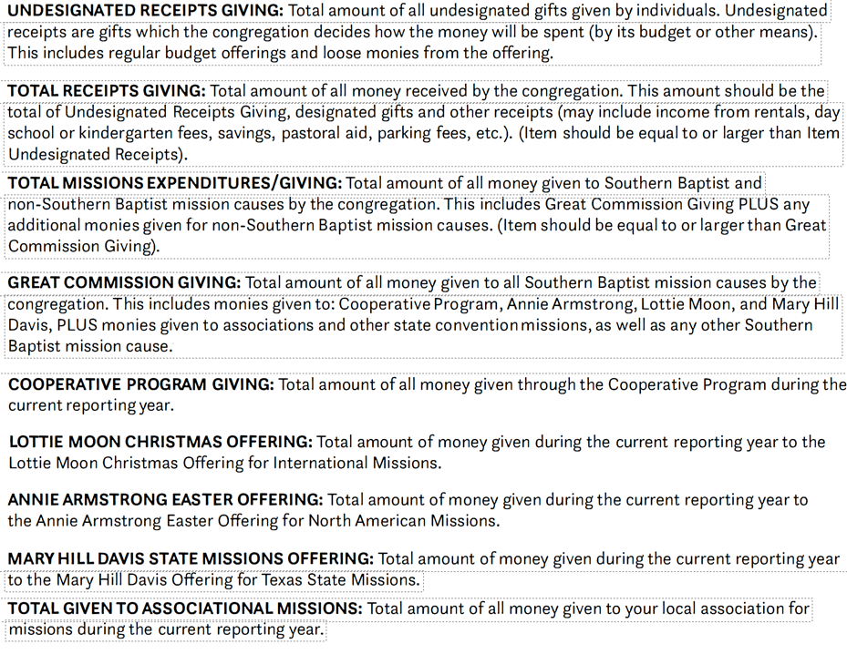

Total People Participating in Missions (may list people in more than one category)

Local U.S. & Canada International Missions

Person completing the ACP

Contact Phone Number

Please return to Paula at paula@smithbaptist.org by October 30, 2023.
If you have trouble, please call 903-581-6139

