Help out the Shea Middle School chapter of **Veterans Heritage Project (VHP)**. Every time you shop at Fry’s that will count toward a donation to our club.

It is so easy to do, and once you have signed up, you don’t have to do any thing else- just buy groceries!

Go to. <https://www.frysfood.com>

You have to have a Fry’s account. Once you are logged into your account, go to SAVINGS & REWARDS.

Choose FRY’S COMMUNITY REWARDS.

If you do not have a Fry’s account, choose Fry’s Community Rewards, and you will be able to create one.

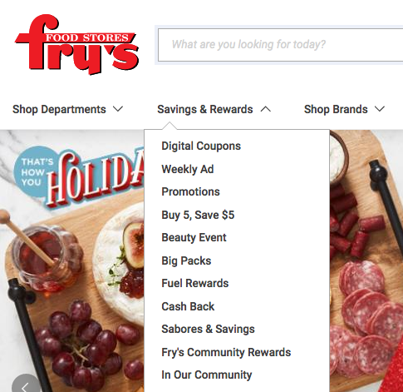

**Thank you**

**For helping us**

 Click here to create your own account.

Click here to enroll.

Now put this code in to find VHP: NX403

You can also search for Veterans Heritage Project.

Now enroll. Thank you for supporting VHP.