Christmas Poinsettia,
Wreaths, Roping and Swags
As the Holiday season quickly approaches, please consider purchasing live poinsettia or greens to brighten your home. All proceeds benefit the North Catholic Robotics Team.
The flowers and greens are purchased through Gumto Greenhouse (Renfrew, PA) their quality and products are excellent.
ORDERS ARE DUE MONDAY, NOVEMBER 25, 2019
PICK UP is THURSDAY, DECEMBER 5TH BETWEEN 1P-5P at the school main office (if you are unable to make it by 5p, your order will be placed inside the main doors
Please email Natalie Cannon at naparacca@gmail.com with any questions. If collecting checks from friends or relatives, please have the checks made out in your name and submit one large order in your name. Please click on the link below to place your order!
https://nchs.formstack.com/forms/robotics_poinsettia_wreath_fundraiser
Product description and cost – please note images are for example only
Item | Description | Cost
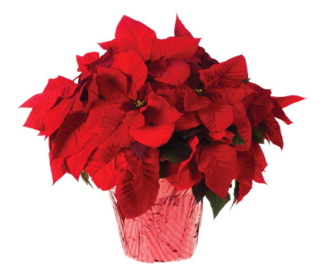 | 7 inch  Double stem  Florist quality  Multi-branch Poinsettia Colors Red or White | $15
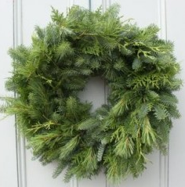 | 24 inch Wreath  Frasier Fir  Soft needle  Excellent Fragrance | $22
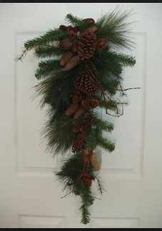 | 18 inch door swag  Pine cone decorated  Mixed greens | $18
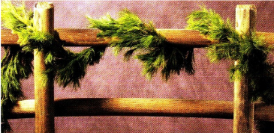 | 30 foot in length  White Pine Roping  Great for indoors or outdoors  Heavy duty, florist quality | $18
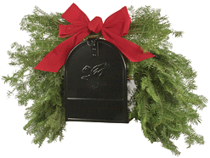 | Mailbox covering with bow  Mixed greens | $37

