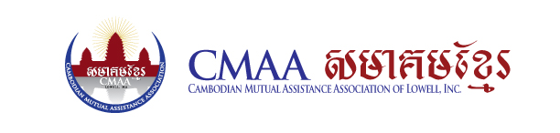

Position: Civic Engagement Coordinator (Full-Time)

Position Overview: Reporting to the Executive Director, the coordinator will manage CMAAs’ non-partisan voter registration, persuasion, GOTV, GOTC, and advocacy work. The ideal candidate has a strong commitment to social, racial, and economic justice movements, is results oriented, enjoys working with a team, and has a demonstrated ability to work with a diverse array of stakeholders.

Responsibilities:
- Coordinate and meet all deliverables for the non-partisan civic engagement efforts
- Manage the development and implementation of civic and voter engagement program, including voter registration, non-partisan voter education, voter turn-out efforts, and field/data tracking
- Manage the development and advocacy on issues affected SEA communities including data equity education and mobilization, SEA deportation, Census, Redistricting, and public charge
- Work closely with CMAA team to communicate and build relationships with partner organizations, including community organizations, environmental groups, faith organizations, and others civic engagement coalitions
- Bottom line responsibility for civic engagement data management
- Support CMAAs’ civic engagement fundraising activities
- Assist in recruiting and supervising interns and volunteers
- Additional duties as assigned

Qualifications:
We are seeking individuals with previous experience working on or managing civic engagement programs, grassroots/political organizing in the social justice movement, or comparable experience, who are passionate, enthusiastic, and energetic. Qualified applicants should be interested in connecting civic engagement to base-building, leadership development, and issue campaigns. The successful candidate will have strong communication skills, understanding of campaign and political strategies, and ability to create a civic engagement framework that yields clear results:

- Demonstrated experience (2+ years preferred) in civic engagement and/or organizing
- Proficiency in VAN (Voter Activation Network) and/or MiniVAN, Microsoft Word, Excel, PowerPoint, and Google Docs
- Excellent verbal and written communications skills
- Ability to present information concisely and effectively, both verbally and in writing
- Belief in and commitment to progressive social, racial, and economic justice
- Ability to work independently with little supervision
- Ability to work with a diverse team of individuals
- Commitment to understand race, class, gender, and other equity issues as part of your work as well as the impact these structural issues have on our own work environment
- Event planning and marketing skills
- Required Language is English and Khmer is preferred
- MA Driver’s License and access to a vehicle (preferred)

Compensation: Salary commensurate with experience.

Starting Date: Immediate

Procedure for Applying: Qualified candidates submit via e-mail a current resume and a cover letter to Sovanna Pouv, Executive Director at spouv@cmaalowell.org. Applications will be reviewed on a rolling basis.

Organization Overview: Founded in 1984, The Cambodian Mutual Assistance Association is dedicated to improving the quality of life for Cambodian Americans and other minorities and economically disadvantaged persons in Lowell through educational, cultural, economic and social programs.

