INFORMATION:
2020 NRC Whale Watching Excursion

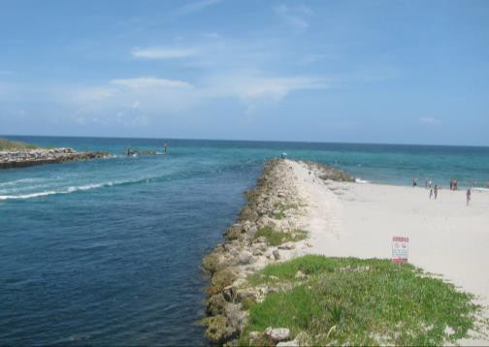
Tuesday, January 7, 2020 | 1:00 PM – 5:00 PM

The 2020 NRC Whale Watching Excursion will be depart from across the street of the Hotel Del Coronado, on Glorietta Bay, January 7th from 1:00pm to 5:00pm. We ask that you arrive no later than 12:40pm, with an expected return at 5:00pm. Each boat can accommodate up to 48 people.
Come aboard one of two 58-foot catamarans for an unforgettable charter adventure. The beautiful, deep blue Pacific Ocean is the perfect venue for the ideal excursion! Gray, Finback, and even Blue Whales can be seen during their southern migration down to Mexico, which hits its peak from November to April. The excursion registration fee also includes food and beverages on the boat.

All sailors must be registered for the 2020 NRC Conference in order to participate in the Whale Watching Excursion.

- REGISTRATION:

Whale Watching Excursion Fees: | On or Before 10/1/2019 | 10/2/2019 - 12/1/2019 | 12/1/2019 and Later
Conference Attendees | $220.00 | $240.00 | $260.00

Name(s) of Sailors* | Email | Company | $ Amount
Primary Contact Phone #: Total:
*Attach additional sheets, if necessary. Excursion space is limited and will be capped at 96 attendees total. No on-site registration will be available. Please register as far in advance as possible. Boats can accommodate up to 48 sailors.

PAYMENT
All payments may be made online at http://www.nrcma.org/2020conference or by completing information below:
Email: Completed forms may also be emailed to Conference@nrcma.org – Please indicate “Whale Watching” in the subject
By mail: Checks may be made payable to: NRC. (This form must be included with all payments by check)
Attn: NRC 80 M St. SE, Washington, DC 20003.
Credit Card Payment: NRC accepts Visa, MasterCard and Amex for credit card payments.
Card Type:

Cardholder’s Name (Please Print): Billing Zip Code: Card Number: - - - Exp. Date CV2 Code: Billing Address (Street, City, and State):
Email Address (for Receipt): Phone #:
For all registration questions please contact Mike McGonagle at 202-965-0365 or by email at mmcgonagle@nrcma.org

