912 Market Street La Crosse, WI 54601-4782 PHONE 608-791-5282
E-MAIL: rnicks@fspa.org
www.fspa.org

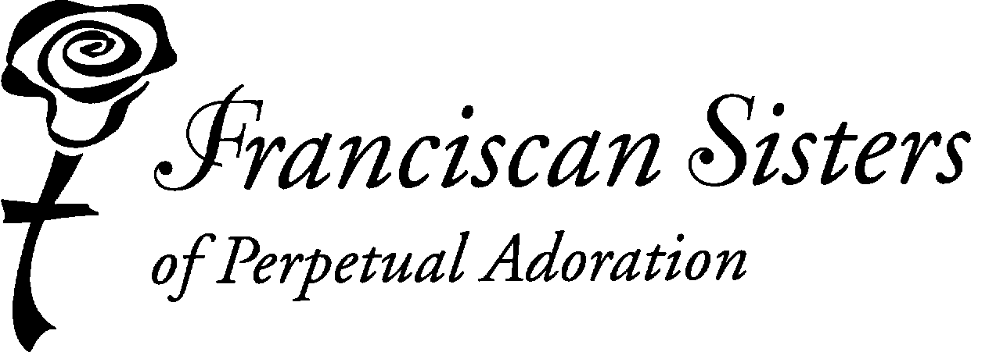

FSPA MINISTRY FUND

MISSION STATEMENT
We are a community of vowed Franciscan women centered in the Eucharist, committed to be loving presence through prayer, witness and service.

DESCRIPTOR
FSPA Ministry Fund is sponsored by the Franciscan Sisters of Perpetual Adoration. Funds are allocated to projects which empower people in ministries that are consistent with our FSPA values and the Mission of the Church.

To be considered for funding, your completed application must be submitted to your sister/affiliate sponsor on or before February 1, 2025.

INPUT LANGUAGE HERE ABOUT FUNDS FOR SALARIES AND OTHER REQUIREMENTS

REQUIREMENTS
- Funding request is initiated by a sister or affiliate
- Project is non-profit
- Project has few resources for funding
- Meets at least 5 of the following criteria
  - Benefits the poor and oppressed with preference given to women, children, eco-sustainability concerns, and immigration issues
  - Is an innovative, creative project that has far-reaching impact to benefit the poor
  - Provides leadership development or spiritual growth for those served
  - Stresses self-help (not a hand out) to those served by the project
  - Involves those served in the planning, implementation and policy-making of the project or organization
  - Supports services to the participants of the project
  - Organization/project has a strategy for self-support beyond the period of Ministry Grant funding

REQUESTS THAT ARE NOT FUNDED

- Salaries
- The same project within an organization after its sixth year of funding. Consideration may be given for projects past six years if there is no reasonable potential to be self supporting and funds are available.
- Requests for educational needs for post secondary education
- Naming a particular building or project for a deceased FSPA
- Funding the general operating funds, a foundation, or an endowment fund of an institution

TIME LINE/PROCEDURE

FALL Information is distributed to sisters and affiliates
Sisters/affiliates give application forms to organizations for completion

FEBRUARY 1 Completed applications are returned to sister/affiliate sponsor

FEBRUARY Applications are reviewed by sister/affiliate and her/his reviewers

MARCH 1 Recommendations of reviewers are submitted to the
FSPA Ministry Fund Committee

MARCH FSPA Ministry Fund Committee recommendations are submitted
to the Leadership Team for approval

APRIL/MAY Notification of FSPA Ministry Fund approvals or denials are sent and
Payment Request Form is sent with the notification of the award

JUNE 15 Payment Request Form is returned to the Coordinator of the FSPA
Ministry Fund

AUGUST Payments may be distributed

Due by Feb 1, 2025
Official Use Only
Date Rec __________
Grant # __________
APPLICATION FY 2025

(July 1, 2025 – June 30, 2026)

- Name, address, and phone number of organization seeking funding

Name of Organization

Name of Project __________________________________________________________

Contact Person ___________________________________________________________

Address:

City State Zip

Telephone: E-mail:

Name of sister/affiliate sponsor

Sister/affiliate involvement ___Employee ___Board Member ____Volunteer ___ Advocate

2. Total budget for the project $

3. Amount requested from the FSPA Ministry Fund $

4. Number of years THIS project has received FSPA funds

5. Number of years the organization has received FSPA funds

6. In 50 words or less state succinctly what is being requested and for whom.

Mission Advancement Office Notes

Page 2
FSPA Ministry Fund Application

COMPLETE ALL PARTS OF THE APPLICATION WHICH ARE APPLICABLE. INDICATE N/A IF NOT APPLICABLE.

6. CRITERIA: Please check and write a brief sentence on how the criteria are met for your project/organization. (At least five must be met.)

Benefits the poor and oppressed with preference given to women, children, eco-sustainability concerns, and immigration issues. State which category your project serves. How are these groups involved in service planning?

Is an innovative, creative project with a far-reaching impact to benefit the poor.
Specifically, how is your project creatively different from other projects in your area?

Provides leadership development and/or spiritual growth for those served. How?

Stresses self-help (a leg up and not a hand out) to those served by the project. How?

How does your organization/project foster collaboration in your area?

Funding supports services rather than administrative costs.

Has a strategy for this project/organization’s sustainability or self-support been adopted? Please state.

Page 3
FSPA Ministry Fund Application

7. State the mission and values of your organization.

8. Briefly describe the population served and the services that would be provided by this
grant request.

9. What does your organization hope to accomplish with a grant from the FSPA? State goals and objectives.

10. What motivates you to participate in this project?

Page 4
FSPA Ministry Fund Application

11. Provide or attach a program budget

12. It is important that you solicit other funds. Please list requests for funds from other sources.

13. Attach a copy of the organization operational budget.

14. Please include a supporting document or brochure with the application.

Signature Date

**Completing an annual evaluation is an expectation of an FSPA Ministry Grant award**

