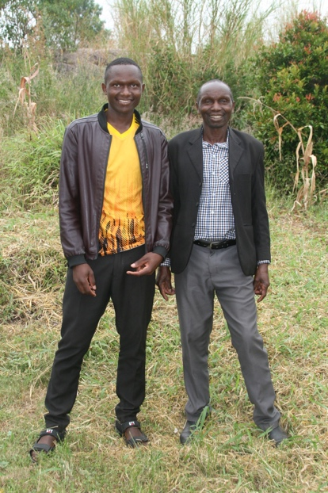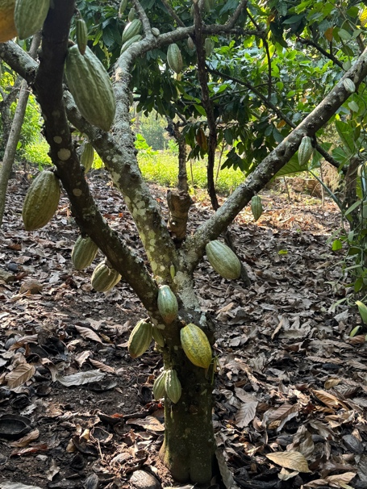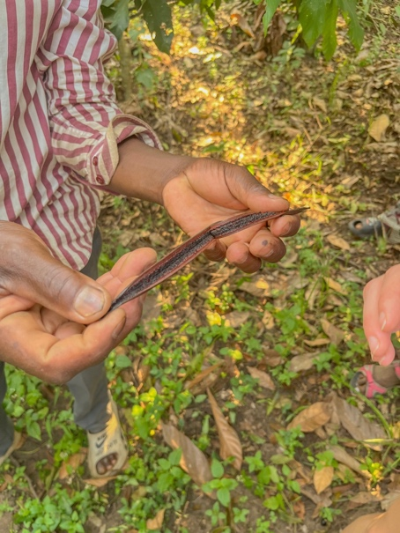

Marianne Bassing, Emarson Dearborn and I had the privilege of visiting Joab's family's cocoa and vanilla garden. (Joab is one of the graduating students headed to nursing school) They are one of only a few farmers who grow these crops. In Joab's words: "We worked hand in hand to raise the cocoa up for a period of 3 years though we were in school but we would wake up at 5:00am to fetch water about 2km distance and my work was to water early morning then after we would run to school. Some times we would reach late and punished but we could not stop to help our dad. We said as children "we shall except any kind of punishment so we have fulfilled dad's idea". In 2018 it had now grown up where it needed little effort except weeding and pruning. It is now a home project from 2018 up to date. This is where we get home income for education and other family needs and wants."
This family works together, appreciates the value of education and the work Reaching Beyond Globally is doing for Joab. His sponsorship allows them to pay school fees for their other children.

