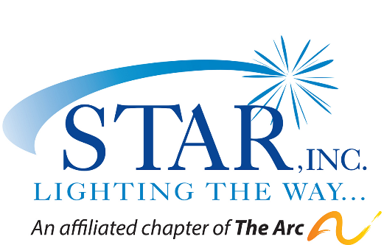

FOR IMMEDIATE RELEASE

For more information:
Peter Saverine
STAR, Inc.
(203) 846-9581, ext.302
psaverine@starct.org

STAR, Inc. Executive Director Passes Torch after 40 Years of Service
New Fairfield Resident to Take the Helm in January

STAR, Inc., Lighting the Way…is excited to announce that MaryGrace Giuliano will become the organization’s Executive Director on January 8, 2024, following a nationwide search to replace retiring Executive Director, Katie Banzhaf. Ms. Banzhaf, who recently passed a forty-year milestone at STAR, announced her plans to retire last spring

Ms. Banzhaf’s tenure saw STAR growing to serve over 700 individuals annually from birth to senior years since its founding in 1952 by parents who believed that children with IDD are entitled to the same basic opportunities as other children. Advancements were seen in early intervention pediatric therapy services, meaningful paid employment opportunities for people with IDD, inclusion in schools and the community, improved accessibility with the ADA, closure of some state institutions, expanded residential and supported housing options, assistive technology and smart homes, senior memory care, aspirations for college and continued learning, and other milestones that positively improve the lives of our neighbors with unique abilities.

Commenting on her 47 years in the human services field and four decades at STAR, Katie said, “It has been an amazing career, and I am incredibly proud of what we have accomplished together. Whatever has been achieved over my time has been the result of a great team effort. I am grateful to the STAR Board of Directors, staff, parents, and the individuals we support who continue to teach me about strength, determination, and the joy of realizing your dreams. They have all played a part in ensuring that my professional life is meaningful and joyful.”

MaryGrace Giuliano has over 30 years’ experience serving children, families, and adults with intellectual and developmental disabilities. She currently serves as the Chief Operating Officer for Institutes for Applied Dynamics in Tarrytown, NY and resides in Connecticut. Previously, she was the Director of Disability Services in the Office of Persons with Developmental Disabilities appointed by the Governor of New York. She has her B.S. in Social Work from Marist College, H.R. Certificate from Villanova University, and M.S. Social Work from Fordham University. After her recent tour of STAR offices, visit to a group home, and meetings with directors, staff, self-advocates and the board of directors, MaryGrace shared, “I am inspired by how deeply the STAR family cares for the individuals, staff, families and each other. I look forward to joining this dedicated team and contributing to STAR’s sustained success in the future.”

Meghan Cioffi, President of STAR Board of Directors said, “The Search Committee has been impressed with MaryGrace throughout the interview process and the entire board agrees that she is an excellent candidate to carry on Katie’s legacy and to lead STAR going forward. We are confident that she has all the competencies and compassion to continue STAR’s successful rise into the future.” Ms. Cioffi acknowledged, “I realize that this announcement probably feels bittersweet, as it also means that Katie’s departure is near. However, it also means that Katie can retire, as she wishes to do, and embark on world travels and new adventures! We look forward to celebrating Katie and all that she has done for STAR”.

STAR, Inc., Lighting the Way is a not–for-profit organization that has grown to include a full array of services for over 700 individuals with disabilities, from birth to their senior years and their families in Fairfield County, CT. STAR’s mission is to create opportunities for individuals to live full lives with independence, freedom of choice and personal growth by providing support, services and advocacy. They inform and encourage the community to recognize and appreciate the value of all individuals. Services include early intervention pediatric therapies; family support services; high school transition, customized employment and ongoing job supports; assistive technology, adult day services, recreation; and residential support to adults in group homes and apartments. For more information about STAR, Inc., Lighting the Way or to explore current job openings, visit www.starincct.org. We are hiring.

# # #
PHOTOS:

Katie Banzhaf, retiring Executive Director of STAR, Inc., Lighting the Way…a non-profit organization serving Fairfield County since 1952.

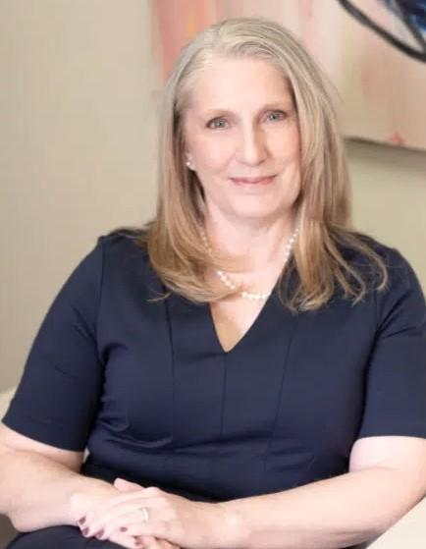
MaryGrace Giuliano, incoming Executive Director of STAR, Inc., Lighting the Way…

Instructions: MaryGrace is one word as shown. Thank you.

