Parish Elections Nominations for 2027 Leadership at St. Andrew’s

Vestry - Class of 2030

Sara McAdory-Kim
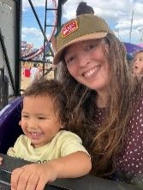
Sara was born in Texas and raised in Mississippi. After living in several other states and countries as an adult, she's settled in Houston, hopefully permanently. She became a part of St. Andrews and the Episcopal church in 2022 shortly after moving to the city, having spent time in other Christian traditions as she moved around. Sara lives with her husband Jaymin and sons Inho (6) and Taeho (3) in the Garden Oaks area. Her paid work is as an editor, mostly managing medical journals. She enjoys hiking, gardening, and traveling and is happy to have more energy to devote to church, school, and community as her kids get a little older.

Robin Page
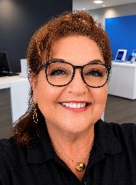
I am a native Houstonian and a lifelong member of the Episcopal Church. I have been a member of St. Andrew’s since 2018. I currently serve on the Altar Guild and I am the lead for the Alms Counting Team. I look forward to serving on the Vestry.

Greg Powell
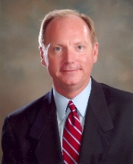
Dr. Gregory Powell retired in 2024 after a 41-year career in higher education in Texas and Georgia as a professor and administrator. He served his last 24 years as President of Panola College in Carthage, Texas. He continues to serve as President Emeritus for Panola College. He and his wife Joann have three daughters and three grandchildren. In Carthage, they attended St. John’s Episcopal Church. Greg served as a reader, Lay Eucharistic Minister, a delegate to the Diocesan Council, and as Senior Warden on the Vestry for many years. Greg, Joann, and Chloe regularly attend the 2:30 pm service at St. Andrews.

Denise Hansen
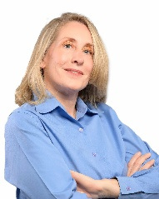
My family and I have lived in Garden Oaks for about 17 years and have been attending St. Andrews church for 8 years. I have a passion for medicine and all things wellness. After earning my undergraduate degree at the University of Houston, I completed my medical training at the Sophie Davis School of Biomedical Education Physician Assistant Program in New York City. I now balance my busy professional life as a small business owner and health care practitioner with my role as mother to one teenager, three dogs and four chickens. Married for 27 years, my husband and I have fostered six children, reflecting our commitment to supporting families in our community.

Finance Committee - 3 year term
Ross Allen

Ross Allen works in Houston’s energy industry as a communications professional. He is a graduate of West Virginia University and is a loyal Mountaineer. Ross began his career as a firefighter and paramedic but soon decided to do something easier and jumped to journalism. That career has taken him for stints in Washington, DC, New York City and London, but Houston is now his home.

Dylan Townsend

Property Committee - 3 year term

Betsy Burns
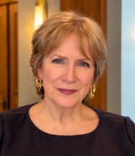
After moving from San Diego to Houston in early January 2025, Rick and I were so pleased to discover an Episcopal church in our neighborhood. We attended a Saturday evening service at St. Andrew’s just a week or two after arriving, and Jimmy’s warm, heartfelt welcome made us feel at home immediately. Since joining St. Andrew’s, I’ve been involved with the Newcomer Team, the Neighborhood Engagement Study Team, and monthly alms counting. While living in San Diego, Rick and I started a monthly social gathering at our church called Second Saturday, a tradition we were happy to bring to St. Andrew’s several months ago.
St. Andrew’s is an important part of my life, and I want to contribute wherever I’m needed. I see serving on the Property Committee as a chance to help care for the place where we gather, worship, and build relationships with one another and our neighbors. I would welcome the opportunity to serve on this committee.

Richard Solis
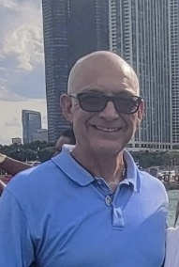
My name is Richard Solis born and raised in San Antonio, Texas, moved to Houston in 2011 with my wife and 2 children now 17 and 23. Retired after 32 years of teaching P.E. Two years into retirement and working on home projects, I decided to get back into teaching part time. I enjoy fishing, watching sports and spending time with family and friends. We joined St Andrews in the Fall of 2019, I look forward to serving in our church community.

Diocesan Council Delegates

Doug Pecore
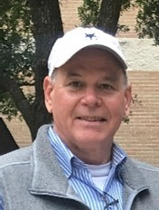
I have been a member of St. Andrews since 2015, attending with my wife, Paige, and our three children. Over the years, I have served on the Vestry, guiding efforts as stewardship chair, finance committee chair, and ultimately as Senior Warden. I am committed to supporting our community and look forward to serving as an alternative delegate to the Diocesan Council if called upon.
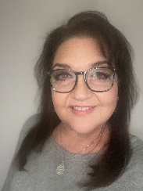
Robin Page
I am a native Houstonian and a life long member of the Episcopal church. I have been a member of St. Andrews since 2018. I currently proudly serve on the Altar Guild, Alms Counting and Hospitality teams. I look forward to serving as a delegate representing St. Andrews at the Diocesan Council.

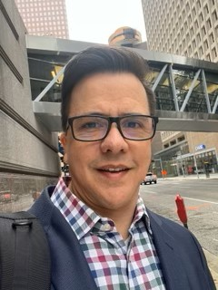
Bryan Robinson
I found my way to the Episcopalian faith 7 years ago because of their practice of accepting/loving all people. Shortly after I became a member of St. Andrews and almost immediately joined the Alter Guild so I could better understand their way. Since then, I have served on the Finance committee (5 years), Finance Chair (2 years) and also Vestry for the past 3 years. St. Andrew's and the Episcopal church are my home by choice and now my daily practice. I look forward to serving the church as a Diocesan Council Alternate. When I am not at church, you can find me participating in Scouting events at an assistant Scout master with Troops 879B/1879G. My workdays/nights are spent managing an accounting platform for a large Oil and Gas company.in Houston.

Kyle Jones
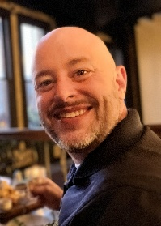
Kyle has been attending St. Andrew's Episcopal Church since 2011. He is proud to have three generations of his family sing at St. Andrew's. He works as an appellate prosecutor with the Montgomery County District Attorney's Office.

Diocesan Council Alternates

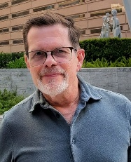
Andrew Bowden
I am truly honored to be nominated as an alternate delegate for the Diocesan Council. I feel passionately about our church family here at St. Andrew’s in the Heights, and I am grateful for the opportunity to represent our congregation. I look forward to participating in annual meetings, sharing our voice to strengthen the life and mission of our church.

Paul Hardwick
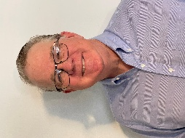
Paul Hardwick has been a member of St. Andrew’s for more than 25 years. During that time, he has served in many areas including vestry, Men of St Andrews, choir, usher and senior warden. He currently serves on the Outreach Committee and is St. Andrew’s representative to Memorial Assistance Ministries (MAM). He is recently retired and enjoys playing music and traveling.

Kay Lynn Jenkins
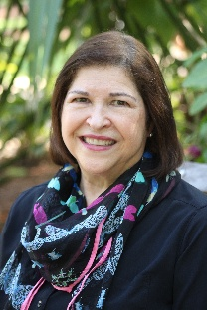
I would be honored to have the opportunity to represent St. Andrew’s as an alternate to Diocesan Council. I am a “cradle Baptist” who found my way to the Episcopal Church through singing in the choir at another Episcopal parish shortly before meeting and marrying Stacy (my husband of 42 years!) in that same choir. Since that time, I have served in many capacities in my church families (vestry member, school board member, stewardship chair, vestry secretary, senior warden, diocesan council delegate, parish retreat coordinator, LEM, lector, LOTS volunteer, and always a choir member!) My commitment to my private psychotherapy practice precludes me from serving in a more time-consuming manner, but I am a self-described “church geek” who truly enjoys being and working with our Diocesan family.

DeAnna Bosch
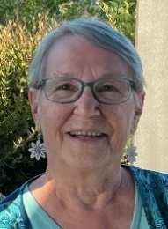
I would be honored be a delegate to Council of the Diocese of Texas and participate in the process that governs our church. Michael and I have been members of St. Andrew’s for 14 years and were confirmed in the Episcopal Church in 2001.I have served as a Council before and have been a member of the Diocesan Executive Board in the past. At St. Andrew’s I am on the Altar Guild, Linen Guild and serve as the Clerk of the Vestry. Networking with other Episcopalians at Council meetings can help foster ideas to help St. Andrew’s grow.

Property Maintenance Fund Trustee

David Rennie
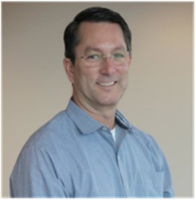
My name is David Rennie. I have been a member of St. Andrew’s since birth, having been baptized by Father Little with my 4 siblings together in the 1960s. My wife, Mary, and I were married by Father Binford in 1988, and we raised our now grown children, Meagan (33) and Andrew (31) at St. Andrew’s. In the past, I have served on Vestry and as Treasurer. I have also served on Property Committee on multiple occasions, and more recently, I was the Project Manager for the recently completed 2022 Capital Campaign. Professionally, I have a Bachelor of Science degree in Mechanical Engineering from Texas A&M University, graduating in 1986. I have spent the bulk of my professional life working 30 years for Shell Oil Company in the refining and the petrochemical space, primarily in industrial asset management, including project management, engineering, turnaround maintenance, and construction. I retired in 2020, and spend my discretionary time volunteering at St. Andrew’s and other places. Mary and I attend the 10:30 service weekly when we are not traveling or otherwise out of town.

Nominating Committee for 2027

Mary Eyuboglu
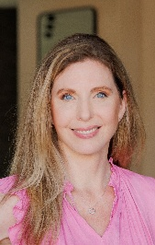
I have been a member of St. Andrew's since 2016 and feel blessed to call it my church home. I have previously served on the vestry, as Senior Warden (2023), the Capital Campaign Fundraising Committee, the Capital Project Committee, the Children and Youth Committee, the Finance Committee, as vestry liaison to the school, Diocesan Council Delegate, organizer for Great Gatherings, and founded Family Fridays and The Ladies of St. Andrew's (with Sarah Itz). I am happily raising my 2 daughters in the church and I work as a Realtor here in the Heights. I am very honored to be nominated to be a non-vestry member of the Nominating Committee for 2027!

Steve Runner

St. Andrew’s Episcopal Church & School
1819 Heights Boulevard
Houston, Texas 77008
saecheights.org | 713-861-5596

Our Mission
We are a caring community of Christ that, by God’s grace,
nurtures faithful relationships and spiritual growth.

Our Core Values
Church Family - An intergenerational congregation that serves
as a spiritual home providing fellowship and support.
Tradition - Practice and value traditional Episcopal/Anglican liturgy
in worship based on regular Holy Communion and prayer.
Inclusive - A loving community of Christ welcoming all.
Outreach - Supports the surrounding community through hands-on volunteerism
which reflects the Christ within and among us.

Clergy & Staff
The Reverend James M.L. Grace, Rector
The Reverend Catie Greene, Associate Rector
The Reverend Jeff Bohanski, Assistant Rector
The Reverend Bob Merrill, Assisting Priest
Carrie Conti, Office Manager
John Kirk, Director of Music & Organist
Taylor Durr, Director of Children and Youth Ministries
Amber Reid, Interim Head of School
Cooper Reid, Facilities Technician
Byron Pineda, Sexton

Lay Leadership
Nancy Simpson, Senior Warden
Mike Sullivan, Junior Warden
Doug Pecore, Treasurer
Steve Runner, Chancellor

