Support A Shared Vision
While You Shop for Groceries!
If you love the work that A Shared Vision does to support families with children who are blind or visually impaired, then support us while you shop for groceries at King Soopers or CityMarket. IT'S THAT EASY!
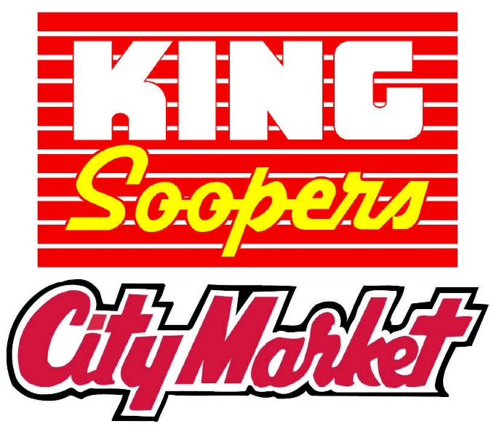
All you need is a King Soopers or CityMarket loyalty card and an online account. See the other side for instructions to create an online account.
To connect your loyalty card with A Shared Vision, visit www.KingSoopers.com or www.CityMarket.com and log in. Select ‘My Account’ from drop down menu. Then select Community Rewards from the left-hand side under ‘Account Summary.’ Click on Community Rewards. Under Find an Organization enter A Shared Vision or NPO number LE640. You may need to select an organization’s description (Education). Then select Search Results.
King Soopers/CityMarket will give A Shared Vision five percent of your total grocery store purchases. If you spend $100 a week on groceries, A Shared Vision earns $260 a year just from your shopping list! Rewards are not earned on purchases of money orders, Western Union products/services, lottery tickets, stamps, Tickets West products/services, gift cards, alcohol or gas.

Instructions
PLEASE NOTE: You must have an Email to proceed
STEP 1: CREATING AN ONLINE DIGITAL ACCOUNT
**NOTE: If you already have an online digital account, skip to #2
Go to www.KingSoopers.com/CommunityRewards or www.CityMarket.com/CommunityRewards
- Select ‘Create an Account’.
- Under Sign-In information, enter your email and create a password.
- (Write down your email & password—will need it in step 2)
- Select ‘Use Card Number’.
- Enter your King Soopers Loyalty Card Number or Alt ID, last name and postal code.
- Under ‘Select Your Preferred Store’ enter your postal code.
- Select ‘Find Stores’.
- Choose your store then select ‘Create Account’.
- You will then be prompted to check your email for a confirmation email.
- Click the hyperlink in your email to finish creating your Online Account.
- Continue to step #2 to register for the King Soopers Community Rewards Program of your choice.
STEP 2: REGISTER FOR KING SOOPERS or City Market
COMMUNITY REWARDS PROGRAM
Go to www.KingSoopers.com/CommunityRewards or www.CityMarket.com/CommunityRewards
- Select ‘Sign-In’.
- Enter your email and password then select ‘sign in’.
- (This will be the email and password you created in step 1)
- Select ‘My Account’ from drop down menu. Then select Community Rewards from the left-hand side under ‘Account Summary’
- Click on Community Rewards.
- Under Find an Organization: Enter the organization name (A Shared Vision) or the NPO number (LE640). You may need to select an organization’s description (Education).
- Then select Search Results.
You should now see your organization information listed under ‘Community Rewards’ on your Account.

