Rainbow Smoothie
A fun and easy sensory experience for the summer

Our Rainbow Smoothie is a healthy snack for you and your child. The smooth texture is appealing to picky eaters. It can be sucked or sipped. You can dab a little on your child’s tray so they can experience it with all their senses. Narrating the process of making the smoothie – from the trip to the grocery store to your kitchen where you assemble and blend the ingredients – gives a child who’s blind or visually impaired access to information about everyday routines.
With each step in this recipe, we provide sensory suggestions for you to try with your child. Enjoy the rainbow of colors, flavors and textures this summer!

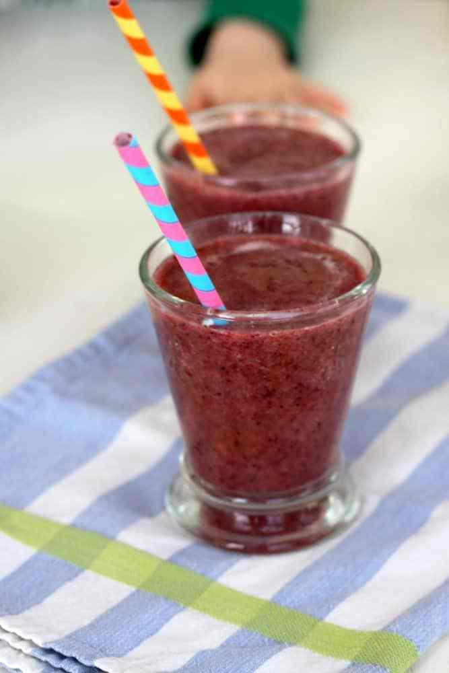

Ingredients (makes 4 medium smoothies or 8 small smoothies)
- ½ cup frozen, diced pineapple
- ½ cup frozen raspberries
- ½ cup fresh baby spinach
- ½ cup fresh shredded carrots
- ½ cup frozen blueberries
- 1 banana
- 1 cup water

 | Recipe | Suggested Sensory Directions
1. | Gather the ingredients, a measuring cup, a spoon or spatula, bowls to assemble the ingredients in, and a blender. | 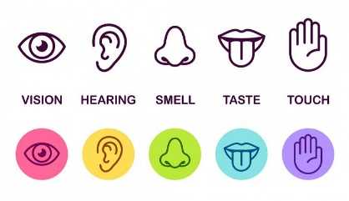Touch your utensils. What do they feel like? Are their textures rough or smooth? Do the bowls feel warm or cold?  What happens when you bang the utensils together or turn the blender on? What sounds do they make?  Talk about your kitchen utensils. Are you using glass or metal bowls? Plastic measuring cups? The blade of your blender is sharp. Compare the different materials.
2. | Start with the frozen ingredients. Put ½ cup each of the pineapple, raspberries and blueberries into individual serving bowls. | Open the freezer and describe what’s inside – is there ice cream? Pizza? Dinner leftovers? Bags of frozen fruit? It’s different than what’s fresh inside the refrigerator.  Take out the fruit from the freezer – brr, the bags are cold! Explain why fruit can be fresh or frozen. When you open each bag of fruit, let your child feel the fruit inside. Is it cold or sticky? What happens to the fruit as it thaws?  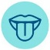After you touch the fruit, lick your fingers or put some fruit on your finger and touch it to your child’s lips. Let a piece of fruit thaw on the counter or on your child’s tray so your child can touch and taste it.
3. | Now take out the fresh ingredients from the refrigerator. Put ½ cup each of the spinach and carrots into individual serving bowls. | Open the refrigerator and describe what’s inside. Where did you find the spinach and carrots in your refrigerator? Where do they grow?  Describe the soft, supple texture of the spinach leaves. All plants and trees have green leaves to help them absorb sunshine and grow. We eat some of these leaves like spinach to help us grow, too.  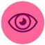What colors are the spinach and carrots? Carrots in a dark bowl are easier to see than in a light-colored bowl because of the visual contrast. The vitamins in carrots are good for your eyes, too!
3. | Pick one banana and peel it. | Talk about why bananas come in a bunch. Count the bananas in your bunch. Even the word “banana” sounds funny when you say it out loud.  Let your child touch the unpeeled banana. The skin feels rubbery.  Peel the banana skin and sniff what’s inside. The banana is sweet.  Cut a slice off the banana and let your child eat it. Touch a little bit to your child’s lips with your fingertips if your child is picky about new textures or flavors.
4. | Assemble the blender and plug the cord into the wall. Add all the ingredients, one at a time, and finish with one cup of water. Put the lid on the blender. | Talk about the purpose of a blender. Why do you plug the cord into the wall?  All the ingredients together make a rainbow of colors! Where else do you find rainbows? Rainbows make us feel happy!
5. | Turn the blender on and blend for about one minute on high until all the ingredients are incorporated. Add more water if the consistency is too thick. | The blender is noisy! If your child is sensitive to loud noises, talk about how the blender is busy making the smoothie smooth. Don’t touch the blender while it’s working!  Where did all the colors go? What color do you see now? When colors are mixed together, they make new colors, like this purplish red.
6. | Serve the smoothie in your child’s favorite cup – with a straw or in a sippy cup. Or pour a little bit on your child’s tray so they can touch it and bring the rainbow to their lips. | The smoothie is cold! If your child is sensitive to temperature, let the smoothie come to room temperature.  Can you taste the rainbow? It probably tastes like fresh berries!

