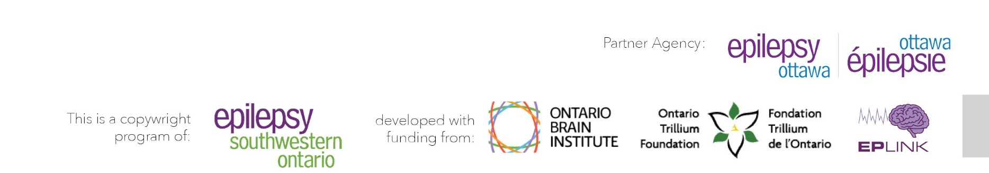

Coordinated Care for People with Epilepsy
clinictocommunity.ca

Referral Form
Please fill out and return to Epilepsy Ottawa E-mail: c2c@epilepsyottawa.ca
Phone (613-594-9255) Fax (613-594-5189)

Referral Date: Name: Date of Birth: Address: City: Postal Code: E-mail: Phone: Seizure Type(s):

Reason For Referral (check all that apply):

☐ New Diagnosis / Coping Strategies ☐ School/ Workplace Support

☐ Seizure Education / First Aid Training ☐ Volunteering / Social Programs
☐ Parent and Family Support ☐ UPLIFT (Depression/Anxiety)
☐ Other

Referral Made By:
Phone: Fax:

Consent to Contact (client / guardian signature):

☐ Consent provided verbally

