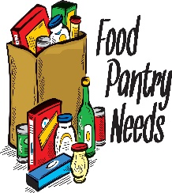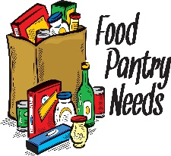
This Photo by Unknown Author is licensed under CC BY-SA
This Photo by Unknown Author is licensed under CC BY-SA
FOOD DRIVE AUGUST 17th
10:00-4:00

FOOD PANTRY NEEDS for PACE@Home
Dry beans (any kind)
Rice, grits or other dry grains
Noodles
Low-Fat Bisquick to make bread items
Dry powdered milk, shelf-stable boxed almond milk (unflavored)
Canned/foil packed chicken or tuna
Crackers
Low sodium broths
Low sodium canned vegetables
Low sodium canned soups with meat (chicken or beef)
Low sugar/juice packed, canned or cups of low-citrus fruits
Peanut butter
Instant Oatmeal
Cereal/Granola Bars

_______________________________________________________
1915 Fairgrove Church Road SE
Newton NC 28658

