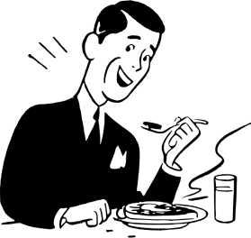
Eating Well As You Get Older

Enjoy Your Meals
Meals are an important part of our lives. They give us nourishment and a chance to spend time with friends, family members, and others. If physical problems keep you from eating well or enjoying meals, talk with a health care professional. If you need help shopping or preparing meals or want to find ways to share meals with others, look for services in your community such as Elder Services of Cape Cod and the Islands (508)-394-4630.

Why Not Eating Can Be Harmful
If you don't feel like eating because of problems with chewing, digestion, or gas, talk with your doctor. Avoiding some foods could mean you miss out on needed vitamins, minerals, fiber, or protein. Not eating enough could mean that you don't consume enough nutrients and calories.

Problems with Taste or Smell?
One reason people lose interest in eating is that their senses of taste and smell change with age. Foods you once enjoyed might seem to have less flavor when you get older. Some medicines can change your sense of taste or make you feel less hungry. Talk with your doctor if you have no appetite, or if you find that food tastes bad or has no flavor.

If you don’t feel like eating because food no longer tastes good, you can enhance the flavor of food by cooking meals in new ways or adding different herbs and spices.

Problems Chewing?
If you have trouble chewing, you might have a problem with your teeth or gums. If you wear dentures, not being able to chew well could also mean that your dentures need to be adjusted. Talk with your doctor or dentist if you're finding it hard to chew food.

Chewing problems can sometimes be resolved by eating softer foods. For instance, you could replace raw vegetables and fresh fruits with cooked vegetables or juices. Also choose foods like applesauce and canned peaches or other fruits.

Meat can also be hard to chew. Instead, try eating ground or shredded meat, eggs, or dairy products like fat-free or low-fat milk, cheese, and yogurt. You could also replace meat with soft foods like cooked beans and peas, eggs, tofu, tuna fish, etc.

Problems with Digestion?

If you experience a lot of digestive problems, such as gas or bloating, try to avoid foods that cause gas or other digestive problems. Talk with your doctor if you have stomach problems that don't go away or if you seem to be losing weight without trying.

