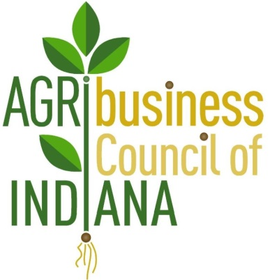
AGRIBUSINESS COUNCIL OF INDIANA NEWSLETTER
Promoting Agribusiness Policy in Indiana
September 22, 2017

NGFA, OSHA create work safety alliance

Source: World- Grain.com

WASHINGTON, D.C., U.S. – The U.S. Occupational Safety and Health Administration (OSHA) formed an alliance with the National Grain and Feed Association (NGFA) with the goal of protecting the safety and health of workers in the grain handling industry. The two-year alliance will focus on preventing exposure to hazards associated with grain bin entry, machine guarding, respiratory protection, falls, heat exposure exposures, combustible dust, struck-by equipment, and lockout/tag-out.
Alliance participants will share recommended practices or effective approaches for recognizing and preventing grain handling hazards with OSHA staff, and industry safety and health professionals. Participants also plan to support and promote events such as the Grain Industry Stand-Up, which focuses on engulfment prevention.
“Grain handling operations pose numerous hazards that can cause serious, sometimes fatal injuries,” said Loren Sweatt, deputy assistant secretary of labor for OSHA. “We look forward to working with NGFA to find ways to reduce exposures to hazards and promote workplace safety and health.”
One threat that impacts the grain industry are grain dust explosions. A total of five grain dust explosions occurred in the United States in 2016 — a 10-year low — according to an annual report issued by Purdue University’s Department of Agricultural and Biological Engineering.
Although the total number of explosions was lower than in recent history, two of the incidents resulted in the first reported fatalities since 2013. According to the report, the five grain dust explosions in 2016 compared with eight in 2015, seven in 2014 and a 10-year average of 9.2 per year.
Through its Alliance Program, OSHA works with unions, consulates, trade and professional organizations, faith- and community-based organizations, businesses, and educational institutions to prevent workplace fatalities, injuries, and illnesses. The purpose of each alliance is to develop compliance assistance tools and resources to educate workers and employers about their rights and responsibilities.
Founded in 1896, the NGFA is a non-profit trade association that represents and provides services for grain, feed, and related commercial businesses. The association has more than 1,000 member companies, which handle more than 70% of all U.S. grains and oilseeds used in domestic and export markets. Its activities focus on enhancing the growth and economic performance of U.S. agriculture.
Under the Occupational Safety and Health Act of 1970, employers are responsible for providing safe and healthful workplaces for their employees. OSHA’s role is to ensure these conditions for America’s working men and women by setting and enforcing standards, and providing training, education and assistance.
Are you Ready, Large and Small Businesses?
Both large and small businesses need to be ready for the next compliance date for the Food Safety Modernization Act's animal food rule, which arrives next Monday, Sept 18. On this date, small businesses (those with fewer than 500 employees) will need to be in compliance with the "Current Good Manufacturing Practice, Hazard Analysis and Risk-based Preventive Controls for Food for Animals" subpart B (the current good manufacturing practices) and related requirements. Businesses with more than 500 employees across the entire business ("large businesses") will need to be in compliance with nearly every other part of the regulation, including subpart C on hazard analysis and risk-based preventive controls, including completion of each facility's animal food safety plan.

Even though the Food and Drug Administration recently indicated that inspections for the hazard analysis and risk-based preventive controls will not start until sometime in the fall of 2018, firms must still be in compliance by Sept. 18. While this announcement on delayed inspections seemed like a "win" for industry, in reality, this small victory really amounted to little relief as firms must still have an animal food safety plan written and in operation by next week. The delay in inspections does allow a firm to "test" the animal food safety plan and hazard analysis and make any necessary adjustments once the FDA releases additional guidance documents next year. AFIA's outside legal counsel--Olsson, Frank and Weeda--wrote a legal memo on the subject that can be viewed here.

Small businesses must be in compliance with the CGMP requirements on Monday, Sept. 18, and we anticipate that inspections at these facilities will likely start in October when the new fiscal year begins. FDA has a goal of conducting 500 inspections in the fiscal year for large- and small-sized animal food firms. Please review the Sept. 14, 2016, FSMA Update to see other reminders to ensure your facility is in compliance.

Indiana Department of Labor Agriculture Worker Safety & Health Webinar
The Indiana Department of Labor works to collaborate with industry stakeholders on educating employees about work-related safety and health. Please click here to review the webinar and presentation and use it as a resource in your workplace.

