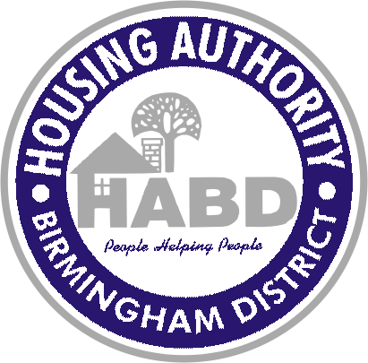
FOR IMMEDIATE RELEASE:
June 9, 2021
Contact: Sherea Harris-Turner
Director of Communications
Office: 205-521-0646
Cell: 205-296-5891
sharris-turner@habd.net

HABD’s proposal submission process has closed in its search for development teams
14 developers show interest in redevelopment of HABD communities

(Birmingham, AL) – The Housing Authority of the Birmingham District (HABD) has closed the Request for Qualifications (RFQ) phase in the search for qualified developer teams to redevelop existing aging HABD communities and offer new development opportunities.

We are pleased to have received responses from 14 local and national Affordable Housing Developers interested in partnering with HABD in this challenging endeavor to preserve and redevelop affordable housing for the citizens of Birmingham.

In partnership with HABD, the selected development teams will be responsible for design, financing, construction and implementation of one or more comprehensive development projects in the City of Birmingham. Below are the HABD legacy properties that will be priority projects for the development teams to either redevelop or identify a new or existing community as replacement units:

Tom Brown Village
Marks Village
Reverend Dr. Morrell Todd Homes
Collegeville Center
North Birmingham Homes
Smithfield Court
Elyton Village

“We are now one step closer to moving forward with our goal of addressing affordable housing needs for our clients and the citizens in the city of Birmingham,” said David A. Northern Sr., HABD’s President/CEO. “This is the first step in our aggressive campaign to reposition our portfolio in order to revitalize our aging public housing communities and provide additional, quality affordable housing options because we realize there’s a great need for a number of families. We are encouraged by the number of developers who submitted an RFQ and who share in our desire to change the face and character of traditional public housing in our city. This is an exciting time for HABD and the city of Birmingham.”

HABD’s repositioning strategy is designed to address the backlog of millions of dollars of capital needs of the public housing portfolio. With the ever-decreasing federal funding, housing authorities across the country are repositioning and converting public housing to a project-based voucher platform to allow access to private capital to meet the capital needs of the properties.

The next step in the search process is anticipated to begin on June 14th when HABD’s evaluation committee will review each proposal based on their qualifications. The evaluation committee consists of HABD staff members and the evaluation will be based on the criteria and factors specified in the RFQ. The anticipated completion of the evaluation process is June 30th. Once the developer teams are selected by the evaluation committee, HABD’s Board of Commissioners will then vote to approve the award of contracts. The anticipated notification of award of contracts is July 19th. We will provide additional updates throughout the evaluation and selection processes.

# # #
HABD provides affordable housing opportunities to 23,000 plus people in the Birmingham area

.

