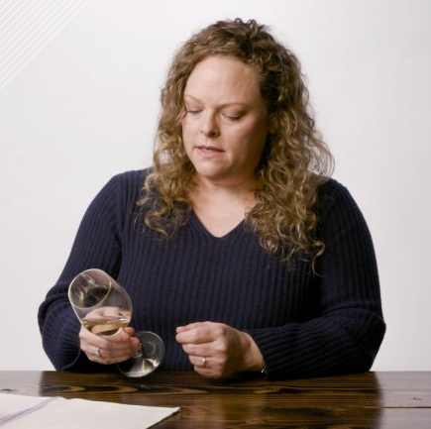
Mollie Battenhouse MW
Mollie Battenhouse is the National Director of Wine Education for Jackson Family Wines. She is a Master of Wine and an Advanced Sommelier with the Court of Master Sommeliers.
She has been an educator for the past 18 years and loves teaching others about wine as much as she enjoys learning about it herself. Whatever the subject may be, winemaking & viticulture, business of wine, Oregon, or Food & Wine Pairing, Mollie brings her expertise and passion for wine to every subject. At Jackson Family Wines, Mollie educates JFW sales teams as well as distributor sales teams up and down the east coast. There’s nothing Mollie doesn’t love about a great day of selling and educating, followed preferably by a crisp, fresh glass of white or some bubbles.
Mollie is from Atlanta, but has been a New York resident since 2005, when she left the South to attend the Culinary Institute of America in Hyde Park, NY. From there, she never left, but graduated from the CIA at the top of the class and headed to New York City first to cook and then to dive into the wine business. Outside of wine, Mollie loves to garden, cook, swim and do Pilates. She is also an instructor for the WSET and is a Partner at Wine Ring|RingIT, a BTB technology company that specializes in personalized consumer experiences in wine.

