January | 2020
Sunday | Monday | Tuesday | Wednesday | Thursday | Friday | Saturday
 |  |  | 1 | 2 | 3 | 4
 |  |  | No School  Vacation | Classes Resume  3/A | 4/B
5 | 6 | 7 | 8 | 9 | 10 | 11
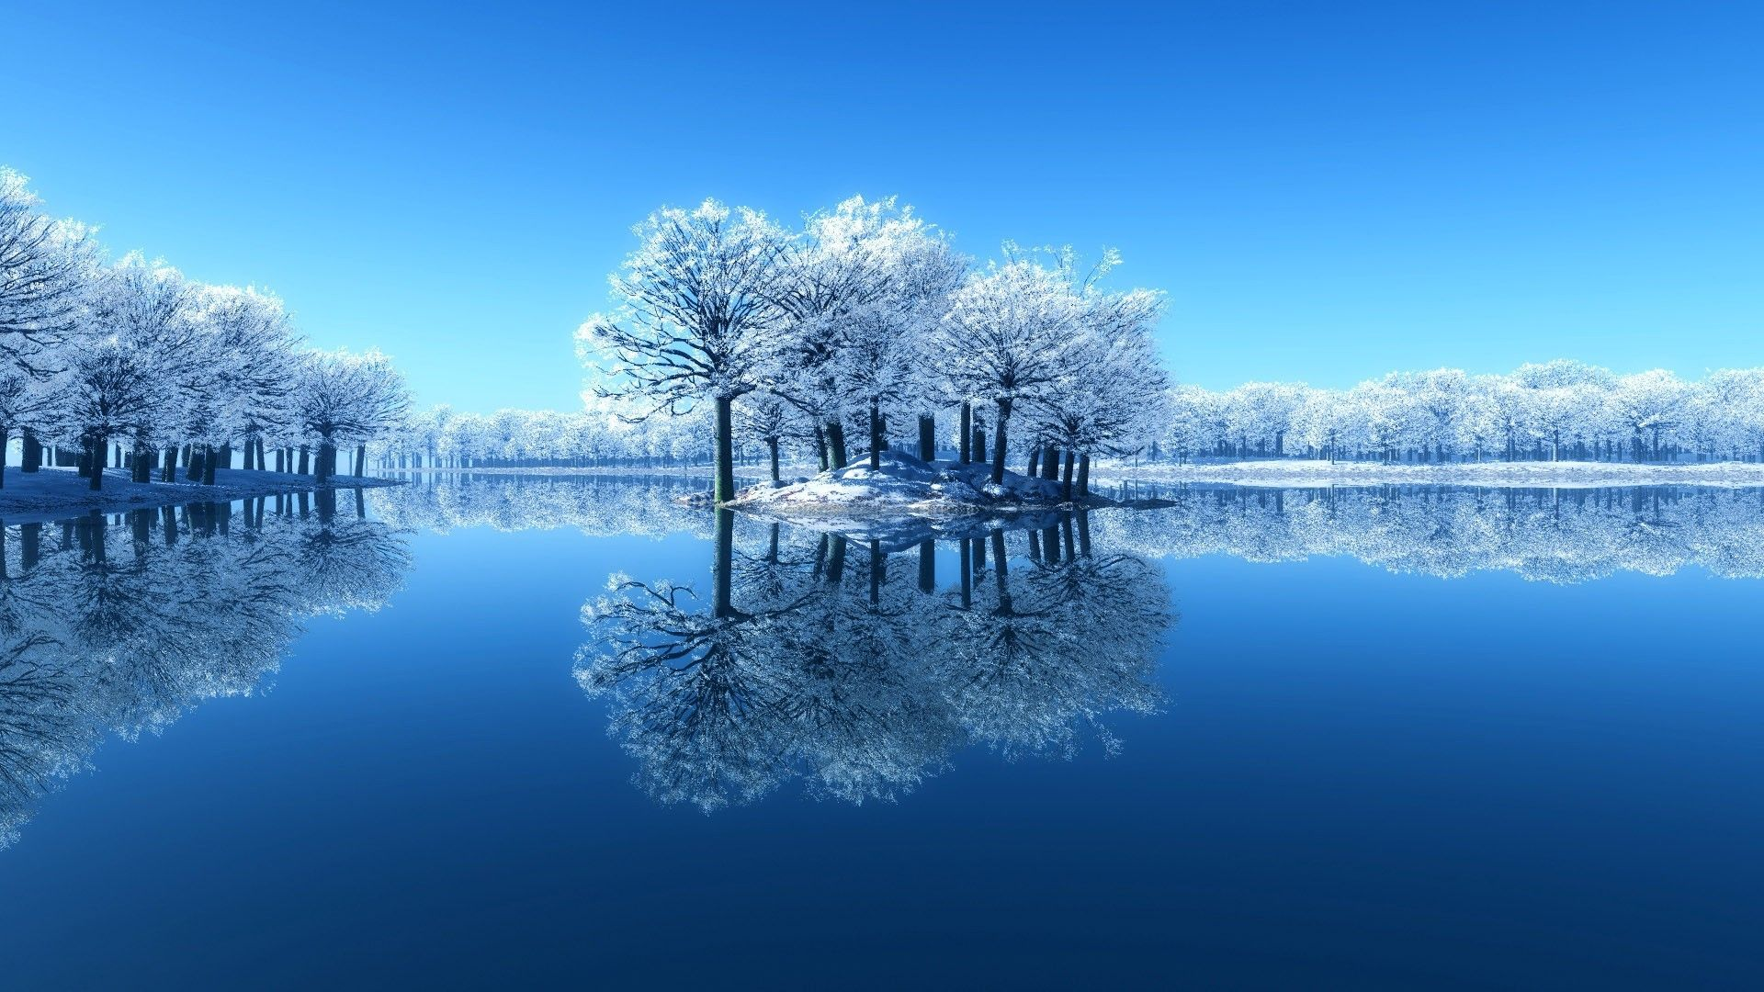 | 5/A | 5th Strings 7:00  1/B | Jazz Band 7:15-7:50  2/A | 3/B | Dress Up: Packers Day  Ski/Snowboard Club to Cascade Mountain 3:30-10:15  Jazz Band 7:15-7:50 4/A
12 | 13 | 14 | 15 | 16 | 17 | 18
 | Drama Club Character Placement 3:45-5:15  Freshman Orientation Night 6:00  5/B | GDS Spelling Bee 8:30 AM in Library  Glass Fusing Class 3:30-4:30  1/A | GSA 3:30 4:30  Jazz Band 7:15-7:50  2/B | Drama Club Character Placement 3:45-5:15  3/A | Dress Up: Tie Dye Day  Jazz Band 7:15-7:50  4/B | 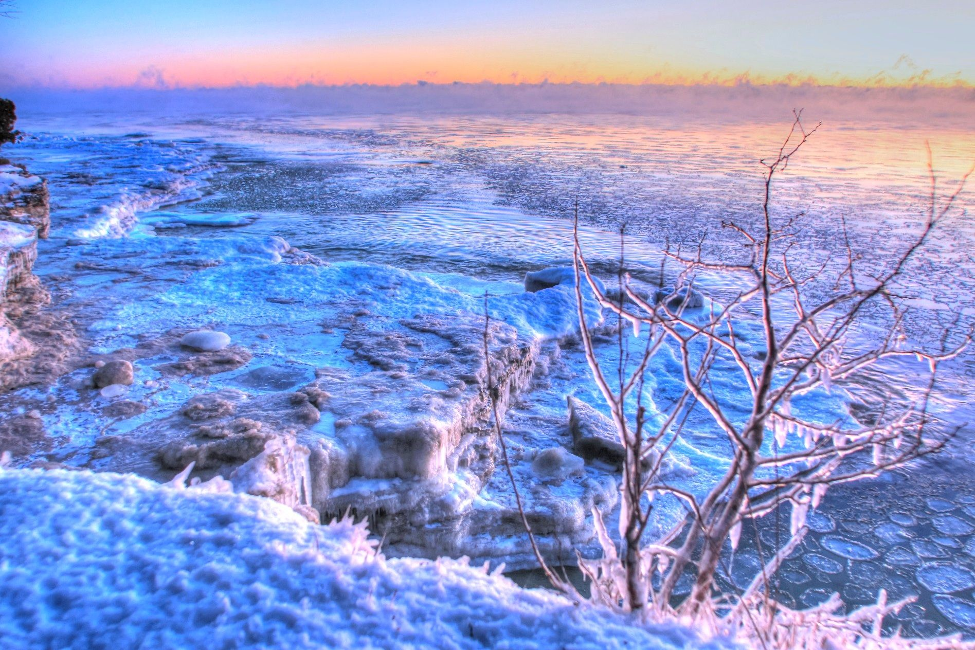
19 | 20 | 21 | 22 | 23 | 24 | 25
 | No School  Vacation  Ski/Snowboard Trip to Cascade Mountain 8:00-5:30 | Glass Fusing Class 3:30-4:30  Girls BB vs. Beaver Dam 4:15  5/A | Jazz Band 7:15-7:50  1/B | 2nd Quarter Assembly  Girls BB @ Patrick View 4:15  2/A | End Quarter 2  Inservice
26 | 27 | 28 | 29 | 30 | 31
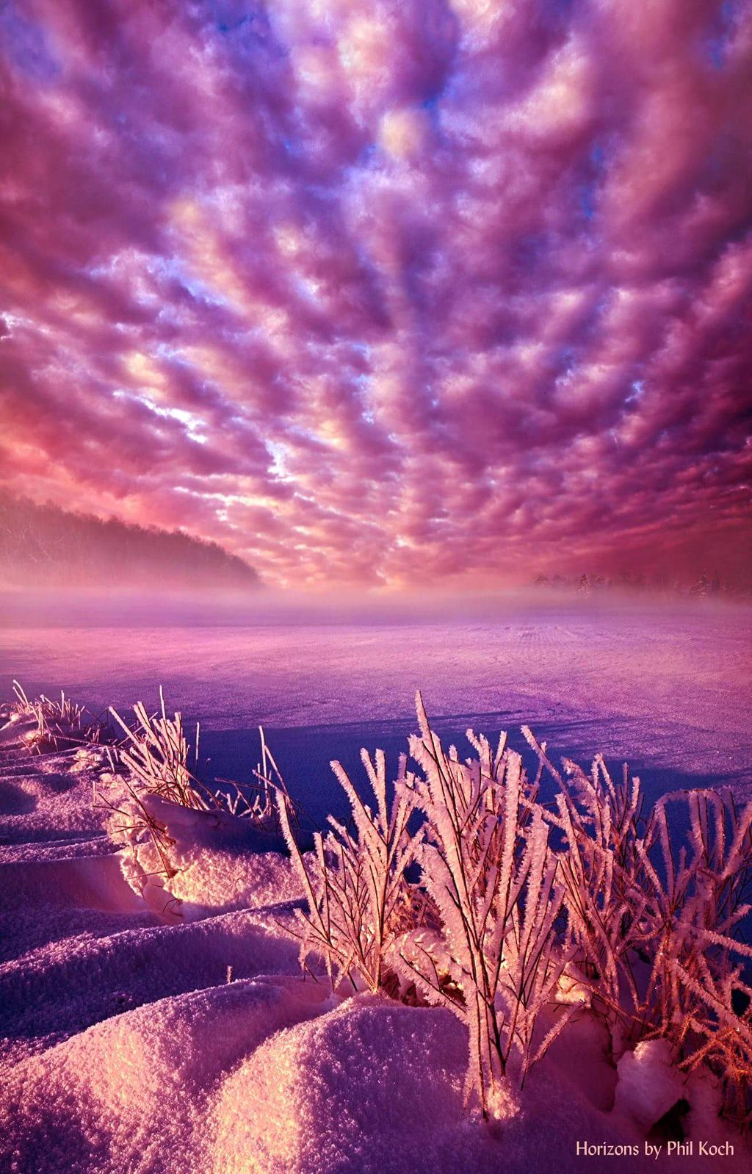 | Girls BB vs. Patrick Marsh 4:15  3/B | GDS Geography Bee 8:30 AM in Library  Student Council Meeting 3:30-4:30 in IMC  Glass Fusing Class 3:30-4:30 4/A | Jazz Band 7:15-7:50  5/B | Drama Club 3:40-5:00  Girls BB vs. Deforest 4:15  1/A | Dress Up:  Winter Blue Day  Ski/Snowboard Club to Devil’s Head 3:30-10:30  Jazz Band 7:15-7:50  2/B | 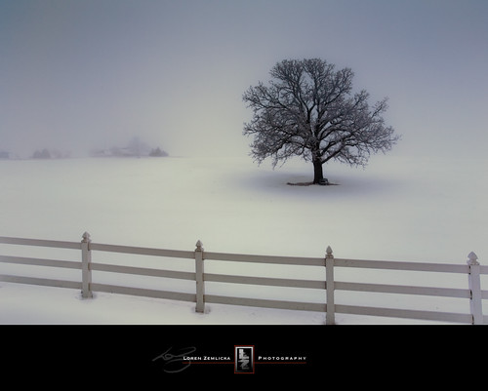
Theme | Responsibility | Focus | Hands to Self

