Healthy Recipes for Busy People
Scleroderma Society of Ontario

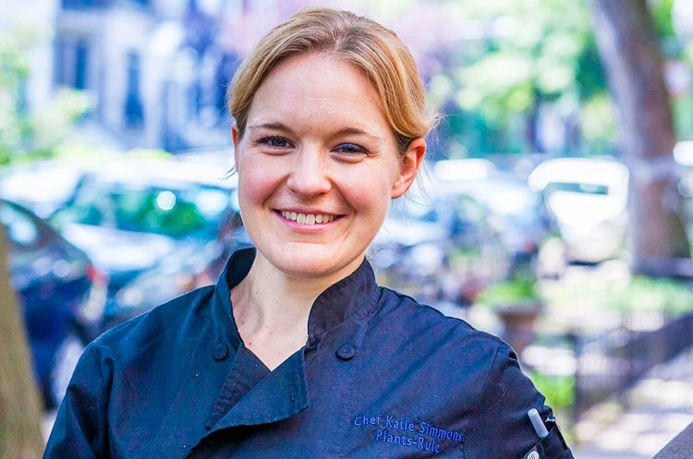

Chef Katie Simmons
www.chefkatiesimmons.com
www.plants-rule.com
Instagram: @chefkatiesimmons

Weekend Prep

Breakfasts
- Cook a pot of oatmeal, breakfast grains, or make overnight oats
- Have fresh fruit ready to eat (wash berries, peel oranges, cut a pineapple or melon)

Lunch
- Make a hearty soup
  - Mushroom Barley Soup or Loaded Cauliflower Soup
  - Minestrone Soup or Kale and White Bean Stew
  - Hearty Chili with beans, ground meat, lentils, or sweet potatoes
  - Chicken Vegetable Soup or Lentil Soup
- Prep ingredients for a salad
  - Wash lettuce, cut veggies
  - Cook chicken, salmon, shrimp, sweet potatoes, or quinoa
  - Make a salad dressing

Dinner
- Roast Veggies and/or Meats for the week (like sweet potatoes)
- Cook a grain (farro, quinoa, rice)
- Keep staples on-hand for quick meals:
  - Frozen veggies and frozen grains (brown rice, quinoa)
  - Dried pasta and canned tomatoes
  - Pre-cut salad and stir-fry veggies
  - Red and gold potatoes or sweet potatoes (you can cook in the microwave)

Snacks
- Buy: Rice Cakes with Hummus, Guacamole, or Avocado
- Buy: Roasted Chickpeas, Steamed Edamame with salt, Air-Popped Popcorn (limit the amount of oil/cheese)
- Avoid: Chips, Crackers, Ice Cream, Fattening Cheese Dips

Eat as Much as You Want Foods:
- Fruits: Watermelon, Pineapple, Mango, Apples, Oranges, Peaches, Berries, Bananas
- Vegetables: Broccoli, Cauliflower, Carrots, Asparagus, Mushrooms, Spinach, Baby Greens, Cucumber, Tomato
- Complex Carbs (no oil or butter): Sweet potatoes, red potatoes, Russet potatoes, yams, corn, beans (all varieties), peas, lentils

Weekly Goal:
- Eat at least 2 cans (3 cups) beans or whole grains a week
- Eat something green every day
- Eat at least 3 fruits AND 3 vegetables/day

Recipes

Quick Dinner: Cauliflower Fried "Rice"
Healthy, Gluten-Free, Vegan

Shredded cauliflower replaces rice in this faked-out Asian dinner recipe. This healthy, grain-free, vegan dish is a great base for adding any stir-fried veggies, edamame, or baked tofu.

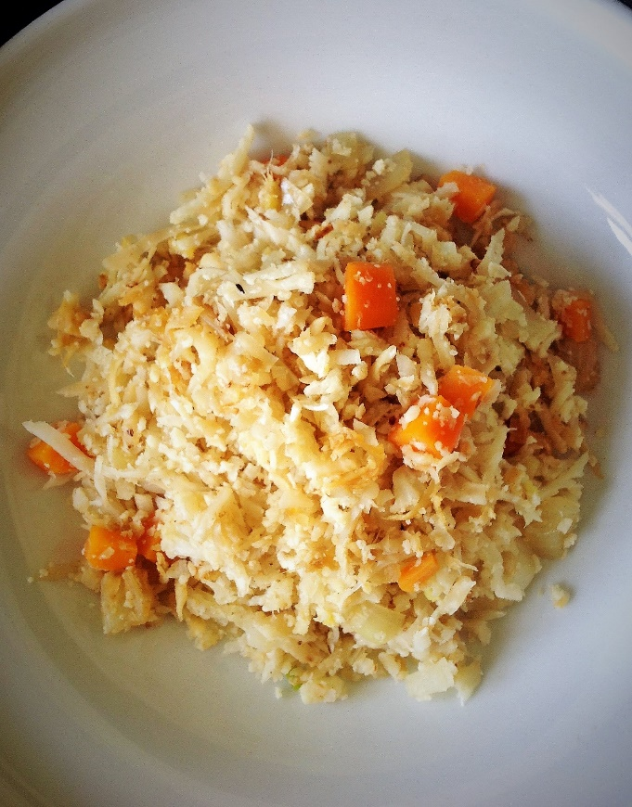
Servings: 4 Ready In: 20 minutes

Ingredients
2 medium carrots, diced
1 medium onion, diced
2 teaspoons fresh ginger, minced
2 teaspoons minced garlic
1/2 teaspoon red chili flake (optional)
1 tablespoons miso paste
1 bag frozen Cauliflower “Rice”
1 cup frozen green peas
1 tablespoon soy sauce or tamari
Optional Add-ins: Cooked shrimp, chicken, steak, edamame, or tofu

How to do it:
Heat a large non-stick pan or wok over medium high heat. No oil needed as long as you stay close to your pan and stir often.
Place the onions, and carrots into the pan and sauté 5-7 minutes.
When starting to brown around the edges, add the ginger, garlic, and red chili flake. Sauté 1-2 more minutes, until aromatic.

Add the miso past and the Cauliflower "Rice". Sauté 2-3 minutes, until brown around the edges.

Add the tamari (or soy sauce) and frozen peas. Sauté until the peas are hot, 1-2 minutes. Taste and adjust seasoning.

Serve immediately.

Tips: Use any of your favorite veggies in this stir-fry. Bell peppers, spinach, onion, and pea pods are all great mix-in. Top with edamame, tofu, or frozen peas for extra protein. This is a perfect end-of-week meal to clean out your fridge.

Meal Prep: Southwestern Stuffed Sweet Potatoes
Healthy, Gluten-Free, Vegan
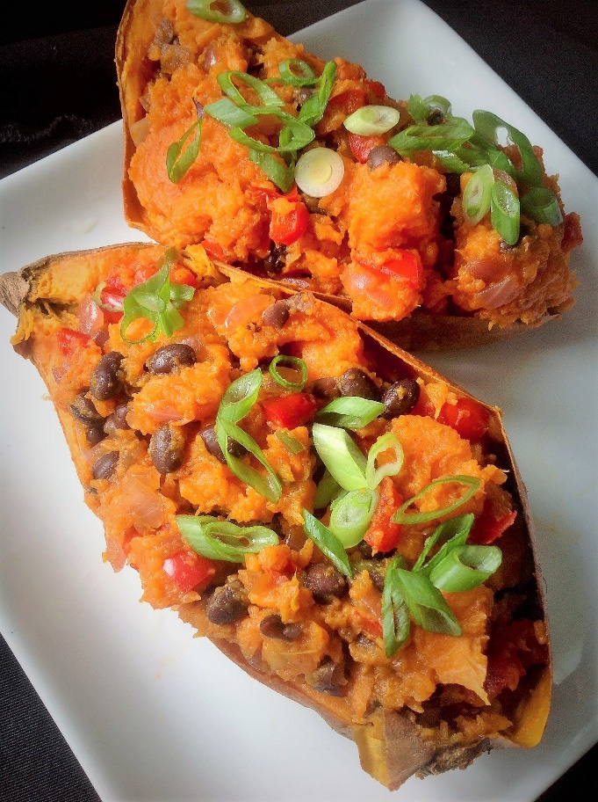
These satisfying sweet potatoes are full of southwestern flavor. Hearty pinto beans come together with green chilis for a hearty stuffing. The spicy flavor plays well with the natural sweetness from the sweet potatoes. You’ll be craving this recipe when you want a smoky, spicy kick!
Servings: 4 potatoes
Prep Time: 15 minutes
Cooking Time: 1 hour

Ingredients
4 medium sweet potatoes, scrubbed but not peeled
2 (15-ounce) cans black beans, drained and rinsed
1 (4-ounce) can mild green chilies
2 teaspoons chili powder
4 plum tomatoes, diced
Salt and pepper, to taste
Sliced scallion, for garnish

How to do it:
Preheat your oven to 375F. Place the potatoes on a baking sheet. Roast until a knife can easily be inserted and removed, about 50-60 minutes.

Meanwhile, prepare the southwest stuffing. In a small pan, combine the beans, green chilies, and chili powder. Gently cook over medium heat until aromatic, about 8-10 minutes. Transfer to a medium bowl and set aside.
When the sweet potatoes are done roasting, remove from the oven and set aside to cool. When cool enough to handle, cut the sweet potatoes in half. Use a spoon to scoop out the roasted potato flesh. Place the sweet potato flesh into the bowl with the bean and green chilies. Add the tomatoes. Stir everything until combined, and season with salt and pepper. Scoop the filling back into the sweet potatoes. Garnish with scallions.
Enjoy immediately or store for later.

Chef’s Tips
•Heat Level: Adjust the spicy heat of this dish by adjusting the types of canned green chilies you buy. Choose mild for less heat. Opt for hot for spicier flavor.
• Microwave Sweet Potatoes: For a quicker way to cook the sweet potatoes, use your microwave. Place the sweet potatoes on a microwave-safe plate. Cook using the “potato” setting for 4 potatoes. Or, if you don’t have a potato setting, cook in 90 second increments, rotating the potatoes every 90 seconds. The potatoes will be done in about 12 minutes, or until a knife can easily be inserted and removed.

Freezer-Friendly
To freeze, wrap in aluminum foil or an air-tight container for up to 2 months. When ready to eat, thaw in the fridge overnight. Then, transfer to a baking pan and bake at 375F for 15 minutes, until warm in the center.

Dessert: Unbelievable Chocolate Avocado Pudding
Healthy, Gluten-Free, Vegan
This Vegan Chocolate Avocado Pudding is unbelievable! It’s made with whole foods, plant-based ingredients like dates and avocado. A satisfying, simple dessert.
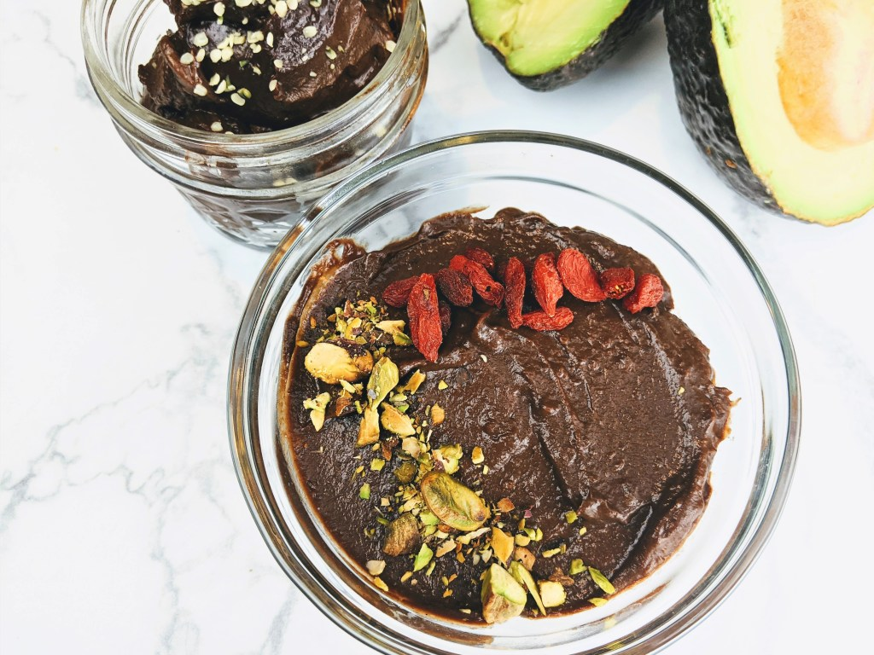
Servings 6

Ingredients
½ cup (100g) pitted dates, soaked in ½ cup warm water
2 large ripe avocados, pitted
1 teaspoon vanilla extract
Dash of salt
¼ cup (24g) unsweetened cocoa powder
Fresh berries, pistachios, or other garnish

How to do it:
Soak the dates in ½ cup warm water for at least 10 minutes, until soft.

In a food processor or high-speed blender, add the dates, their soaking liquid, the pitted avocados, vanilla, and salt. Puree until smooth, scraping down the sides of the bowl a few times. Try to get this as smooth as possible so puree until the dates seem to be completely blended with the avocado.

Add the cocoa powder. Puree to combine. Scrape down the sides of the bowl and puree again until you no longer see any green.

Serve with fresh fruit, berries, pistachios, or other colorful toppings.

Storage
Tightly cover in plastic wrap and store in the refrigerator for up to 5 days. Freeze for longer.

https://plants-rule.com/unbelievably-delicious-vegan-chocolate-avocado-pudding/

Shopping List

Produce
2 medium carrots
1 medium onion
2 teaspoons fresh ginger
2 cloves garlic
4 medium sweet potatoes
4 plum tomatoes
2 large ripe avocados
Fresh berries (for pudding)

Canned Beans, Lentils, Sauces, and Condiments
2 (15-ounce) cans black beans
1 (4-ounce) can mild green chilies
1 tablespoons miso paste
1 tablespoon soy sauce or tamari

Spices and Baking
2 teaspoons chili powder
1/2 teaspoon red chili flake (optional)
1 teaspoon vanilla extract
¼ cup (24g) unsweetened cocoa powder

Dried Nuts, Dried Fruits, and Nut Butter
½ cup (100g) pitted dates

Frozen Items
1 bag frozen Cauliflower “Rice”
1 cup frozen green peas

Snack Ideas
- Rice Cakes with Hummus, Salsa, Guacamole, or Avocado
- Celery Sticks with Almond Butter
- Carrot Chips with Baba Ghanouj
- Roasted Chickpeas, Steamed Edamame with salt, Air-Popped Popcorn (limit the amount of oil/cheese)
- Banana Nice Cream, Frozen Grapes

Eat as Much as You Want Foods:
- Fruits: Watermelon, Pineapple, Mango, Apples, Oranges, Peaches, Berries, Bananas
- Vegetables: Broccoli, Cauliflower, Carrots, Asparagus, Mushrooms, Spinach, Baby Greens, Cucumber, Tomato
- Complex Carbs (no oil or butter): Sweet potatoes, red potatoes, Russet potatoes, yams, corn, beans (all varieties), peas, lentils

