Parish Nurse’s Notes May 2023

Arthritis

Overview

**Osteoarthritis vs. rheumatoid arthritis**

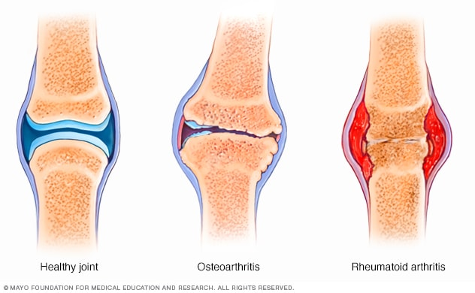

Arthritis is the swelling and tenderness of one or more joints. The main symptoms of arthritis are joint pain and stiffness, which typically worsen with age. The most common types of arthritis are osteoarthritis and rheumatoid arthritis.

Osteoarthritis causes cartilage — the hard, slippery tissue that covers the ends of bones where they form a joint — to break down. Rheumatoid arthritis is a disease in which the immune system attacks the joints, beginning with the lining of joints.

Uric acid crystals, which form when there's too much uric acid in your blood, can cause gout. Infections or underlying disease, such as psoriasis or lupus, can cause other types of arthritis.

Treatments vary depending on the type of arthritis. The main goals of arthritis treatments are to reduce symptoms and improve quality of life.

**Symptoms**

The most common signs and symptoms of arthritis involve the joints. Depending on the type of arthritis, signs and symptoms may inclu

The two main types of arthritis — osteoarthritis and rheumatoid arthritis — damage joints in different ways.

### **Osteoarthritis**

The most common type of arthritis, osteoarthritis involves wear-and-tear damage to a joint's cartilage — the hard, slick coating on the ends of bones where they form a joint. Cartilage cushions the ends of the bones and allows nearly frictionless joint motion, but enough damage can result in bone grinding directly on bone, which causes pain and restricted movement. This wear and tear can occur over many years, or it can be hastened by a joint injury or infection.

Osteoarthritis also causes changes in the bones and deterioration of the connective tissues that attach muscle to bone and hold the joint together. If cartilage in a joint is severely damaged, the joint lining may become inflamed and swollen.

### **Rheumatoid arthritis**

In rheumatoid arthritis, the body's immune system attacks the lining of the joint capsule, a tough membrane that encloses all the joint parts. This lining (synovial membrane) becomes inflamed and swollen. The disease process can eventually destroy cartilage and bone within the joint.

## Risk factors

Risk factors for arthritis include:

* **Family history.** Some types of arthritis run in families, so you may be more likely to develop arthritis if your parents or siblings have the disorder.
* **Age.** The risk of many types of arthritis — including osteoarthritis, rheumatoid arthritis and gout — increases with age.
* **Your sex.** Women are more likely than men to develop rheumatoid arthritis, while most of the people who have gout, another type of arthritis, are men.
* **Previous joint injury.** People who have injured a joint, perhaps while playing a sport, are more likely to eventually develop arthritis in that joint.
* **Obesity.** Carrying excess pounds puts stress on joints, particularly your knees, hips and spine. People with obesity have a higher risk of developing arthritis.

## Complications

Severe arthritis, particularly if it affects your hands or arms, can make it difficult for you to do daily tasks. Arthritis of weight-bearing joints can keep you from walking comfortably or sitting up straight. In some cases, joints may gradually lose their alignment and shape.

* Stiffness
* Swelling
* Redness
* Decreased range of motion