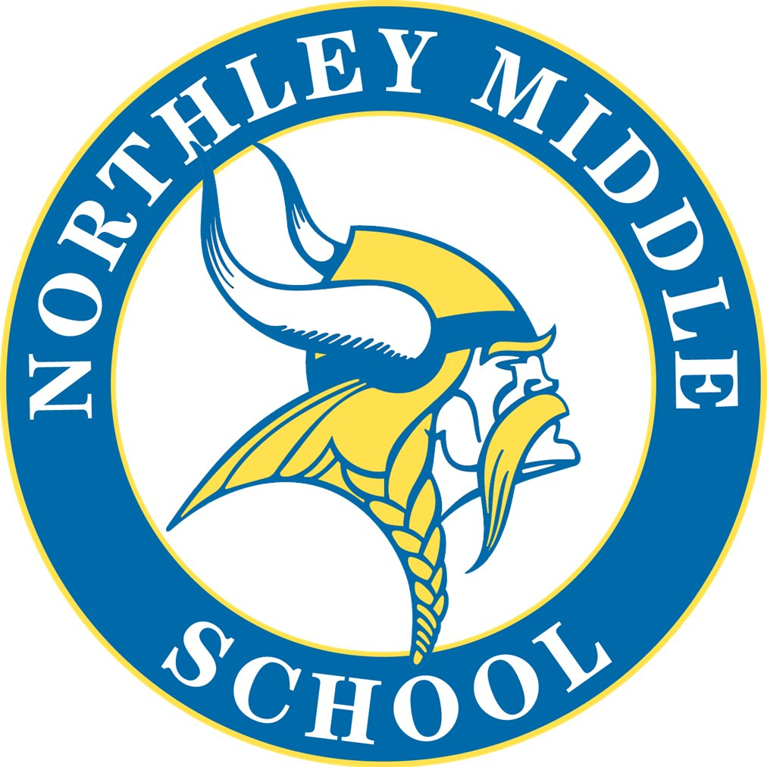
Northley Parent Teacher League

Dear Parents and Guardians of Northley Students:

The Northley PTL is looking forward to the 2020-2021 school year. The PTL plans to continue to enhance our students’ education with the important programs and activities we have developed over the years and we look forward to adapting what we can with the current Covid situation.

This year, to meet our budget needs, the PTL’s major source of income will come from our membership dues, donations and fundraising. We are asking each family to donate $10.00 membership dues. The PTL strives to allocate our funds for the enrichment of our students.

We hope that you will help us continue to serve our students by completing the information below and submitting the $10.00 membership dues to Northley PTL. We look forward to lots of new faces at our PTL meetings throughout the school year. PTL meetings are held the first Wednesday of the month at 6:30 pm in the school library when we are able and via ZOOM or Video Conference. Whether online or in person, the meetings are a great way to meet fellow parents, learn about events, opportunities and school happenings.
Please follow our Facebook page at Northley PTL for links, helpful reminders, and updates.
https://www.facebook.com/NorthleyPTL/
Our PTL wouldn’t work without the generous time and efforts of volunteers. There are a variety of opportunities to become involved – before, after and during school; even from home – WE NEED YOU! If you are interested in helping out, please reach out via Facebook or Email.

For questions or more information about the Northley PTL please contact: NorthleyMSPTL@gmail.com.

In accordance with STATE law the PDSD School Board adopted a volunteer clearance requirement. Please view these requirements on the PDSD website at www.PDSD.org. Click on the “Parent” tab for specific information regarding this policy.

************************************* PTL DUES FORM ******************************************
For Electronic Payments via Venmo, send to @Northley-PTL and include your child’s name and grade.
By Mail/Box Drop off using the form below: Northley PTL c/o Lisa Jennings, 108 Raymond Dr, Aston, PA 19014.
Parent/Guardian Name(s): _______________________________________________________________
Phone: ______________________Email: ___________________________________________________
Child(ren) & Grade(s)___________________________________________________________________
Please Checkoff Membership and/or gift amount; CASH ONLY!!!
_______ $10 Membership Dues: Additional donations to help the PTL: ____$10 ___$15 ___$20 Other: ___________

