
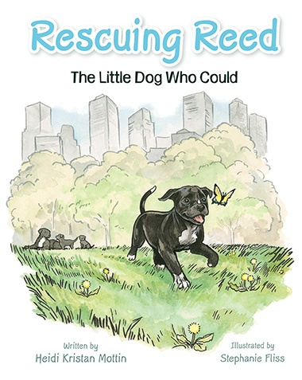
Author Visit to
Aston Elementary
October 9, 2026

Purchase an autographed & “pawtographed” copy for your child directly from the author.

$15 per book

Venmo @rescuingreed or PayPal @heidimottin or Zelle @ 610-357-6578

** Or visit www.heidimottin.com for other payment options **

“Rescuing Reed” shows that EVERYONE has worth & a purpose. It’s a true story of love & 2nd chances showing that we can ALL make a difference!

