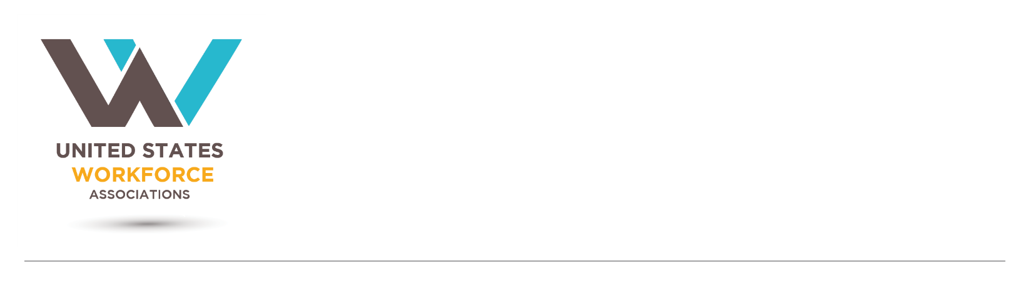

April 1, 2020

The Honorable Roy Blunt The Honorable Patty Murray

Chairman Ranking Member

Senate Labor, HHS, Education Senate Labor, HHS, Education

Appropriations Subcommittee Appropriations Subcommittee

260 Russell Senate Office Building 154 Russell Senate Office Building

Washington, DC 20510 Washington, DC 20510

Dear Chairman Blunt and Ranking Member Murray,

The undersigned organizations make up the United States Workforce Association (USWA), a collaborative effort of local workforce boards, businesses, educational institutions, and organizations involved in workforce and economic development activities across the country. These organizations are directly involved in the implementation of the bipartisan Workforce Innovation and Opportunity Act (WIOA) of 2014, specifically promoting the successful execution by local workforce boards of the law to serve businesses, employers, and job - and career-seekers.

With the country facing unprecedented demand for unemployment insurance and possible economic recession as result of the COVID-19 outbreak, the employer-led, local workforce development system must have the federal resources necessary to provide businesses with talent to begin the recovery and individuals the opportunity to reconnect to jobs. Significant federal investment would ensure the nation’s system is better positioned to address these increasing needs.

We greatly appreciate the direct attention that Congress has given this outbreak by supporting our frontline healthcare workers, first responders, businesses, and individuals/families, but also recognize the need for more direct workforce funding at a moment of unmatched economic uncertainty.

Lessons learned from the Great Recession of 2008 must be applied to this current crisis. America must continue to strengthen its workforce through the American Job Center system and local Workforce Development Boards. As the economy recovers businesses will need funding to adapt their current workers’ skills, as well as address skills gaps in new and existing employees, and workers will need to address education and training gaps to get back to work.

COVID-19 will reshape our labor market, along with changes in technology, growing certification requirements, new production equipment, and work process reorganization. As businesses shift and expand, they often require employers to upgrade the skills of existing “incumbent” workers. Incumbent worker training (IWT) funds aid businesses by providing employee training in order for companies to maintain a competitive edge. It is designed to benefit businesses by enhancing the skills of employees, thereby increasing employee productivity and the potential for company growth.  Training in portable skills results in a more highly skilled and versatile workforce that contributes to our ability to attract new business and creates an environment conducive to expansion.

Incumbent worker training (IWT) creates jobs for low-income adult, youth and dislocated workers through a skill upgrading system by accomplishing two major objectives:

* Provide businesses with the ability to stay competitive, while providing their employees with marketable skills that are transferable; and
* As workers move to positions of greater responsibility and higher earnings within their company, the workforce system is poised to fill vacancies with qualified low-income individuals and dislocated workers.

Enhancing worker skills not only benefits the employee, it benefits the company and economic development efforts. Incumbent Worker Training (IWT) addresses this critical issue by providing funds to upgrade and broaden the skills of employed workers. IWT is for businesses experiencing a skills-gap which restricts the ability to compete, retain workers, and expand.

Given the critical needs across the country, we urge you to appropriate at least an additional $10 billion to WIOA Title I Formula Programs, with the ability to spend this money through June 30, 2023.

1. $6 billion for Adult Training and Employment Services,
2. $2 billion for Youth Activities,
3. $1.5 billion for Dislocated Worker Employment and Services,
4. $500 million for Dislocated Worker National Reserve grants

The profile of impacted businesses cuts across a variety of industries and sadly, many of the industries responsible for fighting the COVID-19 outbreak, like healthcare workforce, continue to be extremely strained and desperate for new workers. Additional funding under the scenario above would be used to focus employment on these frontline industries. We have all seen and anticipate the devastating impacts to our local small businesses; their ability to retain and hire a more skilled workforce is critical as we work to recover.

Unfortunately, a crisis like this strikes the most vulnerable in our population in the earliest, deepest and longest way possible. As unemployment claims increase across the country, we are noticing those low wages workers being impacted disproportionately. These workers were barely surviving when the economy appeared strong and now, they are faced with another barrier to re-connecting to the workforce. The additional funding needs to get to the local workforce system as quickly as possible, to prioritize getting those workers re-employed as quickly as possible in an in-demand occupation.

This education, support and business partnership funding is vital to our country’s economic recovery. For further information, please contact Chris Andresen at (202) 851-3618.

Sincerely,

\\MWA-LANDC01\redirectedfolders\zimmermanm\Desktop\17 USWA Logos\CA Signature.png

O:\Logos\Michigan Works! Association Logos\MWA-red.pngH:\Projects\Public Relations\Signatures\09 Lu signature.jpg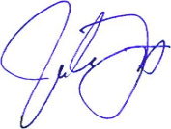\\MWA-LANDC01\redirectedfolders\zimmermanm\Desktop\17 USWA Logos\CA Logo.png

Bob Lanter

Executive Director

California Workforce Association

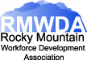

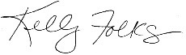

Kelly Folks, President

Rocky Mountain Workforce Development Association

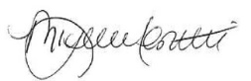

Michelle Cerutti, President

Illinois Workforce Partnership

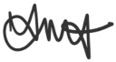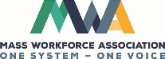

Tonja Mettlach, Executive Director

Massachusetts Workforce Association

Luann Dunsford, CEO

Michigan Works! Association

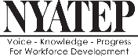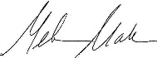

Melinda Mulawka Mack

Executive Director

New York Association of Training and Employment Professionals

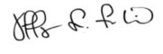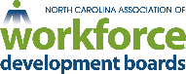

Jeff Frederick

President

North Carolina Association of Workforce Development Boards

John Trott 

President

Ohio Workforce Association

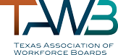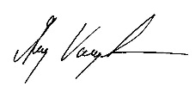

Greg Vaughn

Executive Director

Texas Association of Workforce Boards

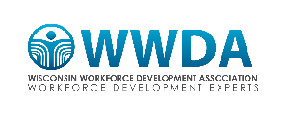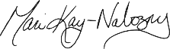

Mari Kay-Nabozny

Chief Executive Officer

Northwest Wisconsin Workforce Investment Board, Inc.

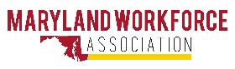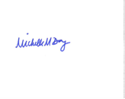 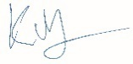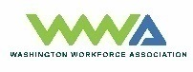 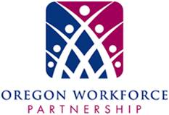

Michelle Day, President Kevin Perkey, President Heather Ficht, Chair

Maryland Workforce Association Washington Workforce Association Oregon Workforce Partnership

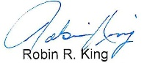 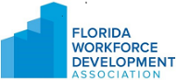 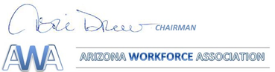 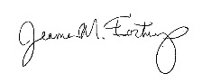 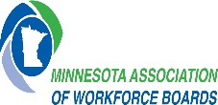

Robin King, President Teri Drew, Chairman

Florida Workforce Development Association Arizona Workforce Association Jeanna Fortney, Director

Minnesota Association of Workforce Boards

 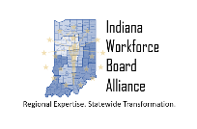 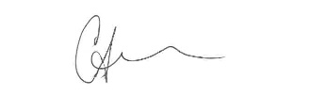 

Angela Carr Klitzsch, Chair Carrie Amann, Executive Director

Indiana Workforce Board Alliance Pennsylvania Workforce Development Association