Opposing Docket # 25-276, “Build America: Eliminating Barriers to Wireless Deployments”
(AKA) “Silence and Squash Public Opposition to Deadly Cell Tower Radiation”

The intent of Docket # 25-276 is to strip away local control of cell tower placement, forcing communities all across the country to just accept their fate of being irradiated with pulsed microwave radiation day and night. This is not only a devastating, totalitarian and potentially deadly attack on human and environmental health, but also unconstitutional.

To add insult to the injurious Docket #25-276, it has recently come to light that the FCC actually removed from their website the docket number “25-267”, so that sometime stemming from Dec. 27th or earlier, if a person were to type “25-276” into the FCC webpage to submit their comment, they would be shown a blank box with a light grey statement underneath saying “No matches found.” Evidence of the removal in the below screenshot taken on Dec. 27th, 2025, but the removal may have happened prior to this date.

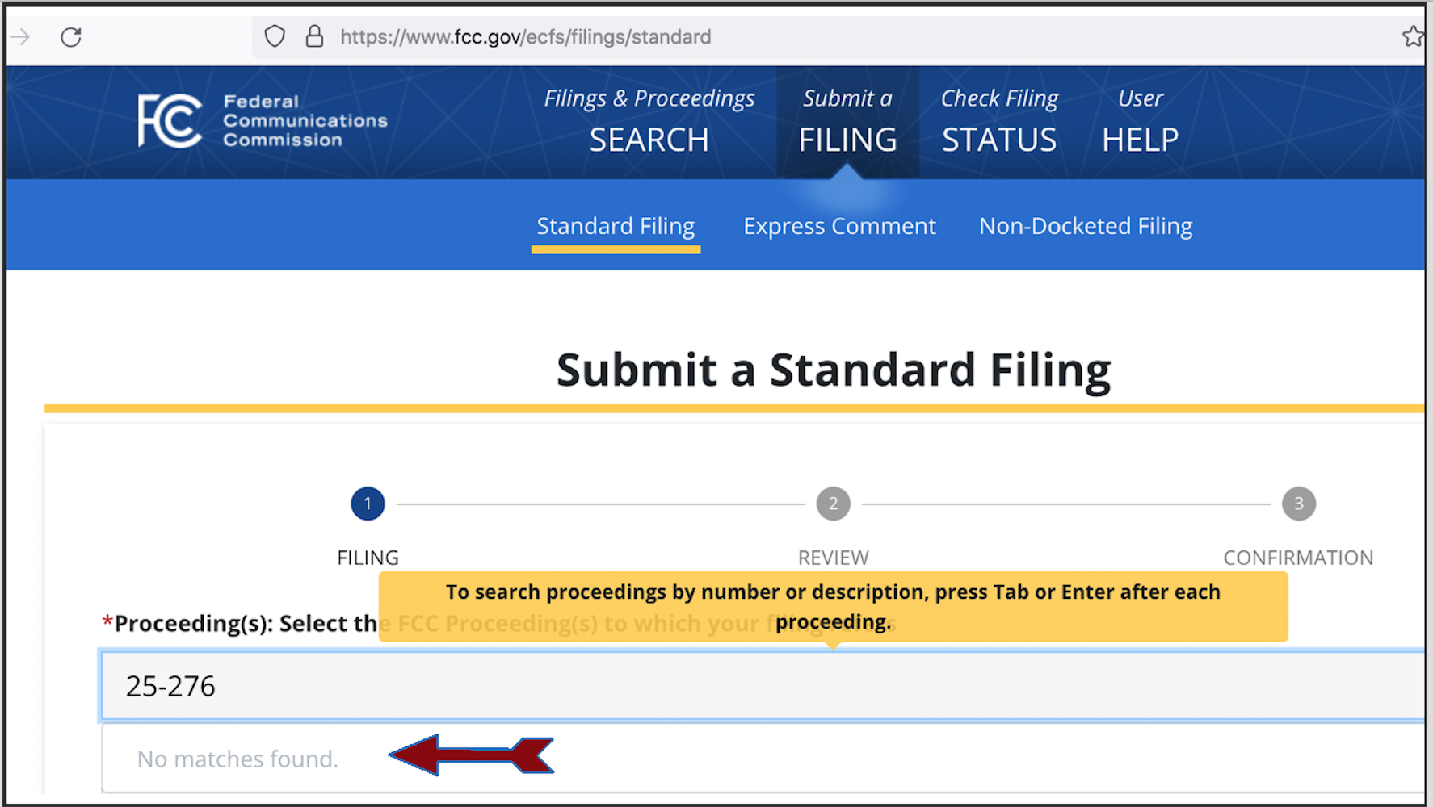

The above is not only an obvious attempt to undermine the process of accepting public input on a privacy invading, harmful, potentially deadly carcinogen, genotoxin and neurotoxin, but is also illegal and a direct violation of the Administrative Procedures Act which guarantees the public be given a full month long window of time within which to submit comments on rule making.

The Federal Register clearly states on their site re: docket # 25-276 that the public will be able to comment on this docket # until Dec 31st, 2025.

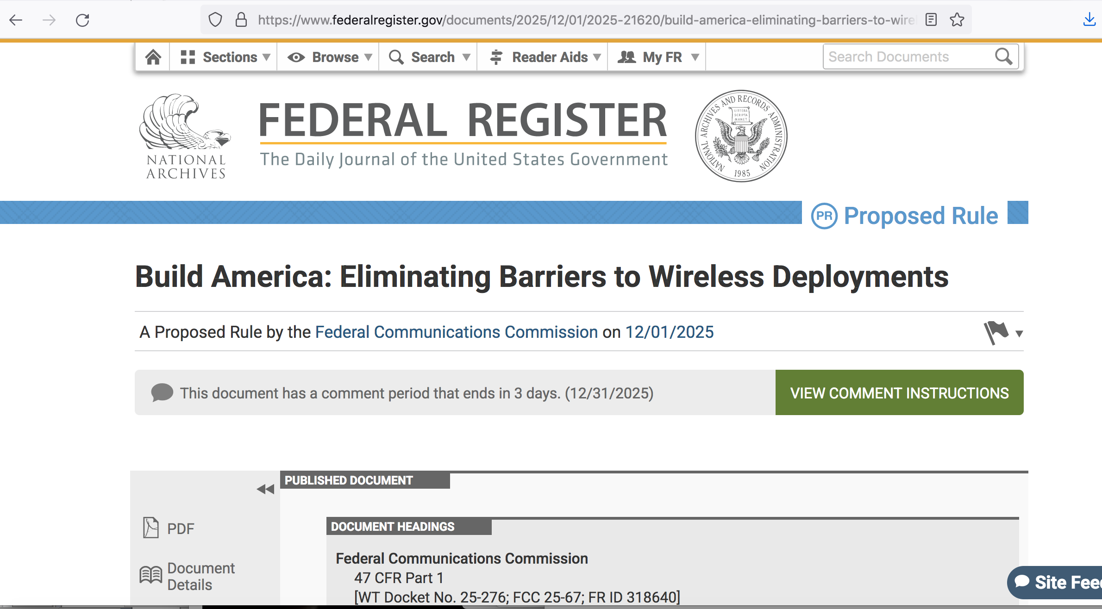

Removing the docket on Dec. 27th or possibly even earlier, is an illegal attempt to deter opposition from the public about the incoming onslaught of unwelcome, privacy invading, ubiquitous, inescapable cell tower radiation for which thousands of studies show harm. It is for this reason that we demand the upcoming vote in early Jan., 2026, on FCC docket # 25-276 be invalidated and an investigation into who was responsible, including the “higher ups” for the removal of the Docket # from the website prior to the end of the month long public comment period be implemented and that punitive action be taken against that individual as well as the upper chain of command who gave the order or “okay-ed” the removal. The docket magically re-appeared again the following day, but that does not change the fact that it had dissappeared for an unknown amount of time on the website in an blatant attempt at lessening the number of public comments. Members of the public who attempted to submit their comments during the time period whereby the docket was removed from the website obviously may never have their comments submitted and also will most likely never pass the link on to friends, family and associates.

Our comments on Docket are below. However, we again stress the vital importance of the FCC vote on 25-276 being halted and postponed or if it takes place to be held invalid, based on the fraud committed by the FCC when they removed the docket from the website, thereby blocking public comment for certain periods of time, on or about 12/27/25 with a day or two ahead of or behind that date and for unknown blocks of time. Additionally, tens of thousands of studies showing harm from wireless radiation emitting infrastructure and devices and specifically cell tower radiation exist today. These studies include harm to children and the environment, the very issues the FCC lost their court case on.

If the vote is to move forward despite all this, it must be invalidated due to illegal behavior by the FCC, attempting to silence public dissent on the issue of local say in cell tower placement in addition to ignoring the lawsuit won in 2021 requiring the FCC to review the safety standards as they do not protect children or the environment. Adult humans are also part of the environment.

Although the FCC has to this day failed to act to protect children and the environment from harmful wireless radiation - the exact kind of radiation emitted from cell towers, that does not give them the excuse that they can now just litter the country with cell towers and silence all local opposition. Below is a link to the ruling on that lawsuit.

https://thepeoplesinitiative.org/wp-content/uploads/2022/11/FCC-Ruling-RF-Standards.pdf

Those proclaiming the standards did not protect against health effects, including children and the environment prevailed and that the exposure standards for RF radiation desperately needed to be updated. The FCC has flat out IGNORED this ruling, never updated the standards and now wants to steam roll over local input and place a cell tower every 750 ft across America! Evidence of cancer, neurological and genotoxic effects, children and the environment be damned! We vehemently OBJECT to docket 25-276.

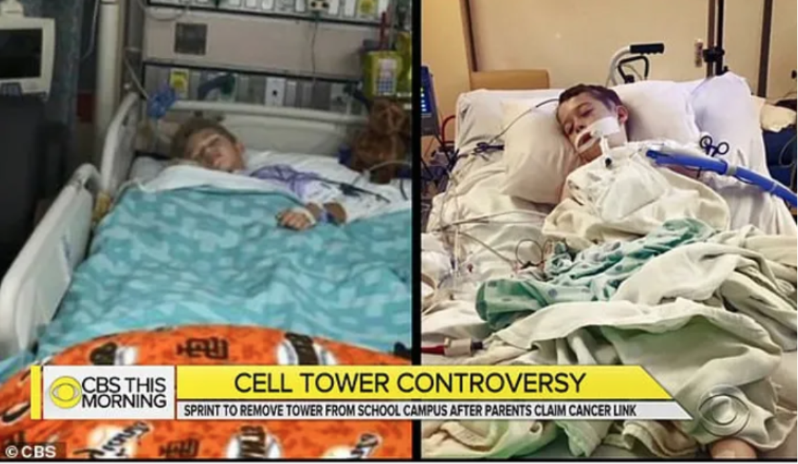
4 Children and 3 teachers from a school in Ripon, CA contract cancer they claim is from the cell tower placed adjacent to the school.

CBS news report on the cancer cluster at the school
https://www.cbsnews.com/news/cell-tower-shut-down-some-california-parents-link-to-several-cases-of-childhood-cancer/

2012 Replacement chapter: Evidence for Childhood Cancers (Leukemia) – Dr. Kundi

Below are just a few links showing harm from cell tower radiation to humans and/or the environment, including animals, insects, plants, trees and wildlife. There are MANY more, we just ran out of time to put them all in here, but these are more than enough to prove our point.

EHS (ELECTROHYPERSENSITIVITY/MICROWAVE RADIATION POISONING), STUDIES ON HUMANS

Abstract
https://pubmed.ncbi.nlm.nih.gov/28678737/

Full study
https://www.degruyterbrill.com/document/doi/10.1515/reveh-2017-0014/html

Case below on left, study participants claiming EHS/microwave radiation poisoning, control on right. A picture says a thousand words.

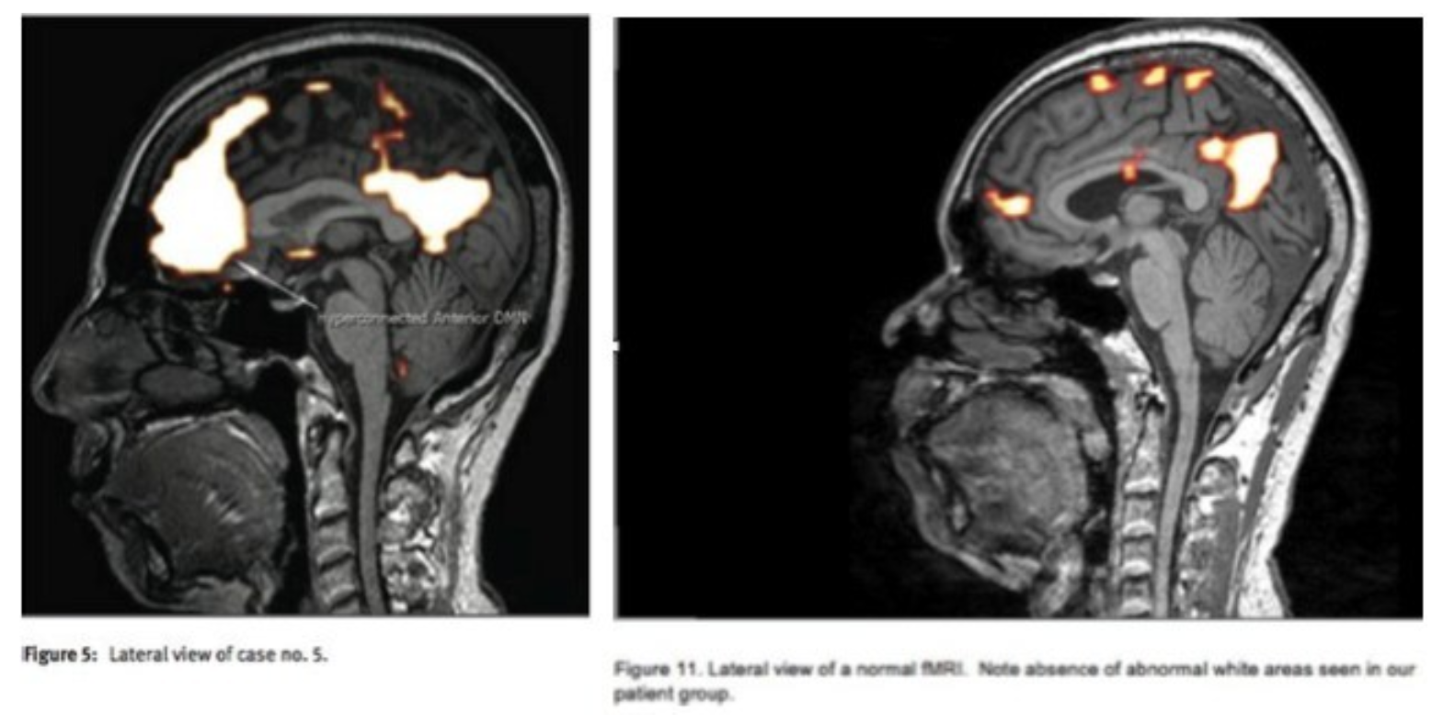

875 pages showing EHS (electrohypersensitivity) or microwave radiation poisoning on humans, courtesy Prof. Joel Moskowitz, PhD
https://drive.google.com/file/d/1s5whVY-uYfkqAc7ETcjnk_a7_D9H0YVu/view

867 pages showing EHS (electrohypersensitivity) or microwave radiation poisoning on humans, courtesy Prof. Joel Moskowitz, PhD
https://drive.google.com/file/d/15AQI_Vm53zG0M7KQP4bFw8PxxajEajhv/view

529 pages showing EHS (electrohypersensitivity) or microwave radiation poisoning on humans, courtesy Prof. Joel Moskowitz, PhD
https://drive.google.com/file/d/1EaqsY67bAZoxu_U50_aqs3tYEWxS2gmw/view

Compilation of studies on cell towers and human illness and death
https://thepeoplesinitiative.org/wp-content/uploads/2020/05/Belo-Horizonte.pdf

Table of 78 studies showing health problems from cell towers including:
Cancer Neurological Effects Effects on Reproductive Organs and Fertility Effects Effects on Wellbeing Effects on Sleep Effects on Cells Effects on Eyes Oxidative Stress Effects on Blood Death Effects on Hormones Genetic Effects Effects on Glands Effects on Animals and Environment Effects on Skin Effects on Protein Effects on Immune Function Electromagnetic Hyper-Sensitivity RF Levels in Cities Effects on Water RF Levels From Cell Towers Danger Perception and Symptoms Reason Why Not A Lot of Studies on Cell Towers Miscellaneous Effects
https://thepeoplesinitiative.org/table-of-78-cell-tower-studies-showing-health-problems/

US Dept of the Interior
https://www.ntia.gov/files/ntia/us_doi_comments.pdf

BIRDS, BEES, INSECTS, FOLIAGE,,PLANTS, ANIMALS AND TREES
https://thepeoplesinitiative.org/the-birds-the-bees/
US Department of the Interior: “Non ionizing (wireless) cell tower radiation causes plumage deterioration, reduced survivor-ship and death to birds and wildlife, hypoxia and heart attacks to birds and offspring and even migratory nesting problems.”
UNESCO WILDLIFE REPORT: Botanist Report Links Pulsed Microwave Radiation from Wireless Transmitters to Disappearance of Birds, Bats and Insects
Millions of bees die – are electromagnetic signals to blame
Increased and Reduced Aversive Learning in Honey Bees Exposed to Extremely Low Frequency Electromagnetic Fields
Exposure to Cell Phone Radiation Produces Biochemical Changes in Worker Honey Bees
Mobile Phone Mast Effect on Common Frogs (Rana Temporaria) Tadpoles: The City Turned Into a Laboratory
Non Thermal GSM RF and ELF EMF Effects Upon Rat BBB Permeability
Ants Can be Used as Bio-Indicators to Reveal Biological Effects of Electromagnetic Waves from Some Wireless Apparatus
The Incidence of Electromagnetic Pollution on Wild Mammals: A New Poison with a Slow Effect on Nature
Fruit Flies…Drosophila Oogenesis as a Bio-Marker responding to EMF Sources
Radiofrequency Radiation Injures Trees Around Mobile Phone Base Stations
Adverse Influence of Radio Frequency Background on Trembling Aspen Seedlings: Preliminary Observations
Incredible photographs of what microwaved water does to plants
This is a study on plants… The Effect of Electromagnetic Radiation from the Skrunda Radio Location Station on Spirodela Polyrhiza (L.) Schleiden Cultures
Birds and Trees of Northern Greece: Changes Since the Advent of 4G Wireless
Video from Europe with Subtitles… Unknown Tree Damage By Electromagnetic Radiation

Property Value Decline Near Cell Towers
https://thepeoplesinitiative.org/property-value-decline-near-cell-towers/

Thousands of studies showing biological harm to humans, animals and the environment from wireless electromagnetic radiation
Bioinitiative.org. Key excerpts from the Bioinitiative Report are below:

Prof. Henry Lai:
RFR Research Summary (1990-2017)
Genetic Effects of Non-Ionizing EMF Abstracts (2022)
Genetics Effects Studies Percent Comparison Graphic 2022
ELF-EMF/Static Field Neurological Effects Abstracts 2022
RFR Neurological Effects Abstracts (2022)
Neurological Effects Studies Percent Comparison Graphic 2022
ELF-EMF Static Field Free Radical (Oxidative Damage) Abstracts (2022)
RFR Free Radical (Oxidative Damage) Abstracts (2022)
Free Radical Studies – Percent Comparison Graphic, 2022
Table 1 RFR Comet Assay Studies (2020)
Table 2 Static Field_ELF-EMF Comet Assay Studies (2020)
Electrohypersensitivity Abstracts (2017)
Comet Assay Studies – Percent Comparison, 2020

Effects from wireless radiation on the BBB blood brain barrier
2012 New Chapter – Dr. Salford, Dr. Nittby and Dr. Persson

Evidence for brain tumors and acoustic neuromas
2007 Report: Evidence for Brain Tumors and Acoustic Neuromas – Dr. Hardell, Dr. Hansson Mild and Dr. Kundi

2012 Supplement – Dr. Hardell, Dr. Hansson Mild, Mr. Carlberg Use of Wireless Phones and Evidence for Increased Risk of Brain Tumors
2012 Supplement – Dr. Kundi Evidence for Brain Tumors (Epidemiological)
2017 Supplement – Dr. Hardell Use of Wireless Phones and Evidence for Increased Risk of Brain Tumors
Key Scientific evidence and public policy recommendations from Bioinitiative authors Cindy Sage and Dr. David Carpenter
2007 Report: -Dr. Carpenter and Ms. Sage
2012 Supplement – Ms. Sage and Dr. Carpenter

Study on RF radiation and current summary of studies on its relation to cancer
Yakymenko et al.: Oxidative Mechanisms of Biological Activity of Low-Intensity Radiofrequency Radiation, published in the journal Electromagnetic Biology and Medicine,
Abstract:
Low-intensity radiofrequency electromagnetic fields (EMF) are ubiquitous in modern society, but their biological effects and potential health risks remain controversial. This review summarizes the current state of knowledge on the oxidative mechanisms underlying the biological activity of low-intensity radiofrequency radiation. We analyzed numerous in vitro, in vivo, and ex vivo studies investigating the effects of low-intensity EMF on various biological systems, including human cells, animal models, and plants.
The majority of studies reported that low-intensity radiofrequency radiation can induce oxidative stress and inflammation, leading to cellular damage, impaired function, and increased susceptibility to diseases. DNA damage, including single-strand breaks, double-strand breaks, and DNA base modifications, was also observed in response to EMF exposure. Furthermore, low-intensity radiofrequency radiation was found to affect the central nervous system, reproductive health, and the immune system, contributing to the development of neurodegenerative disorders, reproductive problems, and immune dysfunction.

