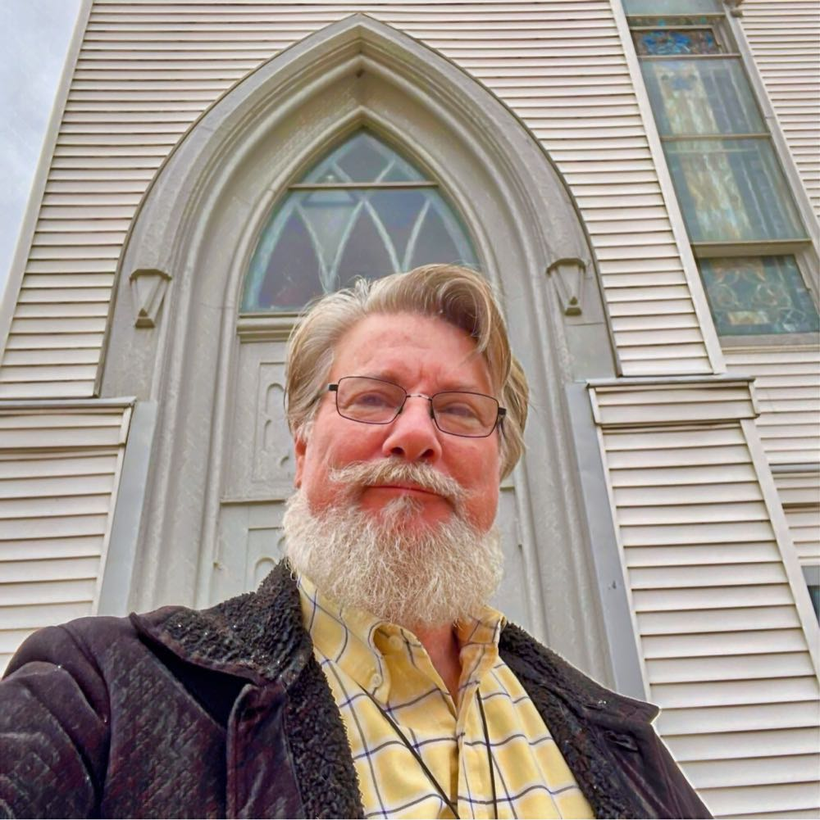
My fellow Venture Church ministers,
I am so happy to be able to say that! Before I moved from California (exactly 2 years ago) to take the pulpit of First Baptist Church of Galva (IL) I was apprised of the Search Committee’s opinion that its denominational affiliation should be changed. Having come from a region where virtually the whole West Coast seceded from the ABC to become Transformation Ministries, I was aware of the issues, but also that there were still conservative congregations everywhere, and this current church of mine is one of those. When the deacons tasked me with the job of narrowing the options, I had already been through several candidating programs with the likes of Converge, and TM and others, had talks with NAB and more; I’ve served both Southern and American Baptist Churches with ordinations in both, but I’ve never been one to willingly jump onboard something that holds sticky little non-issues as requirements for membership, and when helping in the process here, it wasn’t difficult putting Venture up front. VCN’s dba was a tiny hurdle, as “Conservative Baptist” resonated more in our leadership’s ears, but they came around, and now here is First Baptist Church wondering where do we get a Venture flag and how soon can we change the logo on our sign? Should it be the logo or the logo for “Midwest?” Well, happy problems, and so glad we’re on board! Let me tell you a little bit about us: FBC began in 1855. It’s had a series of heydays in its long history, but Covid messed up a lot of things and neither we nor the area has fully recovered. Galva is definitely a small town, and our church has about 20% of its residence on our outdated membership rolls. Our actual attendance is about 10% of that 20% and there are 8 other churches here in town competing for the same populace of church-hoppers and the church-burnt. We have the most productive Food Pantry in the county, I believe, but we’re feeling the cost and questioning its future when our small congregation is already trying to figure out how to pay the normal ministry expenses as well as the skyrocketing power bill. Many of our members are snowbirds, and I’m reminded of their soon return by the snowflakes beginning to fall on me as I take the selfie for this article (on March 9th!). Snow?? Sheesh, Midwest…Our church does seem to have a sudden boost of energy, and hope “springs” literally, so perhaps we will witness some observable growth in the upcoming months. You know, I have never baptized so many people in so little time as I’ve done here; it’s encouraging. Personally, I came to faith outside the Church many years ago and sought one on TV to baptize me. They did, and the rest is history. I’m a grad of Biola, Talbot, and Fuller; with degrees in Biblical Studies, Philosophy of Religion & Ethics, and Divinity. I’ve served several churches in a variety of rolls, but as senior pastor in 3 Baptist Churches and a couple of baptistic Congregational ones. I’m involved in the musical worship of our church since I can strum a guitar and generally sing in key. My wife (Joy) is a coloratura soprano and she knows more than I about music, so she often does the Special numbers and sings sometimes around our area for a few extra dollars. Our church sings mostly hymns with a few slightly more contemporary selections. The folks here have a good sense of humor, and that suits me just fine. I have a theatrical background, have a penchant for cooking, and I’ve worked so many different kinds of jobs throughout my life that I have an endless supply of sermon illustrations. Ministry has been the glue, however, since nearly the moment I was saved. I’m outgoing, artistic, and committed to the Word of God. If the Bible says it, I believe it. If it doesn’t, I’m a Doubting Thomas. I’ve gotten into gardening a bit since half my congregation consists of farmers, and the wife and I are pleased with our current situation although we scratch our head with the rest of the congregation about how to fill the spaces in our pews. Perhaps our new relationship will help us with that. Again, so happy to be part of a godly association and I look forward to meeting you all in whatever venue provides opportunity. Thank you for welcoming our church into your fold. Many blessings to you all,
Your Brother, ~Pastor Bryan (Griem).

