2021 Christmas Eve Service Pageant
Dec. 24 at 7:00 p.m.
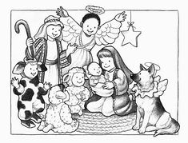

We are excited to offer an in-person children’s Christmas pageant this year at the 7:00 p.m. Christmas Eve Service. Masks and social distancing will be incorporated.

Our script is Godly Play’s “On the Way to Bethlehem”. Kindly ask local families/children to be available for two rehearsals on Dec. 19 (11:30 a.m., after the service) and Dec. 24 (9:30 a.m.). Light snacks provided at both.

Roles include:
- Speaking roles: Up to six narrators and the Angel Gabriel;
- Nonspeaking roles: Mary, Joseph, 3 Kings, shepherds, angels, Star of Bethlehem, various animals (sheep, camels, cows, etc.)

There will be plenty of roles and costumes even for last minute guests and friends who would like to participate. Costumes sizes range from 18 months to youth 14.

To sign-up, please contact Megan Coffey at megcoffey05@gmail.com or 571-230-9346. Roles will be assigned by Dec. 19, the first practice.

