Capturing or Recording Your Class
You can capture and record your class using Capilano’s videoconferencing software, WebEx, and run your class as normal, with the option for students to join the class live via WebEx, or to view the recording afterwards. We have included the written instruction below as well as in video https://youtu.be/XmFvMh8zl_0
Email cte@capilanou.ca to further support or if you need help in your class.

Getting Started
If you haven’t used WebEx before click here to get started. As faculty, you will have access to a “host account”, however you will need to enable it first. To do so:
- Go to https://capilanou.webex.com/
- Verify your email address
- Ignore the browser pop-ups. You do not need to install anything
- Go to https://capilanou.webex.com/ and login with your CapU username and password. You’ll see a welcome message
- Click start meeting

Once you have enabled your host account, you will have access to your own “Personal Meeting Room” with a permanent URL i.e. : https://capilanou.webex.com/meet/yourname. Students can enter once you’re in the room. You do not need to schedule this.

Before Class:
- Go to the IT Services Desk and book a WebEx Pop-up station for your class. This is an external USB camera and microphone to plug in to your laptop or the podium computer in the room.
- Send the URL to your personal meeting room (https://capilanou.webex.com/meet/yourname) to students and post it as an announcement, or as an Activity – URL on your eLearn site.

Set-up in class:
- Plug the USB camera into the podium computer or your laptop
- Enter your WebEx personal meeting room
- Select Call Using Computer
- Pick the USB camera (Logitech HD Pro Webcam) as your audio and video connection as you enter
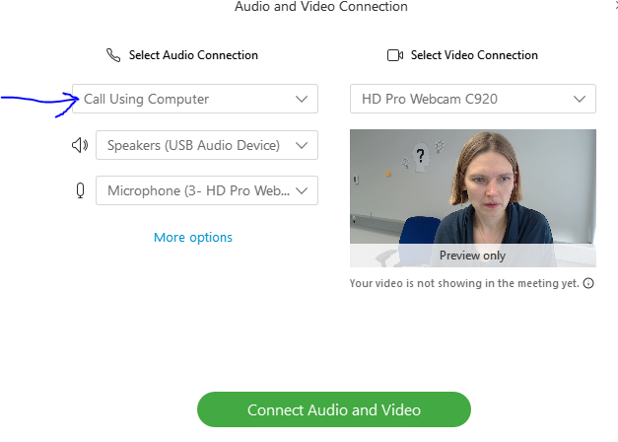

Make sure the camera is pointed at you. Webex will be capturing your computer screen.
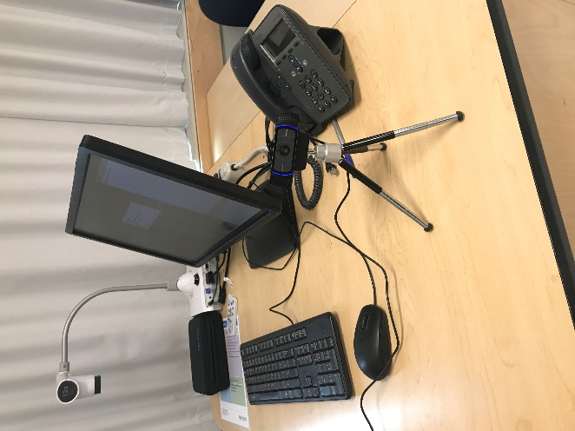
- Click record in the cloud
- Or Share you whole screen i.e. with a PowerPoint and project your screen to the students in class as you usually would

After Class:
- Go to https://capilanou.webex.com/ and login.
- Click on My Recorded Meetings, and click on the Envelope icon to email a link to the recording to students. You can also get the hyperlink and post it on your eLearn course site.
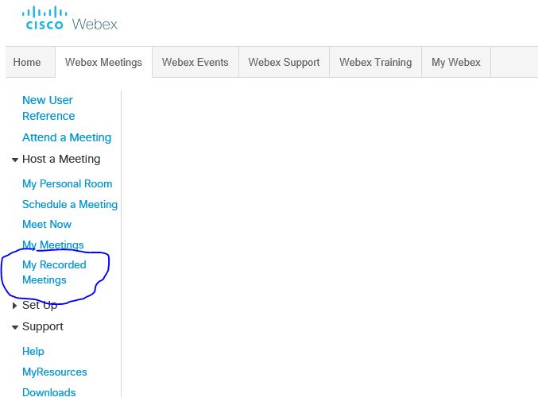

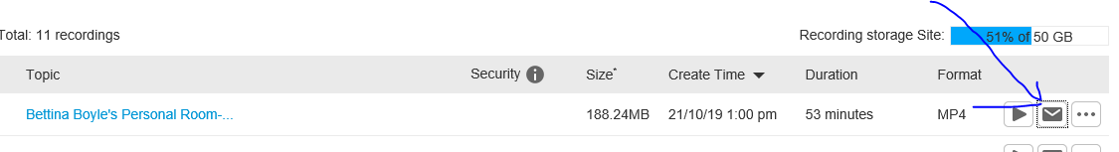
- Note, it may take a few hours for the recording to upload to the cloud.

Additional Options:
- Use WebEx or MS Teams to connect with individual students or teams…

