Items to be Donated to
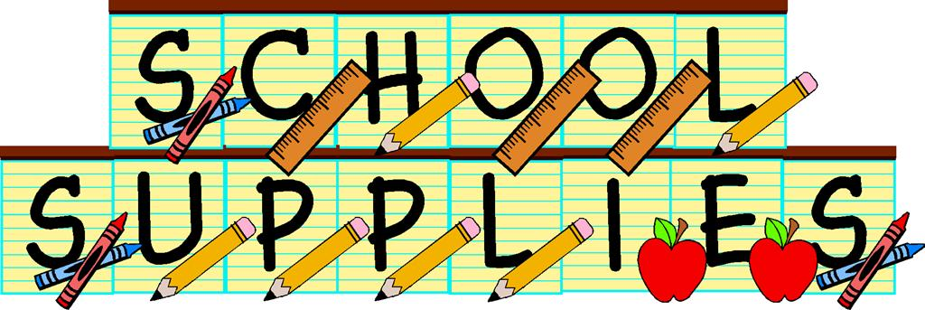
Several Columbus Public Schools

Notebooks
Folders
Markers
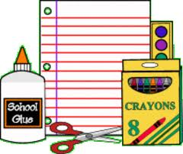
Highlighters
Pencils
Backpacks
Colored Pencils
Ruled Paper
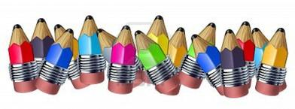
Composition Notebooks

Pens
Pencil Pouches
Page Protectors
Index Cards
Post-Its
Erasers
Binders
Dividers

