United Way
of Tompkins County
313 North Aurora Street
Ithaca, New York 14850
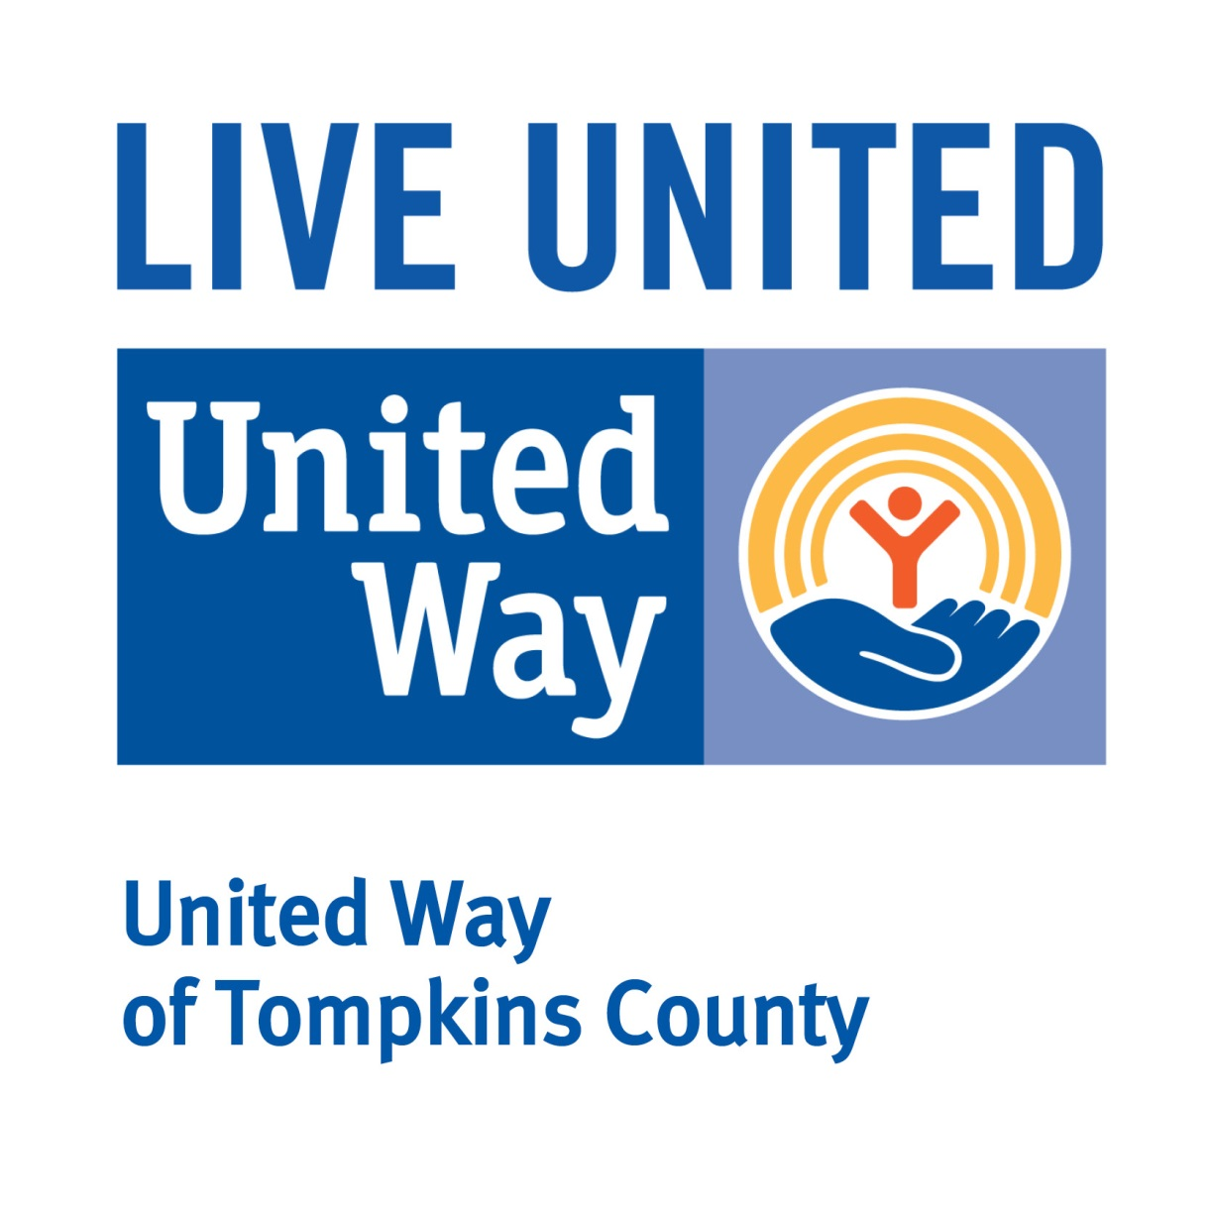
Phone: 607.272.6286
Fax: 607.272.2736
www.uwtc.org

FOR IMMEDIATE RELEASE
April 1, 2025
Contact: Ashton Teribury, UWTC Relationships Manager, 607-272-6286, ateribury@uwtc.org
Marcie Rivera, Wegmans Senior Public Relations Coordinator, 585-279-4307, marcie.rivera@wegmans.com
Photos: https://drive.google.com/drive/folders/1OC3dCPO7OxcYFnZMCA5qX4al9TpQHnXE?usp=drive_link

United Way of Tompkins County Extends Campaign to Meet Basic Needs
ITHACA, NY - Given the current reality for human needs in combination with changes in funding from both federal and state sources, United Way of Tompkins County has announced an extension of its annual campaign specifically to meet human needs in the areas of food security, children & youth success, health including mental health, and housing. The “Meet the Need” campaign extension’s goal is to raise $200,000 by April 30. 100% of funds will be directed to the United Tompkins Impact Fund to ensure that all UWTC funded programs delivered through 58 impact partners receive the same funding in their upcoming fiscal year starting July 1, 2025 as in the current fiscal year.
“Imagine yourself as a parent skipping a meal once a week so your child can eat. Now think of the effects of trucks full of chicken, turkey and other healthy, protein-rich foods – the product of agricultural commodities – being turned around in a land where food insecurity hovers around 12%. Consider now, how will your child without nutritious meals progress in school and grow into the vibrant adult that is your dream and their destiny? While families are faced with hard, basic choices due to realities beyond their control, WE have to decide how, just as we did during the pandemic, we will take care of one another,” states UWTC President & CEO Michael Ramos.
“Reaching this goal will enable UWTC to provide for basic needs and support our local mission-driven sector,” explains Gail Belokur, Chief Development Officer for UWTC. “Our impact partners prove every day their ability to deliver programs and services vital to meeting the current human needs in Tompkins County.” Campaign Co-Chair and Executive Director of Ithaca Community Childcare Center Sherri Koski adds, "Consistent funding is the cornerstone of sustainable change. In a time when many funding sources are shrinking, it is more important than ever to ensure that our impact partners have the resources they need to continue their vital work. These organizations are on the front lines, driving progress in our communities, and without dependable support, their efforts may be stifled. By maintaining and even increasing funding, we are not only securing their ability to deliver lasting impact, but we are also sending a message that we are committed to the long-term vision of a better, more equitable future."
In support of UWTC’s campaign, Wegmans of Ithaca has launched a “scanning campaign” in which shoppers may add to their total with 100% of gifted funds going to food security and other basic needs. Alex Adelewitz, Service Manager for Wegmans of Ithaca and Koski’s campaign co-chair shares, “Wegmans is proud to support meeting basic needs provided through local nonprofits and has launched a ‘scanning campaign’ towards United Ways goal. Now through May 3rd, shoppers can add donations on to their purchases and all funds will directly support this effort.”
Community members can also learn other ways to come alongside others by visiting uwtc.org. Donors may utilize the website, email campaign@uwtc.org or call (607)272-GIVE to make a pledge and support our community.
###
Give. Advocate. Volunteer. LIVE UNITED.

