Making Sensory Items for Your Church

1. Sensory lap or shoulder pad
Weighted pads may help calm and regulate the sensory system, allowing the user of any age to focus and participate. They can be used in combination with other input, e.g., rocking and headphones. Make sure user wants to use and enjoys the pad.
Fabric selection – washable fabrics: woven fabrics for the weighted pad, woven, knit, or fleece for the cover. Choose fabrics that don’t ravel or fray.
Weighted material for filling – never more than 10% of the person’s body weight. 2-5 pounds should work for most uses. Plastic pellets are the most versatile as they are washable. Rice or small beans can be used if in a waterproof bag inside the cover. You can also purchase a basic weighted lap pad online and sew a cover for it.
Size and shape – rectangular or oval – a little larger than lap size for lap pads, long and narrow or horseshoe shape for shoulder wraps or pads.
Making the weighted insert – sew the outside into a pillowcase, leaving one end open. Turn right side out and sew 2 or three lines from the closed to the open end of the case, leaving the top open. Fill channels partway (to the 1/3 or 1/2 point) with equal amounts of weighted material. Pin and sew above your pins across the case. Fill the next section of the channels to the 2/3 mark (and repeat the previous step), or to nearly the top, leaving space to fold the open end over twice and sew closed to seal.
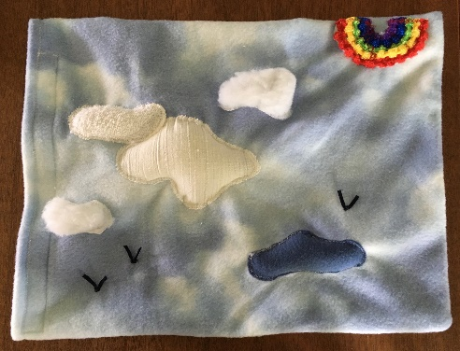
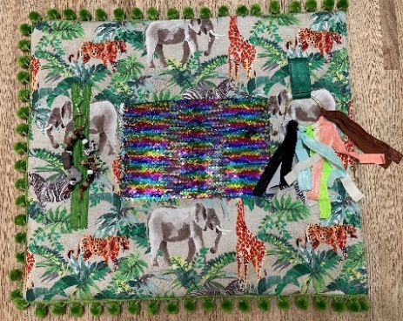
Making the cover – Cut a slightly larger pillowcase, allowing room for the filled insert. Attach your decorative pieces first, then finish the edges. One edge needs to open – secure with hook and loop tape or a zipper. Be creative with textures and shapes to touch and with fasteners and objects to fiddle with. Pick an age-appropriate theme. Secure items so there is no chance of loosening and swallowing them. Find idea inspiration online. Examples:

2. Sensory “calm down” bottles
Sensory bottles also serve a variety of purposes. They can be calming, like the one shown here where the glitter falls slowly and the “clouds” rise slowly to the top. Other bottles might give the individual something to focus on, like finding all of the objects hidden inside. Search online and you will find many ideas.
Supplies needed –
- A large (16 – 24 oz.), transparent, unbreakable plastic bottle with a screw-on cap. The one pictured below was a Voss® brand water bottle with the label removed. Michael’s® sells empty bottles for this purpose.
- Regular or chunky glitter, a teaspoon or less should be enough.
- A drop or two of food coloring – add carefully!
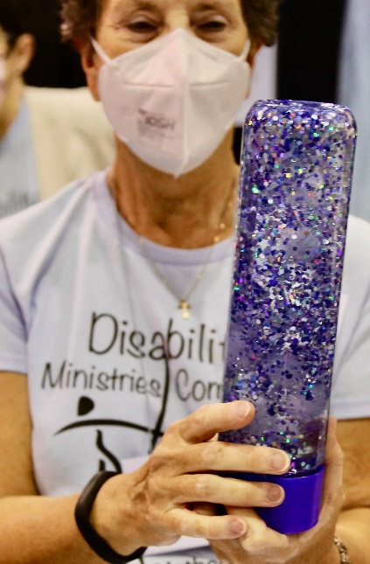
- Objects that will hold up to being permanently in the water – tinsel pom poms are used for the clouds in the Gentle Rain bottle (https://www.teainthewild.com/gentle-rain-sensory-bottle/) shown here. The other bottle at Assembly held a variety of plastic animals to go along with the Noah’s Ark theme. Small stones and shells and other natural objects work well.

- Clear glue such as Elmer’s ® for slow movement use 1/3 glue to 2/3 warm water, or less glue and more water for faster falling items.
- Hot glue gun or other permanent adhesive to seal the cap when finished. Wrap with colored duct tape for additional security.

- An alternative option is an oil and water bottle which provides a different visual experience. Find instructions online.
- Some programs create sensory bags using gel, coloring, and small objects in double thicknesses of clear plastic storage bags that are glued shut and duct-taped around all edges. Users can push and manipulate the objects.
- If you have participants with low vision, use items with contrasting colors, or create a dry bottle similar to a rain stick with rice cascading past obstacles.

