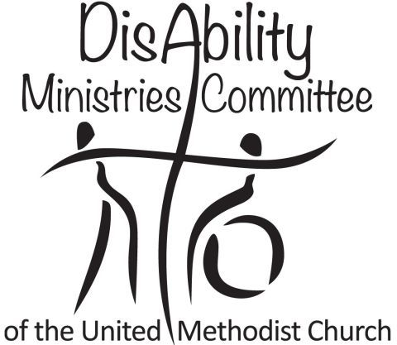Congregational Survey: Ministries with People with Disabilities

1. Do you need accommodations (e.g. large print, assisted listening devices) in order to participate in worship and church activities? ___yes___no
If yes, are you receiving these accommodations? ___yes___no If not, what would enable you to participate more fully?_________________________________________

2. Do you consider yourself a person with a disability, or does someone in your immediate family have a disability or special needs? ___yes___no (skip to #4 if “no”)

3. If so, do you feel that your (or your family member’s) gifts and skills are being well-utilized? ___yes___no If no, how are you being called to serve?___________________

4. Are you aware of persons in our community who want to participate, e.g. to attend worship, but aren’t able to because of disability-related concerns? ___yes___no
If yes, what accommodations would help?_____________________________________

5. Are you willing to serve on a task force to determine how this congregation can become increasingly accessible and disability-friendly? ___yes___no

Please rate the following on a scale of 1 = we do a poor job to 5 = we do an excellent job

1—2—3—4—5 The ushers and greeters appear to have sufficient training, information, and skills to welcome and support people with disabilities and their families.

1—2—3—4—5 The pastor(s) and staff seem to have sufficient training, information, and skills to welcome and support people with disabilities and their families.

1—2—3—4—5 Our Sunday School teachers have sufficient training, information, and skills to welcome and support children and youth with disabilities or special needs.

1—2—3—4—5 Our congregation welcomes guests with disabilities and their families, and integrates all persons into the life and ministries of the congregation.

Comments (include feedback about what the church is doing well and areas for growth):_________________________________________________________________________________________________________________________________________________________________________________________________________________

Name (optional):______________________________ Contact info:________________

Please note: individual surveys are confidential! Thanks for your assistance.
Idea: This survey can also serve as a questionnaire and conversation guide.

