AAUW Big Rapids Member Survey Fall 2023

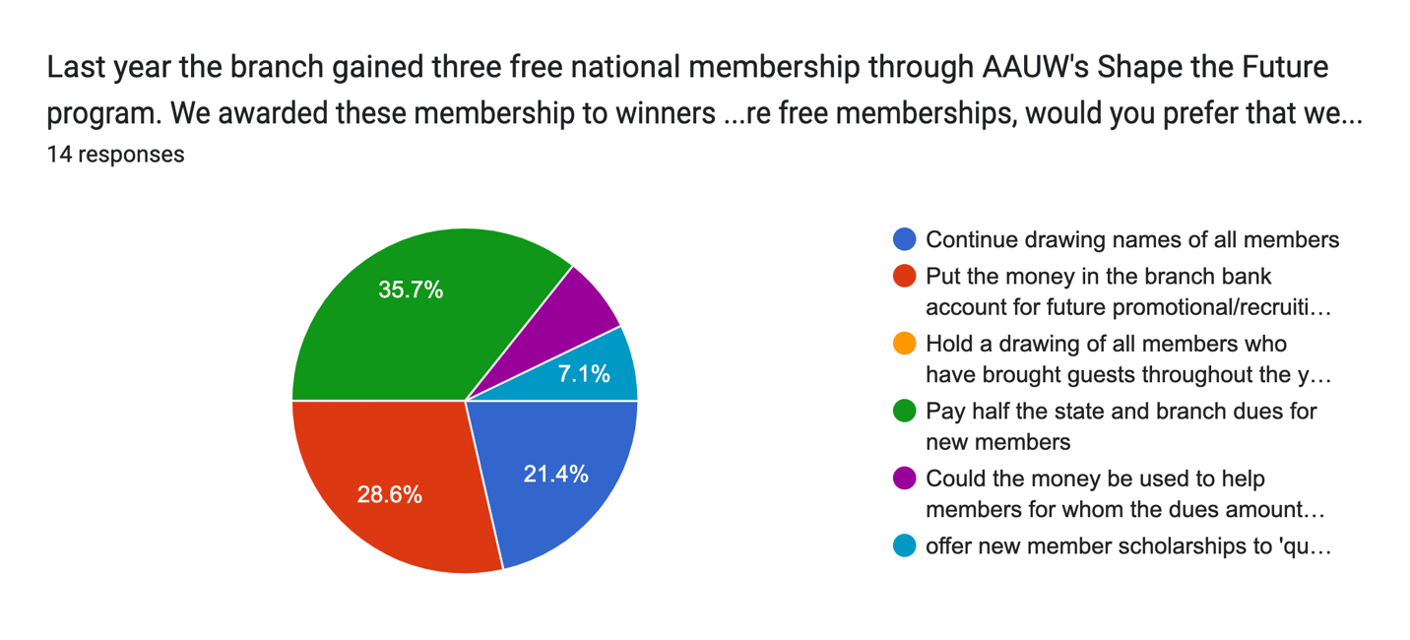
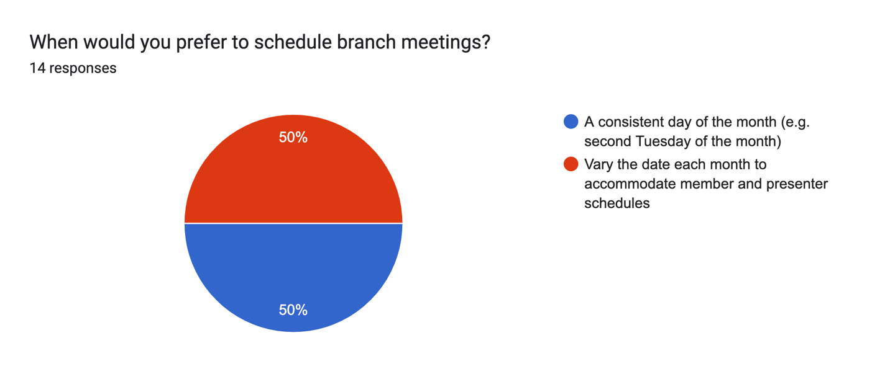
What days of the week/month would you rather we didn't schedule branch meetings due to standing conflicts with your other obligations?14 responses

I have obligations on the second Wednesday of the month and on the fourth Thursday of the month.
no preference, flexible availability
Tuesday or Wednesday evenings
Weekends
Monday and Friday
Thursday
Monday or Thursday
I have other meetings on Wednesdays and Thursdays.
I don't have a lot of standing meetings, so I don't have consistent days of the week that would pose conflicts
Thursday, Sunday,
None
Mondays
Wednesday
Wednesdays and Fridays

What program topics or speakers would you like to suggest?7 responses
history of women's rights/women in higher education.
Women in the field of law/political science and politics
Dana Nessel
Becoming acquainted with different organizations that provide help for women
N'Kenge Gonzalez from AAUWMI to kickstart DEI discussion for our branch. Are there Ferris faculty/staff who can speak to gender issues in their disciplines, whether that's health, business/finance, technology, etc.?
So far it has been wonderful, I learn something new each time.
N'Kenge Gonzalez on how to use the DEI toolkit and what we can do to recruit more members of color

Last year we sponsored a panel of women in the arts for the Festival of the Arts in February. Should we sponsor another FOTA program in 2024? Alternatively, should we sponsor a program during Black History Month? If you think we should sponsor a program, what should be subject matter and format of the program?10 responses

both, same format
Participating in FOTA is a great way to have a presence. Brainstorming possibilities during a meeting seems like a good idea.
Black history
I like the idea of collaborating with the MoSO for a FOTA event.
Women artists who could be of help in focusing on women's rights, and how to focus on this
For Black History, we could have someone from the early settlers speak. For FOTA, I liked the idea presented at the picnic concerning the Barbie exhibit.
For this year, I like the proposed idea to do something with the Ferris Art Gallery and MOSO on Barbie during FOTA.
Racial diversity: black, indigenous(MMIW)Missing Murdered Indigenous Women, or Chinese women's culture. Format: I liked the panel discussion at ArtWorks.
For Black History month I'd like to see a program on black women entrepreneurs and the challenges they face, and have as a speaker Dr. Kasey Thompson from FSU, who in addition to teaching, owns Fatty C's restaurant and has just been named as Special Assistant to the President for Innovation and Entrepreneurship
yes to both, just move black history to january

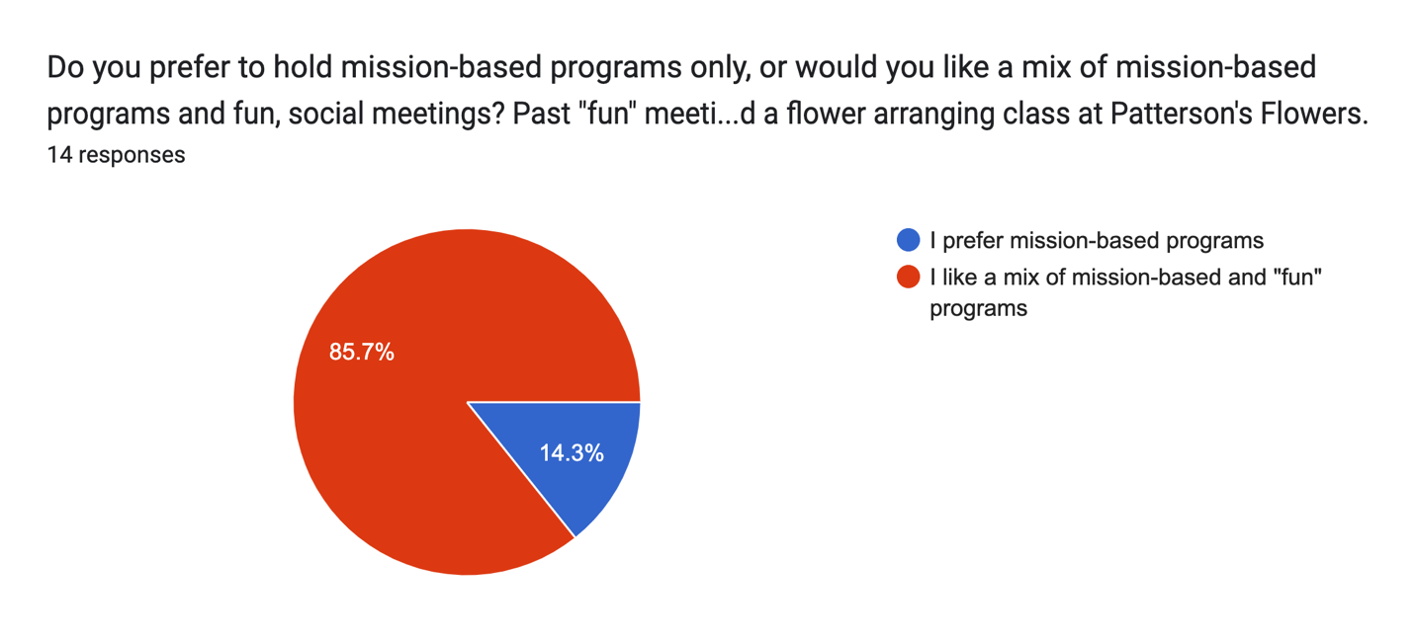
If we were to schedule a new, fun instructional activity, what type of class would you like to attend?11 responses
Although not “fun”, a CPR class would be useful.
arts and crafts. jewelry making.
hmm. out of creativity right now.
Maybe have a list of possibilities we could then vote on?
Yoga or cardio drumming
Something to make that is functional: basket-weaving, pottery, etc.
Painting class, wine tasting, cooking/baking class
Can we try to find a mission-based twist to "fun" activities? For instance, if we do a kitchen demo with a local chef, if the chef is a woman, ask her to speak on her experience working in the industry as a woman.
Making mosaics out of broken glassware for gardens,
No ideas; others have suggested a number of good ones
cooking, wine,

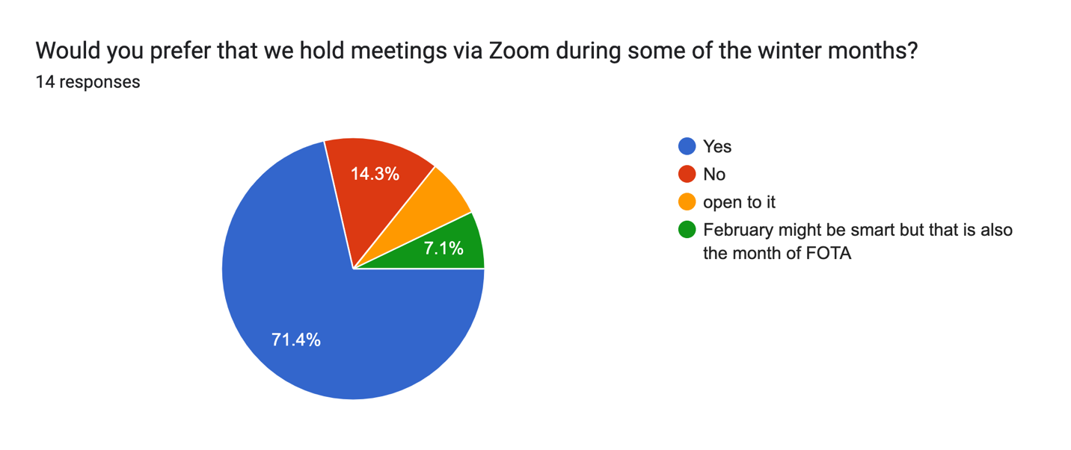
Some AAUW branches offer optional study/interest groups in addition to branch meetings for the whole membership. Examples include book or movie groups, dining/travel groups, and bridge/game groups. Should our branch consider forming one or more interest groups, and if so, what type of small group activities would interest you?13 responses
Art, dining, wine tasting, visiting local sites of interest, games
book club
all for one, one for all. no organized special interest groups, if the spontaneously are formed by interested groups, let them be open-invitation.
It seems a variety would be helpful for members,
Book/Travel
I think it is a good idea. I would be interested in a book group.
Bridge, book study
Yes. Day trips, visit a winery, lunch get togethers, game nights.
I would try to participate in activities that tied in with the AAUW mission, but I already belong to two book groups. If we had a travel group, field trips to places like the Ziibiwing Cultural Center in Mt. Pleasant or Idlewild would be interesting, and we could attend mission-relevant exhibits at GR museums
I love playing cards (but not Bridge), I like book groups, and a travel group.
No opinion
day trips to Michigan Women's Histoical Museum Lansing and Idlewild museum, other destinations.
Book or Movie Group, Dining, Games!

Traditionally, our branch has used most of its fundraising proceeds to support Ferris scholarships for nontraditional students. Are there other community projects you would like to see the branch support? If yes, please name.12 responses
no preference
stay with these scholarships, still needed. let interest groups should they form, be involved with other projects should they choose.
WISE.
Support for WISE
No
WISE
Interested in figuring out how to support MOSO, but don't want to cut back on scholarship support. Are there gender-based registered student organizations at Ferris that we might support?
Tough question. Of course. WISE is a great community group to support.
How about giving a scholarship to a high school graduating senior?
Tracy B and I have talked about the possibility of pursuing an endowment of some kind for MOSO, which would not need to take funds from the scholarship. There are gender based groups on campus as well, a fairly new one whose name I can't recall that could use financial support. Tracy would know.
yes, something for Ferris & high school female students on empowerment and leadership
Libraries etc.

Would you like to extend invitations to spouses/partners to attend some of our events? If so, what types of events?13 responses
No
open to it
yes, zoom is a good format for this.
Only if it was a social event not a meeting.
Nah
Socially, partners/spouses have many opportunities with other couples. The best part of being involved with AAUW functions is the relaxed female companionship.
Maybe the December holiday dinner, but I'm not particularly interested in inviting husband/partners to other meetings unless they want to become active members and allies
Prefer to keep it to women.
No, I have always enjoyed just being with other females!
maybe Christmas
Yes

Is there anything else you would like to suggest that the branch should consider doing?9 responses
??? dk.
We could try to recruit some college women.
Other fundraising ideas other than the book sale
I think these are all good ideas. I don't have more to add.
Explore alternative/supplemental fundraisers to book sale; if Ferris Women's Network is still active, maybe consider student scholarship to NCCWSL, but I'm concerned that the cost is a lot for our branch to support now that it is a face-to-face event again.
I have really enjoyed AAUW. Meeting new women in a new community has been fun. It is nice that there is a diversity of women from around the county - not just in Big Rapids. I like the diversity of the age of women - I love meeting the younger women and hearing about their successful careers. A dynamic group of women.
I would like to see us focus on strengthening our ties with FSU
A couple other fundraisers
New to group so learning but so far so good!

